As filed with the Securities and Exchange Commission on August 23, 2023

Registration No. 333-
UNITED STATES
SECURITIES AND EXCHANGE COMMISSION
Washington, D.C. 20549
FORM S-8
REGISTRATION STATEMENT UNDER THE SECURITIES ACT OF 1933
Peloton Interactive, Inc.
(Exact name of registrant as specified in its charter)

Delaware |  |  |  |  |  |  |  |  |  |  |  |  |  |  |  |  |  | 47-3533761
(State or other jurisdiction  of incorporation or organization) |  |  |  |  |  |  |  |  |  |  |  |  |  |  |  |  |  | (I.R.S. Employer  Identification No.)

Peloton Interactive, Inc.
441 Ninth Avenue, 6th Floor
New York, New York 10001
(Address of Principal Executive Offices) (Zip Code)

2019 Equity Incentive Plan
2019 Employee Stock Purchase Plan
(Full title of the plans)

Barry McCarthy
Chief Executive Officer

Peloton Interactive, Inc.
441 Ninth Avenue, 6th Floor
New York, New York 10001
(917) 671-9198
(Name and address of agent for service)
(Telephone number, including area code, of agent for service)

Please send copies of all communications to:

Julia A. Thompson  Latham & Watkins LLP  555 11th Street, NW  Suite 1000  Washington, DC 20004  (202) 637-2200 |  |  |  |  |  |  |  |  | Tammy Albarrán  Chief Legal Officer and Secretary  Peloton Interactive, Inc.  441 Ninth Avenue, 6th Floor  New York, New York 10001  (917) 671-9198

Indicate by check mark whether the registrant is a large accelerated filer, an accelerated filer, a non-accelerated filer, a smaller reporting company or an emerging growth company. See the definitions of “large accelerated filer,” “accelerated filer,” “smaller reporting company,” and “emerging growth company” in Rule 12b-2 of the Exchange Act.

Large accelerated filer |  |  |  |  |  |  |  |  | ☒ |  |  |  |  |  |  |  |  |  |  |  |  |  |  |  |  |  | Accelerated filer |  |  |  |  |  |  |  |  | ☐
Non-accelerated filer |  |  |  |  |  |  |  |  | ☐ |  |  |  |  |  |  |  |  |  |  |  |  |  |  |  |  |  | Smaller reporting company |  |  |  |  |  |  |  |  | ☐
 |  |  |  |  |  |  |  |  |  |  |  |  |  |  |  |  |  |  |  |  |  |  |  |  |  |  | Emerging growth company |  |  |  |  |  |  |  |  | ☐

If an emerging growth company, indicate by check mark if the registrant has elected not to use the extended transition period for complying with any new or revised financial accounting standards provided pursuant to Section 7(a)(2)(B) of the Securities Act. ☐

EXPLANATORY NOTE

Pursuant to General Instruction E of Form S-8, Peloton Interactive, Inc. (the “Registrant”) is filing this Registration Statement with the Securities and Exchange Commission (the “Commission”) to register an aggregate of 21,406,057 additional shares of Class A common stock (“Shares”), consisting of (i) 17,838,381 additional Shares under the Registrant’s 2019 Equity Incentive Plan (the “2019 Plan”), and (ii) 3,567,676 additional Shares under the Registrant’s 2019 Employee Stock Purchase Plan (the “2019 ESPP”), pursuant to the provisions of the 2019 Plan and the 2019 ESPP, respectively, providing for an automatic annual increase in the number of Shares reserved for issuance under such plan.

Pursuant to General Instruction E of Form S-8, this Registration Statement hereby incorporates by reference the contents of the Registrant’s previous registration statements on Form S-8 filed with the Commission on September 7, 2022 (File No. 333-267306), August 27, 2021 (File No. 333-259099), September 11, 2020 (File No. 333-248724) and September 26, 2019 (File No. 333-233941) to the extent not modified or superseded hereby or by any subsequently filed document, which is incorporated by reference herein or therein.

PART II
Information Required in the Registration Statement

Item 3. Incorporation of Documents By Reference.

The following documents filed by the Registrant with the Commission pursuant to the Securities Exchange Act of 1934, as amended (the “Exchange Act”), are incorporated herein by reference:

(a)the Registrant’s Annual Report on Form 10-K for the fiscal year ended June 30, 2023, filed with the Commission on August 23, 2023; and

(b)the description of the Registrant’s Class A common stock contained in the Registrant’s Registration Statement on Form 8-A (File No. 001-39058) filed with the Commission on September 19, 2019, including any amendments or reports filed for the purpose of updating such description.

All documents filed by the Registrant pursuant to Sections 13(a), 13(c), 14 and 15(d) of the Exchange Act subsequent to the filing of this Registration Statement and prior to the filing of a post-effective amendment, which indicates that all securities offered hereby have been sold or which deregisters all securities then remaining unsold, shall be deemed to be incorporated by reference into this Registration Statement and to be a part hereof from the date of filing such documents, except as to specific sections of such documents as set forth therein. Any statement contained in a document incorporated or deemed to be incorporated by reference herein shall be deemed to be modified or superseded for purposes of this Registration Statement to the extent that a statement contained in any subsequently filed document, which also is deemed to be incorporated by reference herein, modifies or supersedes such statement.

Item 8. Exhibits.

The following exhibits are filed herewith or incorporated by reference:

 |  |  |  |  |  |  |  |  |  |  |  |  |  |  |  |  |  |  |  |  |  |  |  |  |  |  |  |  |  |  |  |  |  |  |  | Incorporated by Reference
Exhibit No. |  |  |  |  |  |  |  |  |  |  |  |  |  |  |  |  |  | Exhibit Description |  |  |  |  |  |  |  |  |  |  |  |  |  |  |  |  |  | Form |  |  |  |  |  |  |  |  |  |  |  |  |  |  |  |  |  | File No. |  |  |  |  |  |  |  |  |  |  |  |  |  |  |  |  |  | Exhibit |  |  |  |  |  |  |  |  |  |  |  |  |  |  |  |  |  | Filing Date |  |  |  |  |  |  |  |  |  |  |  |  |  |  |  |  |  | Filed Herewith
4.1 |  |  |  |  |  |  |  |  |  |  |  |  |  |  |  |  |  | Restated Certificate of Incorporation of the Registrant. |  |  |  |  |  |  |  |  |  |  |  |  |  |  |  |  |  | 10-Q |  |  |  |  |  |  |  |  |  |  |  |  |  |  |  |  |  | 001-39058 |  |  |  |  |  |  |  |  |  |  |  |  |  |  |  |  |  | 3.1 |  |  |  |  |  |  |  |  |  |  |  |  |  |  |  |  |  | 11/6/2019
4.2 |  |  |  |  |  |  |  |  |  |  |  |  |  |  |  |  |  | Amended and Restated Bylaws of the Registrant. |  |  |  |  |  |  |  |  |  |  |  |  |  |  |  |  |  | 8-K |  |  |  |  |  |  |  |  |  |  |  |  |  |  |  |  |  | 001-39058 |  |  |  |  |  |  |  |  |  |  |  |  |  |  |  |  |  | 3.1 |  |  |  |  |  |  |  |  |  |  |  |  |  |  |  |  |  | 4/27/2020
4.3 |  |  |  |  |  |  |  |  |  |  |  |  |  |  |  |  |  | Form of Class A Common Stock Certificate of the Registrant. |  |  |  |  |  |  |  |  |  |  |  |  |  |  |  |  |  | S-1/A |  |  |  |  |  |  |  |  |  |  |  |  |  |  |  |  |  | 333-233482 |  |  |  |  |  |  |  |  |  |  |  |  |  |  |  |  |  | 4.1 |  |  |  |  |  |  |  |  |  |  |  |  |  |  |  |  |  | 9/10/2019
5.1 |  |  |  |  |  |  |  |  |  |  |  |  |  |  |  |  |  | Opinion of Latham & Watkins LLP. |  |  |  |  |  |  |  |  |  |  |  |  |  |  |  |  |  |  |  |  |  |  |  |  |  |  |  |  |  |  |  |  |  |  |  |  |  |  |  |  |  |  |  |  |  |  |  |  |  |  |  |  |  |  |  |  |  |  |  |  |  |  |  |  |  |  |  |  |  |  |  |  |  |  |  |  |  |  |  |  |  |  |  |  |  |  |  |  |  | X
23.1 |  |  |  |  |  |  |  |  |  |  |  |  |  |  |  |  |  | Consent of Ernst & Young LLP, independent registered public accounting firm. |  |  |  |  |  |  |  |  |  |  |  |  |  |  |  |  |  |  |  |  |  |  |  |  |  |  |  |  |  |  |  |  |  |  |  |  |  |  |  |  |  |  |  |  |  |  |  |  |  |  |  |  |  |  |  |  |  |  |  |  |  |  |  |  |  |  |  |  |  |  |  |  |  |  |  |  |  |  |  |  |  |  |  |  |  |  |  |  |  | X
23.2 |  |  |  |  |  |  |  |  |  |  |  |  |  |  |  |  |  | Consent of Latham & Watkins LLP (included in Exhibit 5.1). |  |  |  |  |  |  |  |  |  |  |  |  |  |  |  |  |  |  |  |  |  |  |  |  |  |  |  |  |  |  |  |  |  |  |  |  |  |  |  |  |  |  |  |  |  |  |  |  |  |  |  |  |  |  |  |  |  |  |  |  |  |  |  |  |  |  |  |  |  |  |  |  |  |  |  |  |  |  |  |  |  |  |  |  |  |  |  |  |  | X
24.1 |  |  |  |  |  |  |  |  |  |  |  |  |  |  |  |  |  | Power of Attorney (included on the signature page of this Registration Statement). |  |  |  |  |  |  |  |  |  |  |  |  |  |  |  |  |  |  |  |  |  |  |  |  |  |  |  |  |  |  |  |  |  |  |  |  |  |  |  |  |  |  |  |  |  |  |  |  |  |  |  |  |  |  |  |  |  |  |  |  |  |  |  |  |  |  |  |  |  |  |  |  |  |  |  |  |  |  |  |  |  |  |  |  |  |  |  |  |  | X
99.1 |  |  |  |  |  |  |  |  |  |  |  |  |  |  |  |  |  | 2019 Equity Incentive Plan and forms of award agreements thereunder. |  |  |  |  |  |  |  |  |  |  |  |  |  |  |  |  |  | 10-K |  |  |  |  |  |  |  |  |  |  |  |  |  |  |  |  |  | 001-39058 |  |  |  |  |  |  |  |  |  |  |  |  |  |  |  |  |  | 10.3 |  |  |  |  |  |  |  |  |  |  |  |  |  |  |  |  |  | 09/7/2022
99.2 |  |  |  |  |  |  |  |  |  |  |  |  |  |  |  |  |  | 2019 Employee Stock Purchase Plan and form of subscription agreement thereunder. |  |  |  |  |  |  |  |  |  |  |  |  |  |  |  |  |  | S-8 |  |  |  |  |  |  |  |  |  |  |  |  |  |  |  |  |  | 333-233941 |  |  |  |  |  |  |  |  |  |  |  |  |  |  |  |  |  | 4.8 |  |  |  |  |  |  |  |  |  |  |  |  |  |  |  |  |  | 09/26/2019
107 |  |  |  |  |  |  |  |  |  |  |  |  |  |  |  |  |  | Filing fee table. |  |  |  |  |  |  |  |  |  |  |  |  |  |  |  |  |  |  |  |  |  |  |  |  |  |  |  |  |  |  |  |  |  |  |  |  |  |  |  |  |  |  |  |  |  |  |  |  |  |  |  |  |  |  |  |  |  |  |  |  |  |  |  |  |  |  |  |  |  |  |  |  |  |  |  |  |  |  |  |  |  |  |  |  |  |  |  |  |  | X

SIGNATURES
Pursuant to the requirements of the Securities Act of 1933, the registrant certifies that it has reasonable grounds to believe that it meets all of the requirements for filing on Form S-8 and has duly caused this registration statement to be signed on its behalf by the undersigned, thereunto duly authorized, in the City of New York, State of New York, on this 23rd day of August 2023.

PELOTON INTERACTIVE, INC.
/s/ Barry McCarthy
Barry McCarthy
Chief Executive Officer

POWER OF ATTORNEY
KNOW ALL PERSONS BY THESE PRESENTS, that each person whose signature appears below hereby severally constitutes and appoints the Company’s Chief Executive Officer, currently Barry McCarthy, and the Company’s Chief Financial Officer, currently Elizabeth Coddington, and each of them, as his or her true and lawful attorney-in-fact and agent with the full power of substitution and resubstitution, for him or her in any and all capacities, to sign any and all amendments to this Registration Statement (including post-effective amendments to this Registration Statement on Form S-8) and all documents relating thereto, and to file the same, with all exhibits thereto and other documents in connection therewith, with the Securities and Exchange Commission, granting unto said attorneys-in-fact and agents, and each of them, full power and authority to do and perform each and every act and thing requisite and necessary or advisable to be done in connection therewith, as fully for all intents and purposes as he or she might or could do in person, hereby ratifying and confirming all that said attorneys-in-fact and agents, or his or her substitutes, may lawfully do or cause to be done by virtue hereof.
Pursuant to the requirements of the Securities Act of 1933, this Registration Statement has been signed by the following persons in the capacities and on the date indicated.

Signature |  |  |  |  |  |  |  |  |  |  |  |  |  |  |  |  |  |  |  |  |  |  |  | Title |  |  |  |  |  |  |  |  |  |  |  |  |  |  |  |  |  |  |  |  |  |  |  | Date
By: |  |  |  |  |  |  |  |  | /s/ Barry McCarthy |  |  |  |  |  |  |  |  |  |  |  |  |  |  | Chief Executive Officer and Director  (Principal Executive Officer) |  |  |  |  |  |  |  |  |  |  |  |  |  |  |  |  |  |  |  |  |  |  |  | August 23, 2023
Barry McCarthy
By: |  |  |  |  |  |  |  |  | /s/ Elizabeth Coddington |  |  |  |  |  |  |  |  |  |  |  |  |  |  | Chief Financial Officer  (Principal Financial Officer) |  |  |  |  |  |  |  |  |  |  |  |  |  |  |  |  |  |  |  |  |  |  |  | August 23, 2023
Elizabeth Coddington
By: |  |  |  |  |  |  |  |  | /s/ Saqib Baig |  |  |  |  |  |  |  |  |  |  |  |  |  |  | Chief Accounting Officer  (Principal Accounting Officer) |  |  |  |  |  |  |  |  |  |  |  |  |  |  |  |  |  |  |  |  |  |  |  | August 23, 2023
Saqib Baig
By: |  |  |  |  |  |  |  |  | /s/ Karen Boone |  |  |  |  |  |  |  |  |  |  |  |  |  |  | Chairperson of the Board of Directors |  |  |  |  |  |  |  |  |  |  |  |  |  |  |  |  |  |  |  |  |  |  |  | August 23, 2023
Karen Boone
By: |  |  |  |  |  |  |  |  | /s/ Jon Callaghan |  |  |  |  |  |  |  |  |  |  |  |  |  |  | Director |  |  |  |  |  |  |  |  |  |  |  |  |  |  |  |  |  |  |  |  |  |  |  | August 23, 2023
Jon Callaghan

By: |  |  |  |  |  |  |  |  | /s/ Jay Hoag |  |  |  |  |  |  |  |  |  |  |  |  |  |  | Director |  |  |  |  |  |  |  |  |  |  |  |  |  |  |  |  |  |  |  |  |  |  |  | August 23, 2023
Jay Hoag
By: |  |  |  |  |  |  |  |  | /s/ Angel L. Mendez |  |  |  |  |  |  |  |  |  |  |  |  |  |  | Director |  |  |  |  |  |  |  |  |  |  |  |  |  |  |  |  |  |  |  |  |  |  |  | August 23, 2023
Angel L. Mendez
By: |  |  |  |  |  |  |  |  | /s/ Jonathan Mildenhall |  |  |  |  |  |  |  |  |  |  |  |  |  |  | Director |  |  |  |  |  |  |  |  |  |  |  |  |  |  |  |  |  |  |  |  |  |  |  | August 23, 2023
Jonathan Mildenhall
By: |  |  |  |  |  |  |  |  | /s/ Pamela Thomas-Graham |  |  |  |  |  |  |  |  |  |  |  |  |  |  | Director |  |  |  |  |  |  |  |  |  |  |  |  |  |  |  |  |  |  |  |  |  |  |  | August 23, 2023
Pamela Thomas-Graham

Exhibit 107

CALCULATION OF FILING FEE TABLE

FORM S-8
(Form Type)

Peloton Interactive, Inc.
(Exact Name of Registrant as Specified in its Charter)

Table 1: Newly Registered Securities

Plan |  |  | Security Type |  |  | Security Class Title |  |  | Fee Calculation Rule |  |  | Amount Registered (1) |  |  | Proposed Maximum Offering Price Per Share (2) |  |  | Maximum Aggregate Offering Price |  |  | Fee Rate |  |  | Amount of Registration Fee
2019  Equity Incentive Plan |  |  | Equity |  |  | Class A common  stock, $0.000025  par value per share |  |  | Other |  |  | 17,838,381 (3) |  |  | $6.89 |  |  | $122,906,445.09 |  |  | $0.00011020 |  |  | $13,544.30
2019  Employee Stock Purchase Plan |  |  | Equity |  |  | Class A common  stock, $0.000025  par value per share |  |  | Other |  |  | 3,567,676 (4) |  |  | $5.86 |  |  | $20,906,581.36 |  |  | $0.00011020 |  |  | $2,303.91
 |  |  | Total Offering Amounts |  |  |  |  |  |  |  |  |  |  |  |  |  |  | $143,813,026.45 |  |  |  |  |  | $15,848.21
 |  |  | Total Fee Offsets (5) |  |  |  |  |  |  |  |  |  |  |  |  |  |  |  |  |  |  |  |  | $—
 |  |  | Net Fee Due |  |  |  |  |  |  |  |  |  |  |  |  |  |  |  |  |  |  |  |  | $15,848.21

(1) Pursuant to Rule 416(a) under the Securities Act of 1933, as amended (the “Securities Act”), this Registration Statement shall also cover any additional shares of Class A common stock (“Shares”) that may, from time to time, be offered or issued under the 2019 Equity Incentive Plan (the “2019 Plan”) of Peloton Interactive, Inc. (the “Registrant”) and the 2019 Employee Stock Purchase Plan (the “2019 ESPP” and together with the 2019 Plan, the “Plans”) of the Registrant to prevent dilution resulting from stock splits, stock dividends or similar transactions. In addition, pursuant to Rule 416(c) under the Securities Act, this registration statement also covers an indeterminate amount of interests to be offered or sold pursuant to the Plans.

(2) For purposes of computing the registration fee only. Pursuant to Rule 457(c) and 457(h) of the Securities Act, the Proposed Maximum Offering Price Per Share with respect to the Plans is based upon the average of the high and low prices of the Registrant’s Class A common stock, as reported on The Nasdaq Global Select Market on August 18, 2023, which date is within five business days prior to the filing of this Registration Statement. Under the 2019 ESPP, the purchase price of a Share is equal to 85% of the fair market value of the Registrant’s Class A common stock on the offering date or the purchase date, whichever is less.

(3) Represents additional Shares reserved for issuance under the 2019 Plan resulting from the automatic annual increase on July 1, 2023 in the number of authorized Shares reserved and available for issuance under the 2019 Plan pursuant to the terms of the 2019 Plan.

(4) Represents additional Shares reserved for issuance under the 2019 ESPP resulting from the automatic annual increase on July 1, 2023 in the number of authorized Shares reserved and available for issuance under the 2019 ESPP pursuant to the terms of the 2019 ESPP.

(5) The Registrant does not have any fee offsets.
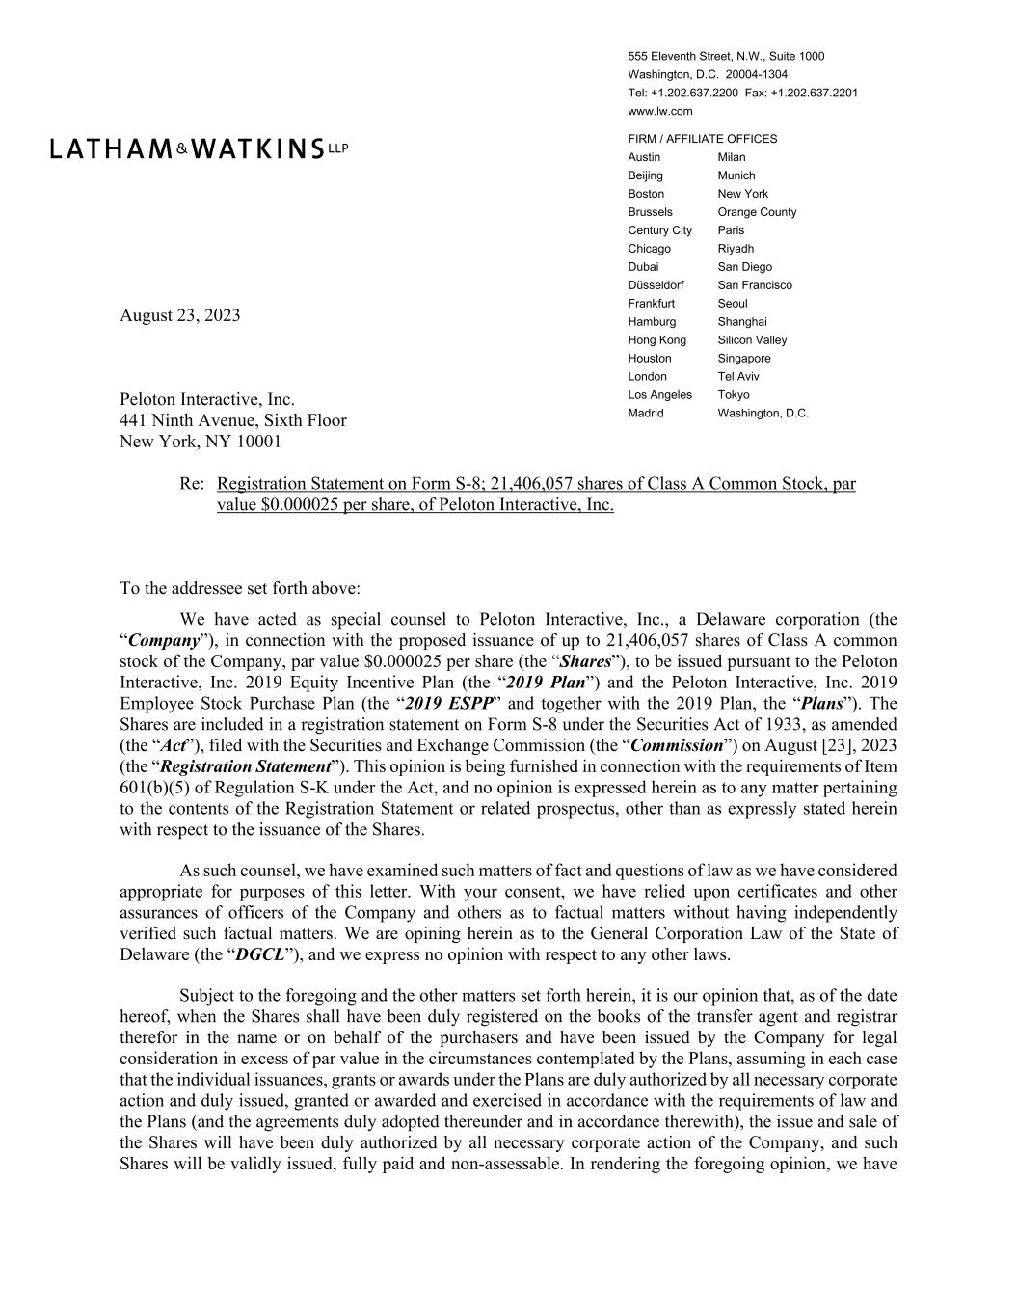

555 Eleventh Street, N.W., Suite 1000 Washington, D.C. 20004-1304 Tel: +1.202.637.2200 Fax: +1.202.637.2201 www.lw.com FIRM / AFFILIATE OFFICES Austin Milan Beijing Munich Boston New York Brussels Orange County Century City Paris Chicago Riyadh Dubai San Diego Düsseldorf San Francisco Frankfurt Seoul Hamburg Shanghai Hong Kong Silicon Valley Houston Singapore London Tel Aviv Los Angeles Tokyo Madrid Washington, D.C. August 23, 2023 Peloton Interactive, Inc. 441 Ninth Avenue, Sixth Floor New York, NY 10001 Re: Registration Statement on Form S-8; 21,406,057 shares of Class A Common Stock, par value $0.000025 per share, of Peloton Interactive, Inc. To the addressee set forth above: We have acted as special counsel to Peloton Interactive, Inc., a Delaware corporation (the “Company”), in connection with the proposed issuance of up to 21,406,057 shares of Class A common stock of the Company, par value $0.000025 per share (the “Shares”), to be issued pursuant to the Peloton Interactive, Inc. 2019 Equity Incentive Plan (the “2019 Plan”) and the Peloton Interactive, Inc. 2019 Employee Stock Purchase Plan (the “2019 ESPP” and together with the 2019 Plan, the “Plans”). The Shares are included in a registration statement on Form S-8 under the Securities Act of 1933, as amended (the “Act”), filed with the Securities and Exchange Commission (the “Commission”) on August [23], 2023 (the “Registration Statement”). This opinion is being furnished in connection with the requirements of Item 601(b)(5) of Regulation S-K under the Act, and no opinion is expressed herein as to any matter pertaining to the contents of the Registration Statement or related prospectus, other than as expressly stated herein with respect to the issuance of the Shares. As such counsel, we have examined such matters of fact and questions of law as we have considered appropriate for purposes of this letter. With your consent, we have relied upon certificates and other assurances of officers of the Company and others as to factual matters without having independently verified such factual matters. We are opining herein as to the General Corporation Law of the State of Delaware (the “DGCL”), and we express no opinion with respect to any other laws. Subject to the foregoing and the other matters set forth herein, it is our opinion that, as of the date hereof, when the Shares shall have been duly registered on the books of the transfer agent and registrar therefor in the name or on behalf of the purchasers and have been issued by the Company for legal consideration in excess of par value in the circumstances contemplated by the Plans, assuming in each case that the individual issuances, grants or awards under the Plans are duly authorized by all necessary corporate action and duly issued, granted or awarded and exercised in accordance with the requirements of law and the Plans (and the agreements duly adopted thereunder and in accordance therewith), the issue and sale of the Shares will have been duly authorized by all necessary corporate action of the Company, and such Shares will be validly issued, fully paid and non-assessable. In rendering the foregoing opinion, we have

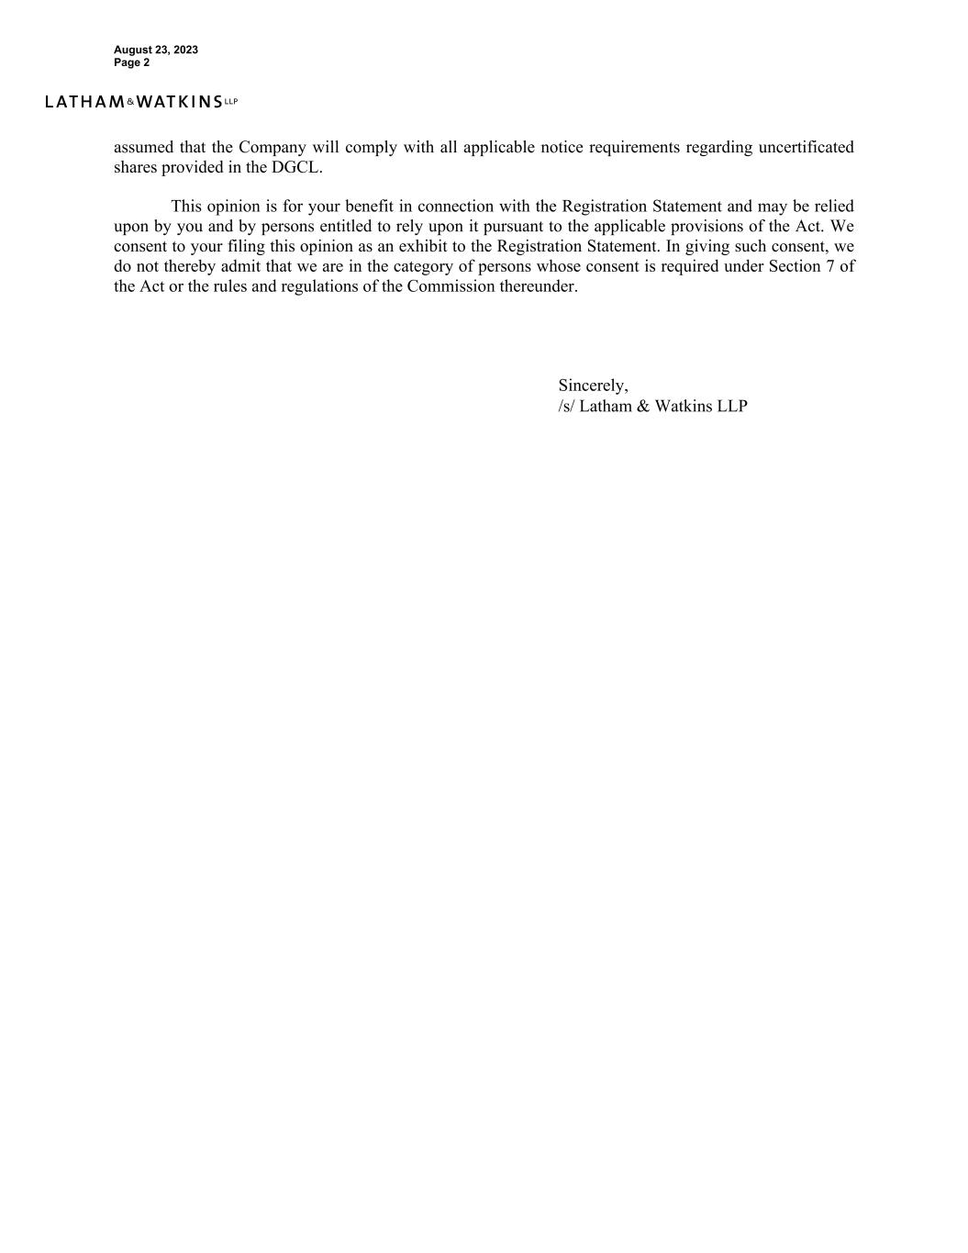
August 23, 2023 Page 2 assumed that the Company will comply with all applicable notice requirements regarding uncertificated shares provided in the DGCL. This opinion is for your benefit in connection with the Registration Statement and may be relied upon by you and by persons entitled to rely upon it pursuant to the applicable provisions of the Act. We consent to your filing this opinion as an exhibit to the Registration Statement. In giving such consent, we do not thereby admit that we are in the category of persons whose consent is required under Section 7 of the Act or the rules and regulations of the Commission thereunder. Sincerely, /s/ Latham & Watkins LLP

Consent of Independent Registered Public Accounting Firm
We consent to the incorporation by reference in the Registration Statement on Form S-8 pertaining to the 2019 Equity Incentive Plan and 2019 Employee Stock Purchase Plan of Peloton Interactive, Inc. of our reports dated August 23, 2023, with respect to the consolidated financial statements of Peloton Interactive, Inc. and the effectiveness of internal control over financial reporting of Peloton Interactive, Inc. included in its Annual Report (Form 10-K) for the year ended June 30, 2023, filed with the Securities and Exchange Commission.
/s/ Ernst & Young LLP
New York, New York
August 23, 2023
Internal Use Only
Exported on 08/18/2023 12:55 am |  |  | © All rights are reserved. |  |  | Page 1

