UNITED STATES
SECURITIES AND EXCHANGE COMMISSION
WASHINGTON, D.C. 20549
_______________________________________________________
FORM 8-K
_______________________________________________________
CURRENT REPORT
Pursuant to Section 13 or 15(d) of the
Securities Exchange Act of 1934
Date of Report (Date of earliest event reported): April 25, 2025
_______________________________________________________

Peloton Interactive, Inc.
(Exact name of Registrant as Specified in Its Charter)
_______________________________________________________
Delaware |  |  | 001-39058 |  |  | 47-3533761
(State or Other Jurisdiction  of Incorporation) |  |  | (Commission File Number) |  |  | (IRS Employer  Identification No.)
441 Ninth Avenue, Sixth Floor  New York, New York |  |  |  |  |  | 10001
(Address of Principal Executive Offices) |  |  |  |  |  | (Zip Code)
Registrant’s Telephone Number, Including Area Code: (929) 567-0006

Not Applicable
(Former Name or Former Address, if Changed Since Last Report)
_______________________________________________________
Check the appropriate box below if the Form 8-K filing is intended to simultaneously satisfy the filing obligation of the registrant under any of the following provisions:
☐ Written communications pursuant to Rule 425 under the Securities Act (17 CFR 230.425)
☐ Soliciting material pursuant to Rule 14a-12 under the Exchange Act (17 CFR 240.14a-12)
☐ Pre-commencement communications pursuant to Rule 14d-2(b) under the Exchange Act (17 CFR 240.14d-2(b))
☐ Pre-commencement communications pursuant to Rule 13e-4(c) under the Exchange Act (17 CFR 240.13e-4(c))
Securities registered pursuant to Section 12(b) of the Act:
Title of Each Class |  |  | Trading Symbol |  |  | Name of Each Exchange on Which Registered
Class A Common Stock, $0.000025 par value per share |  |  | PTON |  |  | The Nasdaq Stock Market LLC
Indicate by check mark whether the registrant is an emerging growth company as defined in Rule 405 of the Securities Act of 1933 (§ 230.405 of this chapter) or Rule 12b-2 of the Securities Exchange Act of 1934 (§ 240.12b-2 of this chapter).
Emerging growth company ☐

If an emerging growth company, indicate by check mark if the registrant has elected not to use the extended transition period for complying with any new or revised financial accounting standards provided pursuant to Section 13(a) of the Exchange Act.☐

Item 8.01. Other Events.

On April 7, 2025, the U.S. District Court for the Eastern District of New York (the “District Court”) issued an order granting preliminary approval of the proposed settlement of the consolidated derivative actions captioned In re Peloton Interactive, Inc. Derivative Litigation, Case No. 1:21-cv-02862-CBA-PK (E.D.N.Y.), which settlement includes other related litigation pending in the United States District Court for the District of Delaware and the Delaware Court of Chancery (collectively, the “Settled Matters”). As previously disclosed, the parties to the Settled Matters agreed to a settlement-in-principle to resolve these matters on July 29, 2024 and plaintiffs filed a motion for preliminary approval of the proposed settlement on November 15, 2024, including a Stipulation and Agreement of Compromise, Settlement, and Release (the “Stipulation”).

Pursuant to the District Court’s order granting preliminary approval of the settlement, copies of (i) the Stipulation (and exhibits thereto) and (ii) the Notice of Pendency and Proposed Settlement of Stockholder Derivative Action are attached hereto as Exhibits 99.1 and 99.2, respectively.

Item 9.01 Financial Statements and Exhibits.

(d) Exhibits.

Exhibit No. |  |  | Description
99.1 |  |  | Stipulation and Agreement of Compromise, Settlement, and Release.
99.2 |  |  | Notice of Pendency and Proposed Settlement of Stockholder Derivative Action.
104 |  |  | Cover Page Interactive Data File (embedded within the Inline XBRL document).

SIGNATURES
Pursuant to the requirements of the Securities Exchange Act of 1934, the Registrant has duly caused this report to be signed on its behalf by the undersigned hereunto duly authorized.

 |  |  | PELOTON INTERACTIVE, INC.
Date: April 25, 2025 |  |  | By: |  |  | /s/ Tammy Albarran
 |  |  |  |  |  | Tammy Albarran
 |  |  |  |  |  | Chief Legal Officer
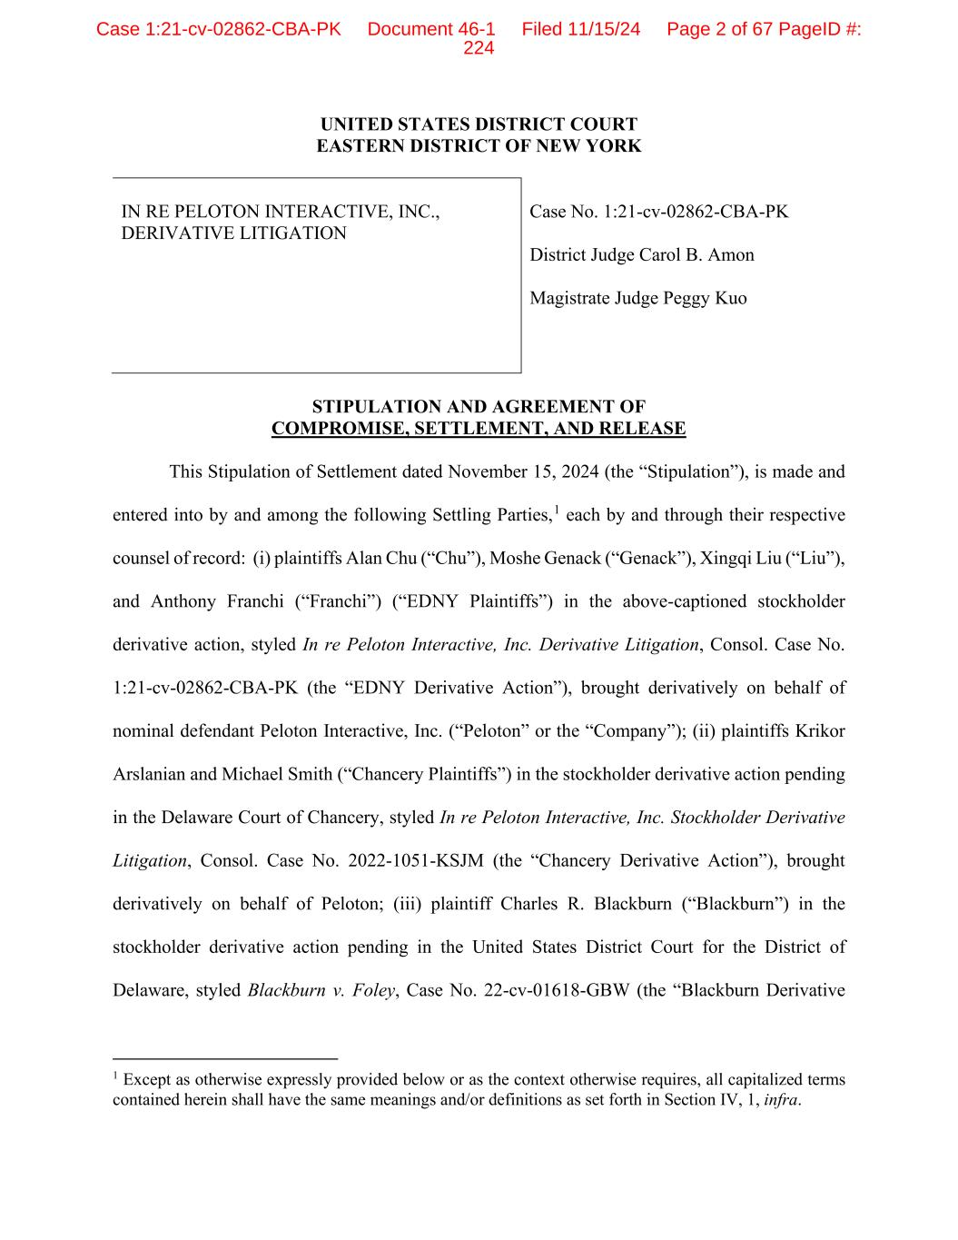

UNITED STATES DISTRICT COURT EASTERN DISTRICT OF NEW YORK IN RE PELOTON INTERACTIVE, INC., DERIVATIVE LITIGATION Case No. 1:21-cv-02862-CBA-PK District Judge Carol B. Amon Magistrate Judge Peggy Kuo STIPULATION AND AGREEMENT OF COMPROMISE, SETTLEMENT, AND RELEASE This Stipulation of Settlement dated November 15, 2024 (the “Stipulation”), is made and entered into by and among the following Settling Parties,1 each by and through their respective counsel of record: (i) plaintiffs Alan Chu (“Chu”), Moshe Genack (“Genack”), Xingqi Liu (“Liu”), and Anthony Franchi (“Franchi”) (“EDNY Plaintiffs”) in the above-captioned stockholder derivative action, styled In re Peloton Interactive, Inc. Derivative Litigation, Consol. Case No. 1:21-cv-02862-CBA-PK (the “EDNY Derivative Action”), brought derivatively on behalf of nominal defendant Peloton Interactive, Inc. (“Peloton” or the “Company”); (ii) plaintiffs Krikor Arslanian and Michael Smith (“Chancery Plaintiffs”) in the stockholder derivative action pending in the Delaware Court of Chancery, styled In re Peloton Interactive, Inc. Stockholder Derivative Litigation, Consol. Case No. 2022-1051-KSJM (the “Chancery Derivative Action”), brought derivatively on behalf of Peloton; (iii) plaintiff Charles R. Blackburn (“Blackburn”) in the stockholder derivative action pending in the United States District Court for the District of Delaware, styled Blackburn v. Foley, Case No. 22-cv-01618-GBW (the “Blackburn Derivative 1 Except as otherwise expressly provided below or as the context otherwise requires, all capitalized terms contained herein shall have the same meanings and/or definitions as set forth in Section IV, 1, infra. Case 1:21-cv-02862-CBA-PK Document 46-1 Filed 11/15/24 Page 2 of 67 PageID #: 224

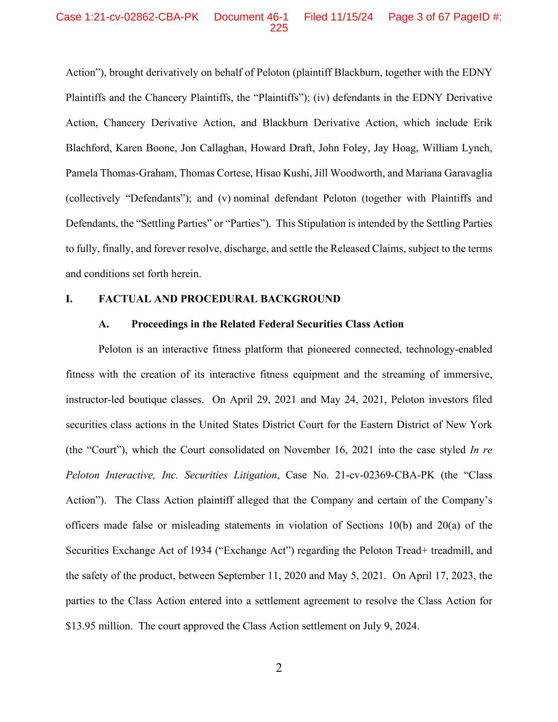
2 Action”), brought derivatively on behalf of Peloton (plaintiff Blackburn, together with the EDNY Plaintiffs and the Chancery Plaintiffs, the “Plaintiffs”); (iv) defendants in the EDNY Derivative Action, Chancery Derivative Action, and Blackburn Derivative Action, which include Erik Blachford, Karen Boone, Jon Callaghan, Howard Draft, John Foley, Jay Hoag, William Lynch, Pamela Thomas-Graham, Thomas Cortese, Hisao Kushi, Jill Woodworth, and Mariana Garavaglia (collectively “Defendants”); and (v) nominal defendant Peloton (together with Plaintiffs and Defendants, the “Settling Parties” or “Parties”). This Stipulation is intended by the Settling Parties to fully, finally, and forever resolve, discharge, and settle the Released Claims, subject to the terms and conditions set forth herein. I. FACTUAL AND PROCEDURAL BACKGROUND A. Proceedings in the Related Federal Securities Class Action Peloton is an interactive fitness platform that pioneered connected, technology-enabled fitness with the creation of its interactive fitness equipment and the streaming of immersive, instructor-led boutique classes. On April 29, 2021 and May 24, 2021, Peloton investors filed securities class actions in the United States District Court for the Eastern District of New York (the “Court”), which the Court consolidated on November 16, 2021 into the case styled In re Peloton Interactive, Inc. Securities Litigation, Case No. 21-cv-02369-CBA-PK (the “Class Action”). The Class Action plaintiff alleged that the Company and certain of the Company’s officers made false or misleading statements in violation of Sections 10(b) and 20(a) of the Securities Exchange Act of 1934 (“Exchange Act”) regarding the Peloton Tread+ treadmill, and the safety of the product, between September 11, 2020 and May 5, 2021. On April 17, 2023, the parties to the Class Action entered into a settlement agreement to resolve the Class Action for $13.95 million. The court approved the Class Action settlement on July 9, 2024. Case 1:21-cv-02862-CBA-PK Document 46-1 Filed 11/15/24 Page 3 of 67 PageID #: 225

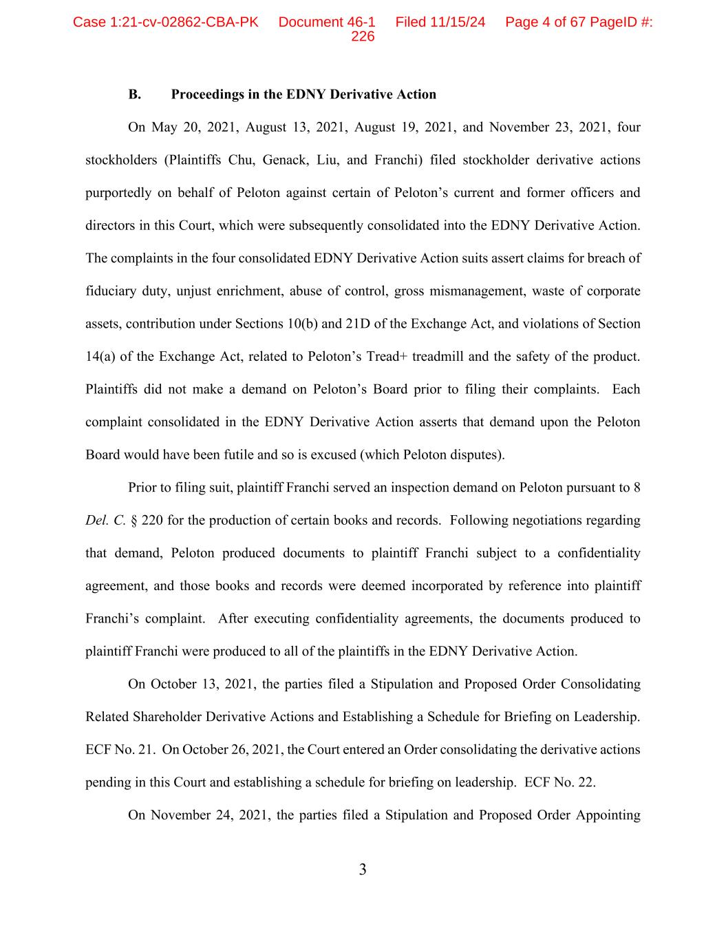
3 B. Proceedings in the EDNY Derivative Action On May 20, 2021, August 13, 2021, August 19, 2021, and November 23, 2021, four stockholders (Plaintiffs Chu, Genack, Liu, and Franchi) filed stockholder derivative actions purportedly on behalf of Peloton against certain of Peloton’s current and former officers and directors in this Court, which were subsequently consolidated into the EDNY Derivative Action. The complaints in the four consolidated EDNY Derivative Action suits assert claims for breach of fiduciary duty, unjust enrichment, abuse of control, gross mismanagement, waste of corporate assets, contribution under Sections 10(b) and 21D of the Exchange Act, and violations of Section 14(a) of the Exchange Act, related to Peloton’s Tread+ treadmill and the safety of the product. Plaintiffs did not make a demand on Peloton’s Board prior to filing their complaints. Each complaint consolidated in the EDNY Derivative Action asserts that demand upon the Peloton Board would have been futile and so is excused (which Peloton disputes). Prior to filing suit, plaintiff Franchi served an inspection demand on Peloton pursuant to 8 Del. C. § 220 for the production of certain books and records. Following negotiations regarding that demand, Peloton produced documents to plaintiff Franchi subject to a confidentiality agreement, and those books and records were deemed incorporated by reference into plaintiff Franchi’s complaint. After executing confidentiality agreements, the documents produced to plaintiff Franchi were produced to all of the plaintiffs in the EDNY Derivative Action. On October 13, 2021, the parties filed a Stipulation and Proposed Order Consolidating Related Shareholder Derivative Actions and Establishing a Schedule for Briefing on Leadership. ECF No. 21. On October 26, 2021, the Court entered an Order consolidating the derivative actions pending in this Court and establishing a schedule for briefing on leadership. ECF No. 22. On November 24, 2021, the parties filed a Stipulation and Proposed Order Appointing Case 1:21-cv-02862-CBA-PK Document 46-1 Filed 11/15/24 Page 4 of 67 PageID #: 226

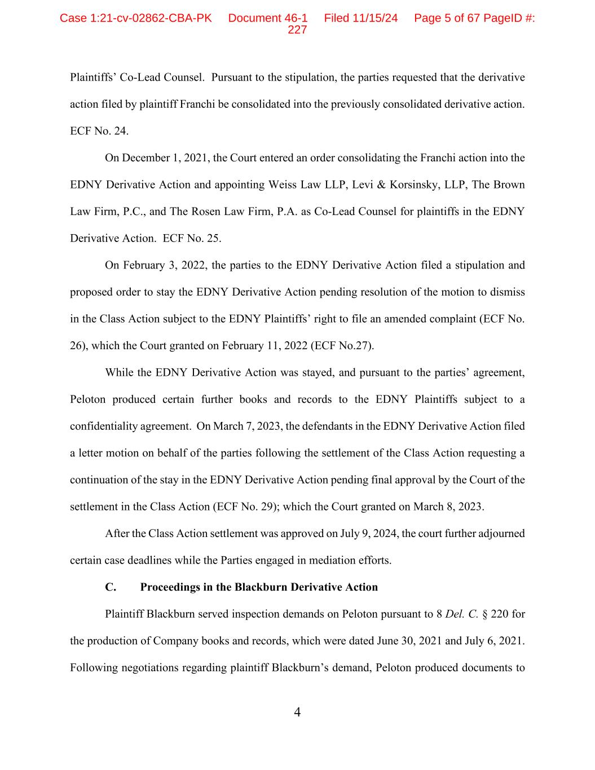
4 Plaintiffs’ Co-Lead Counsel. Pursuant to the stipulation, the parties requested that the derivative action filed by plaintiff Franchi be consolidated into the previously consolidated derivative action. ECF No. 24. On December 1, 2021, the Court entered an order consolidating the Franchi action into the EDNY Derivative Action and appointing Weiss Law LLP, Levi & Korsinsky, LLP, The Brown Law Firm, P.C., and The Rosen Law Firm, P.A. as Co-Lead Counsel for plaintiffs in the EDNY Derivative Action. ECF No. 25. On February 3, 2022, the parties to the EDNY Derivative Action filed a stipulation and proposed order to stay the EDNY Derivative Action pending resolution of the motion to dismiss in the Class Action subject to the EDNY Plaintiffs’ right to file an amended complaint (ECF No. 26), which the Court granted on February 11, 2022 (ECF No.27). While the EDNY Derivative Action was stayed, and pursuant to the parties’ agreement, Peloton produced certain further books and records to the EDNY Plaintiffs subject to a confidentiality agreement. On March 7, 2023, the defendants in the EDNY Derivative Action filed a letter motion on behalf of the parties following the settlement of the Class Action requesting a continuation of the stay in the EDNY Derivative Action pending final approval by the Court of the settlement in the Class Action (ECF No. 29); which the Court granted on March 8, 2023. After the Class Action settlement was approved on July 9, 2024, the court further adjourned certain case deadlines while the Parties engaged in mediation efforts. C. Proceedings in the Blackburn Derivative Action Plaintiff Blackburn served inspection demands on Peloton pursuant to 8 Del. C. § 220 for the production of Company books and records, which were dated June 30, 2021 and July 6, 2021. Following negotiations regarding plaintiff Blackburn’s demand, Peloton produced documents to Case 1:21-cv-02862-CBA-PK Document 46-1 Filed 11/15/24 Page 5 of 67 PageID #: 227

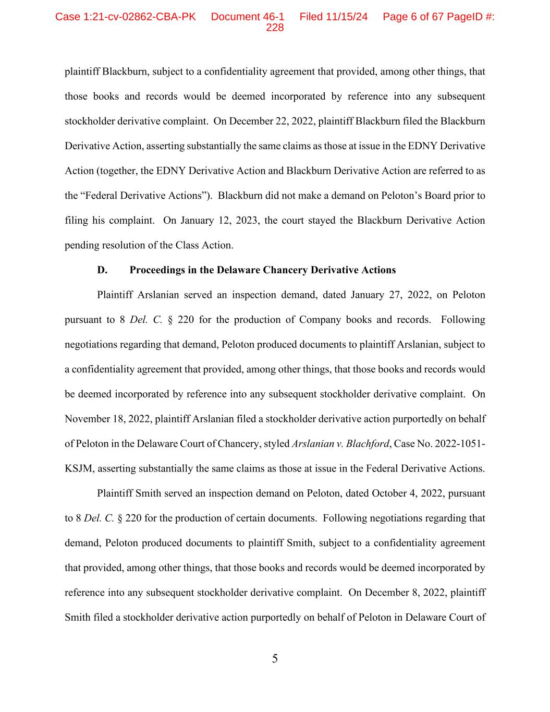
5 plaintiff Blackburn, subject to a confidentiality agreement that provided, among other things, that those books and records would be deemed incorporated by reference into any subsequent stockholder derivative complaint. On December 22, 2022, plaintiff Blackburn filed the Blackburn Derivative Action, asserting substantially the same claims as those at issue in the EDNY Derivative Action (together, the EDNY Derivative Action and Blackburn Derivative Action are referred to as the “Federal Derivative Actions”). Blackburn did not make a demand on Peloton’s Board prior to filing his complaint. On January 12, 2023, the court stayed the Blackburn Derivative Action pending resolution of the Class Action. D. Proceedings in the Delaware Chancery Derivative Actions Plaintiff Arslanian served an inspection demand, dated January 27, 2022, on Peloton pursuant to 8 Del. C. § 220 for the production of Company books and records. Following negotiations regarding that demand, Peloton produced documents to plaintiff Arslanian, subject to a confidentiality agreement that provided, among other things, that those books and records would be deemed incorporated by reference into any subsequent stockholder derivative complaint. On November 18, 2022, plaintiff Arslanian filed a stockholder derivative action purportedly on behalf of Peloton in the Delaware Court of Chancery, styled Arslanian v. Blachford, Case No. 2022-1051- KSJM, asserting substantially the same claims as those at issue in the Federal Derivative Actions. Plaintiff Smith served an inspection demand on Peloton, dated October 4, 2022, pursuant to 8 Del. C. § 220 for the production of certain documents. Following negotiations regarding that demand, Peloton produced documents to plaintiff Smith, subject to a confidentiality agreement that provided, among other things, that those books and records would be deemed incorporated by reference into any subsequent stockholder derivative complaint. On December 8, 2022, plaintiff Smith filed a stockholder derivative action purportedly on behalf of Peloton in Delaware Court of Case 1:21-cv-02862-CBA-PK Document 46-1 Filed 11/15/24 Page 6 of 67 PageID #: 228

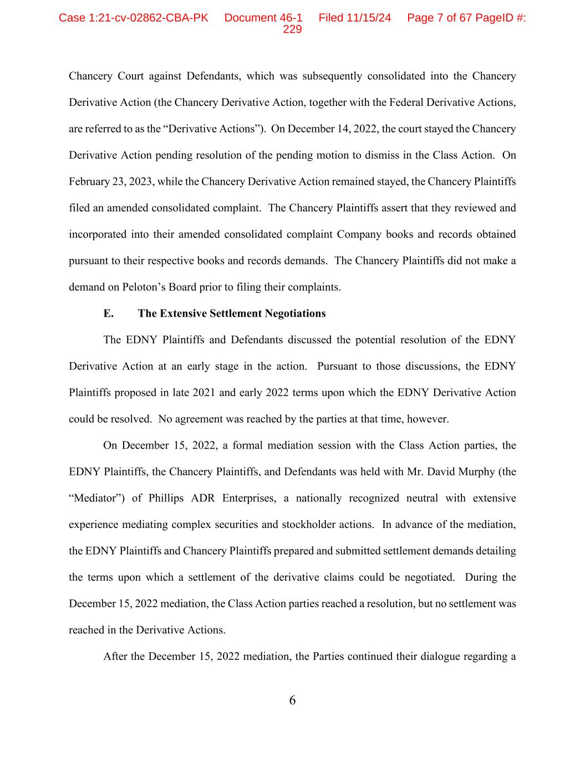
6 Chancery Court against Defendants, which was subsequently consolidated into the Chancery Derivative Action (the Chancery Derivative Action, together with the Federal Derivative Actions, are referred to as the “Derivative Actions”). On December 14, 2022, the court stayed the Chancery Derivative Action pending resolution of the pending motion to dismiss in the Class Action. On February 23, 2023, while the Chancery Derivative Action remained stayed, the Chancery Plaintiffs filed an amended consolidated complaint. The Chancery Plaintiffs assert that they reviewed and incorporated into their amended consolidated complaint Company books and records obtained pursuant to their respective books and records demands. The Chancery Plaintiffs did not make a demand on Peloton’s Board prior to filing their complaints. E. The Extensive Settlement Negotiations The EDNY Plaintiffs and Defendants discussed the potential resolution of the EDNY Derivative Action at an early stage in the action. Pursuant to those discussions, the EDNY Plaintiffs proposed in late 2021 and early 2022 terms upon which the EDNY Derivative Action could be resolved. No agreement was reached by the parties at that time, however. On December 15, 2022, a formal mediation session with the Class Action parties, the EDNY Plaintiffs, the Chancery Plaintiffs, and Defendants was held with Mr. David Murphy (the “Mediator”) of Phillips ADR Enterprises, a nationally recognized neutral with extensive experience mediating complex securities and stockholder actions. In advance of the mediation, the EDNY Plaintiffs and Chancery Plaintiffs prepared and submitted settlement demands detailing the terms upon which a settlement of the derivative claims could be negotiated. During the December 15, 2022 mediation, the Class Action parties reached a resolution, but no settlement was reached in the Derivative Actions. After the December 15, 2022 mediation, the Parties continued their dialogue regarding a Case 1:21-cv-02862-CBA-PK Document 46-1 Filed 11/15/24 Page 7 of 67 PageID #: 229

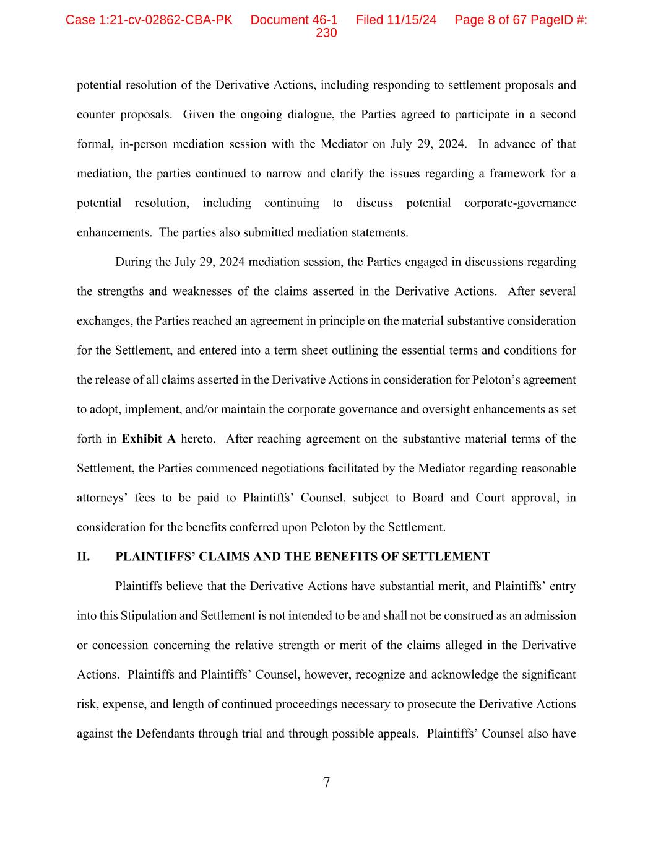
7 potential resolution of the Derivative Actions, including responding to settlement proposals and counter proposals. Given the ongoing dialogue, the Parties agreed to participate in a second formal, in-person mediation session with the Mediator on July 29, 2024. In advance of that mediation, the parties continued to narrow and clarify the issues regarding a framework for a potential resolution, including continuing to discuss potential corporate-governance enhancements. The parties also submitted mediation statements. During the July 29, 2024 mediation session, the Parties engaged in discussions regarding the strengths and weaknesses of the claims asserted in the Derivative Actions. After several exchanges, the Parties reached an agreement in principle on the material substantive consideration for the Settlement, and entered into a term sheet outlining the essential terms and conditions for the release of all claims asserted in the Derivative Actions in consideration for Peloton’s agreement to adopt, implement, and/or maintain the corporate governance and oversight enhancements as set forth in Exhibit A hereto. After reaching agreement on the substantive material terms of the Settlement, the Parties commenced negotiations facilitated by the Mediator regarding reasonable attorneys’ fees to be paid to Plaintiffs’ Counsel, subject to Board and Court approval, in consideration for the benefits conferred upon Peloton by the Settlement. II. PLAINTIFFS’ CLAIMS AND THE BENEFITS OF SETTLEMENT Plaintiffs believe that the Derivative Actions have substantial merit, and Plaintiffs’ entry into this Stipulation and Settlement is not intended to be and shall not be construed as an admission or concession concerning the relative strength or merit of the claims alleged in the Derivative Actions. Plaintiffs and Plaintiffs’ Counsel, however, recognize and acknowledge the significant risk, expense, and length of continued proceedings necessary to prosecute the Derivative Actions against the Defendants through trial and through possible appeals. Plaintiffs’ Counsel also have Case 1:21-cv-02862-CBA-PK Document 46-1 Filed 11/15/24 Page 8 of 67 PageID #: 230

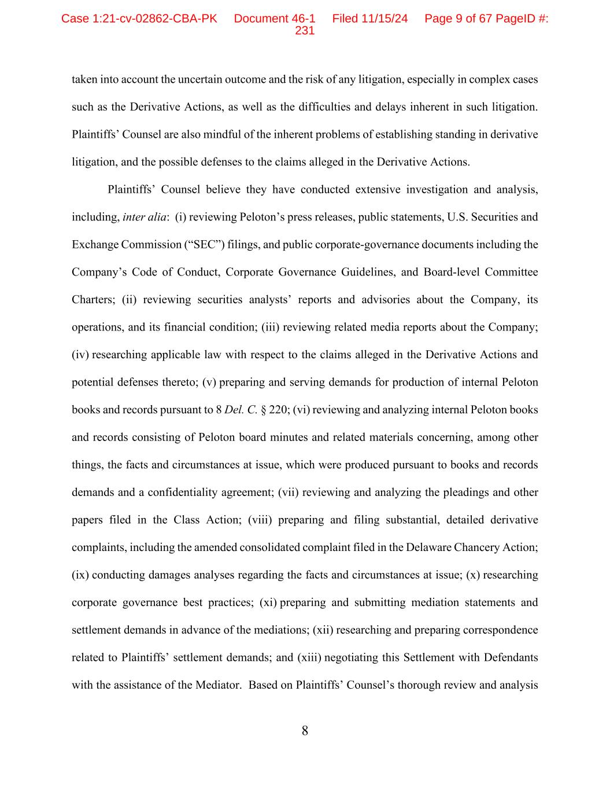
8 taken into account the uncertain outcome and the risk of any litigation, especially in complex cases such as the Derivative Actions, as well as the difficulties and delays inherent in such litigation. Plaintiffs’ Counsel are also mindful of the inherent problems of establishing standing in derivative litigation, and the possible defenses to the claims alleged in the Derivative Actions. Plaintiffs’ Counsel believe they have conducted extensive investigation and analysis, including, inter alia: (i) reviewing Peloton’s press releases, public statements, U.S. Securities and Exchange Commission (“SEC”) filings, and public corporate-governance documents including the Company’s Code of Conduct, Corporate Governance Guidelines, and Board-level Committee Charters; (ii) reviewing securities analysts’ reports and advisories about the Company, its operations, and its financial condition; (iii) reviewing related media reports about the Company; (iv) researching applicable law with respect to the claims alleged in the Derivative Actions and potential defenses thereto; (v) preparing and serving demands for production of internal Peloton books and records pursuant to 8 Del. C. § 220; (vi) reviewing and analyzing internal Peloton books and records consisting of Peloton board minutes and related materials concerning, among other things, the facts and circumstances at issue, which were produced pursuant to books and records demands and a confidentiality agreement; (vii) reviewing and analyzing the pleadings and other papers filed in the Class Action; (viii) preparing and filing substantial, detailed derivative complaints, including the amended consolidated complaint filed in the Delaware Chancery Action; (ix) conducting damages analyses regarding the facts and circumstances at issue; (x) researching corporate governance best practices; (xi) preparing and submitting mediation statements and settlement demands in advance of the mediations; (xii) researching and preparing correspondence related to Plaintiffs’ settlement demands; and (xiii) negotiating this Settlement with Defendants with the assistance of the Mediator. Based on Plaintiffs’ Counsel’s thorough review and analysis Case 1:21-cv-02862-CBA-PK Document 46-1 Filed 11/15/24 Page 9 of 67 PageID #: 231

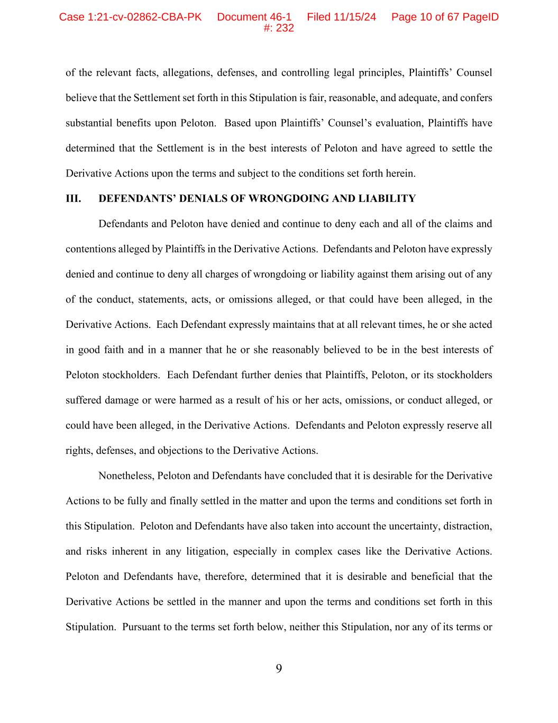
9 of the relevant facts, allegations, defenses, and controlling legal principles, Plaintiffs’ Counsel believe that the Settlement set forth in this Stipulation is fair, reasonable, and adequate, and confers substantial benefits upon Peloton. Based upon Plaintiffs’ Counsel’s evaluation, Plaintiffs have determined that the Settlement is in the best interests of Peloton and have agreed to settle the Derivative Actions upon the terms and subject to the conditions set forth herein. III. DEFENDANTS’ DENIALS OF WRONGDOING AND LIABILITY Defendants and Peloton have denied and continue to deny each and all of the claims and contentions alleged by Plaintiffs in the Derivative Actions. Defendants and Peloton have expressly denied and continue to deny all charges of wrongdoing or liability against them arising out of any of the conduct, statements, acts, or omissions alleged, or that could have been alleged, in the Derivative Actions. Each Defendant expressly maintains that at all relevant times, he or she acted in good faith and in a manner that he or she reasonably believed to be in the best interests of Peloton stockholders. Each Defendant further denies that Plaintiffs, Peloton, or its stockholders suffered damage or were harmed as a result of his or her acts, omissions, or conduct alleged, or could have been alleged, in the Derivative Actions. Defendants and Peloton expressly reserve all rights, defenses, and objections to the Derivative Actions. Nonetheless, Peloton and Defendants have concluded that it is desirable for the Derivative Actions to be fully and finally settled in the matter and upon the terms and conditions set forth in this Stipulation. Peloton and Defendants have also taken into account the uncertainty, distraction, and risks inherent in any litigation, especially in complex cases like the Derivative Actions. Peloton and Defendants have, therefore, determined that it is desirable and beneficial that the Derivative Actions be settled in the manner and upon the terms and conditions set forth in this Stipulation. Pursuant to the terms set forth below, neither this Stipulation, nor any of its terms or Case 1:21-cv-02862-CBA-PK Document 46-1 Filed 11/15/24 Page 10 of 67 PageID #: 232

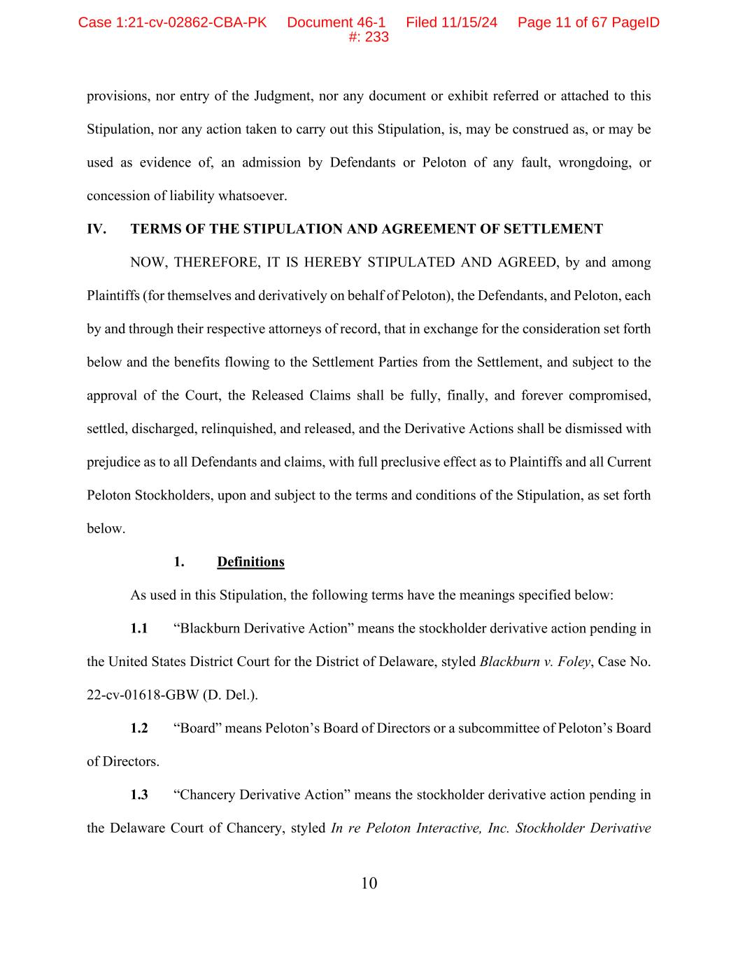
10 provisions, nor entry of the Judgment, nor any document or exhibit referred or attached to this Stipulation, nor any action taken to carry out this Stipulation, is, may be construed as, or may be used as evidence of, an admission by Defendants or Peloton of any fault, wrongdoing, or concession of liability whatsoever. IV. TERMS OF THE STIPULATION AND AGREEMENT OF SETTLEMENT NOW, THEREFORE, IT IS HEREBY STIPULATED AND AGREED, by and among Plaintiffs (for themselves and derivatively on behalf of Peloton), the Defendants, and Peloton, each by and through their respective attorneys of record, that in exchange for the consideration set forth below and the benefits flowing to the Settlement Parties from the Settlement, and subject to the approval of the Court, the Released Claims shall be fully, finally, and forever compromised, settled, discharged, relinquished, and released, and the Derivative Actions shall be dismissed with prejudice as to all Defendants and claims, with full preclusive effect as to Plaintiffs and all Current Peloton Stockholders, upon and subject to the terms and conditions of the Stipulation, as set forth below. 1. Definitions As used in this Stipulation, the following terms have the meanings specified below: 1.1 “Blackburn Derivative Action” means the stockholder derivative action pending in the United States District Court for the District of Delaware, styled Blackburn v. Foley, Case No. 22-cv-01618-GBW (D. Del.). 1.2 “Board” means Peloton’s Board of Directors or a subcommittee of Peloton’s Board of Directors. 1.3 “Chancery Derivative Action” means the stockholder derivative action pending in the Delaware Court of Chancery, styled In re Peloton Interactive, Inc. Stockholder Derivative Case 1:21-cv-02862-CBA-PK Document 46-1 Filed 11/15/24 Page 11 of 67 PageID #: 233

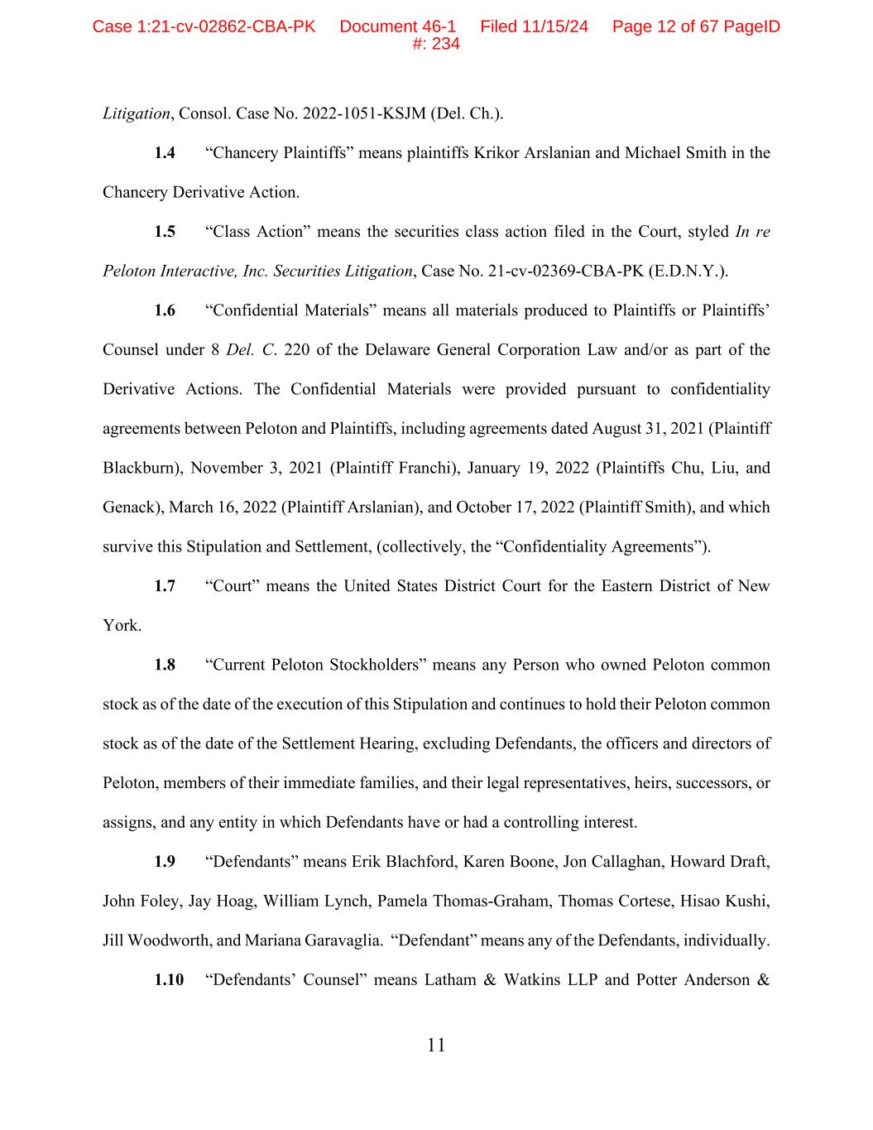
11 Litigation, Consol. Case No. 2022-1051-KSJM (Del. Ch.). 1.4 “Chancery Plaintiffs” means plaintiffs Krikor Arslanian and Michael Smith in the Chancery Derivative Action. 1.5 “Class Action” means the securities class action filed in the Court, styled In re Peloton Interactive, Inc. Securities Litigation, Case No. 21-cv-02369-CBA-PK (E.D.N.Y.). 1.6 “Confidential Materials” means all materials produced to Plaintiffs or Plaintiffs’ Counsel under 8 Del. C. 220 of the Delaware General Corporation Law and/or as part of the Derivative Actions. The Confidential Materials were provided pursuant to confidentiality agreements between Peloton and Plaintiffs, including agreements dated August 31, 2021 (Plaintiff Blackburn), November 3, 2021 (Plaintiff Franchi), January 19, 2022 (Plaintiffs Chu, Liu, and Genack), March 16, 2022 (Plaintiff Arslanian), and October 17, 2022 (Plaintiff Smith), and which survive this Stipulation and Settlement, (collectively, the “Confidentiality Agreements”). 1.7 “Court” means the United States District Court for the Eastern District of New York. 1.8 “Current Peloton Stockholders” means any Person who owned Peloton common stock as of the date of the execution of this Stipulation and continues to hold their Peloton common stock as of the date of the Settlement Hearing, excluding Defendants, the officers and directors of Peloton, members of their immediate families, and their legal representatives, heirs, successors, or assigns, and any entity in which Defendants have or had a controlling interest. 1.9 “Defendants” means Erik Blachford, Karen Boone, Jon Callaghan, Howard Draft, John Foley, Jay Hoag, William Lynch, Pamela Thomas-Graham, Thomas Cortese, Hisao Kushi, Jill Woodworth, and Mariana Garavaglia. “Defendant” means any of the Defendants, individually. 1.10 “Defendants’ Counsel” means Latham & Watkins LLP and Potter Anderson & Case 1:21-cv-02862-CBA-PK Document 46-1 Filed 11/15/24 Page 12 of 67 PageID #: 234

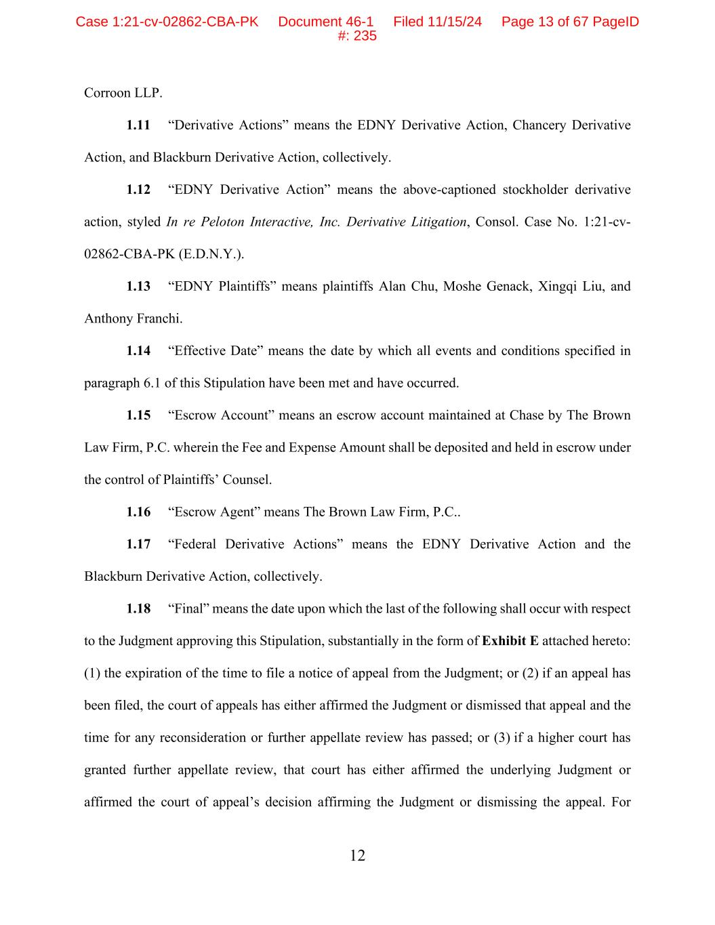
12 Corroon LLP. 1.11 “Derivative Actions” means the EDNY Derivative Action, Chancery Derivative Action, and Blackburn Derivative Action, collectively. 1.12 “EDNY Derivative Action” means the above-captioned stockholder derivative action, styled In re Peloton Interactive, Inc. Derivative Litigation, Consol. Case No. 1:21-cv- 02862-CBA-PK (E.D.N.Y.). 1.13 “EDNY Plaintiffs” means plaintiffs Alan Chu, Moshe Genack, Xingqi Liu, and Anthony Franchi. 1.14 “Effective Date” means the date by which all events and conditions specified in paragraph 6.1 of this Stipulation have been met and have occurred. 1.15 “Escrow Account” means an escrow account maintained at Chase by The Brown Law Firm, P.C. wherein the Fee and Expense Amount shall be deposited and held in escrow under the control of Plaintiffs’ Counsel. 1.16 “Escrow Agent” means The Brown Law Firm, P.C.. 1.17 “Federal Derivative Actions” means the EDNY Derivative Action and the Blackburn Derivative Action, collectively. 1.18 “Final” means the date upon which the last of the following shall occur with respect to the Judgment approving this Stipulation, substantially in the form of Exhibit E attached hereto: (1) the expiration of the time to file a notice of appeal from the Judgment; or (2) if an appeal has been filed, the court of appeals has either affirmed the Judgment or dismissed that appeal and the time for any reconsideration or further appellate review has passed; or (3) if a higher court has granted further appellate review, that court has either affirmed the underlying Judgment or affirmed the court of appeal’s decision affirming the Judgment or dismissing the appeal. For Case 1:21-cv-02862-CBA-PK Document 46-1 Filed 11/15/24 Page 13 of 67 PageID #: 235

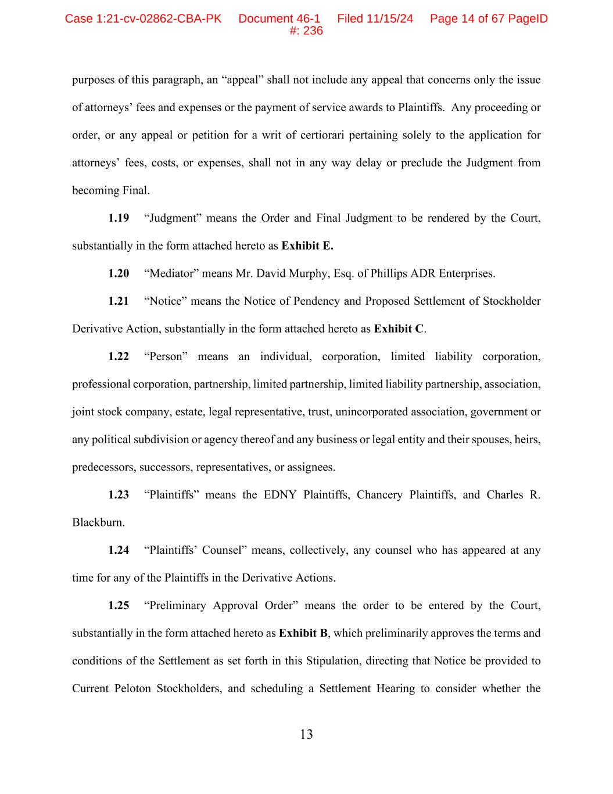
13 purposes of this paragraph, an “appeal” shall not include any appeal that concerns only the issue of attorneys’ fees and expenses or the payment of service awards to Plaintiffs. Any proceeding or order, or any appeal or petition for a writ of certiorari pertaining solely to the application for attorneys’ fees, costs, or expenses, shall not in any way delay or preclude the Judgment from becoming Final. 1.19 “Judgment” means the Order and Final Judgment to be rendered by the Court, substantially in the form attached hereto as Exhibit E. 1.20 “Mediator” means Mr. David Murphy, Esq. of Phillips ADR Enterprises. 1.21 “Notice” means the Notice of Pendency and Proposed Settlement of Stockholder Derivative Action, substantially in the form attached hereto as Exhibit C. 1.22 “Person” means an individual, corporation, limited liability corporation, professional corporation, partnership, limited partnership, limited liability partnership, association, joint stock company, estate, legal representative, trust, unincorporated association, government or any political subdivision or agency thereof and any business or legal entity and their spouses, heirs, predecessors, successors, representatives, or assignees. 1.23 “Plaintiffs” means the EDNY Plaintiffs, Chancery Plaintiffs, and Charles R. Blackburn. 1.24 “Plaintiffs’ Counsel” means, collectively, any counsel who has appeared at any time for any of the Plaintiffs in the Derivative Actions. 1.25 “Preliminary Approval Order” means the order to be entered by the Court, substantially in the form attached hereto as Exhibit B, which preliminarily approves the terms and conditions of the Settlement as set forth in this Stipulation, directing that Notice be provided to Current Peloton Stockholders, and scheduling a Settlement Hearing to consider whether the Case 1:21-cv-02862-CBA-PK Document 46-1 Filed 11/15/24 Page 14 of 67 PageID #: 236


14 Settlement and all of its terms should be finally approved. 1.26 “Peloton” or the “Company” means nominal defendant Peloton Interactive, Inc., a Delaware corporation, and its affiliates, subsidiaries, predecessors, successors, and assigns. 1.27 “Related Persons” means: (i) with regard to Defendants, the Defendants’ spouses, marital communities, immediate family members, heirs, executors, personal representatives, estates, administrators, trusts, predecessors, successors, and assigns or other individual or entity in which any Defendant has a controlling interest, and each and all of their respective past and present officers, directors, employees, agents, affiliates, parents, subsidiaries, divisions, attorneys, accountants, auditors, advisors, insurers, co-insurers, re-insurers, heirs, executors, personal representatives, estates, administrators, trusts, predecessors, successors, and assigns; (ii) with regard to Peloton, all past or present agents, officers, directors, employees, attorneys, accountants, auditors, advisors, insurers, co-insurers, reinsurers, partners, controlling stockholders, joint venturers, related or affiliated entities, advisors, employees, affiliates, predecessors, successors, parents, subsidiaries, insurers, and assigns for Peloton; and (iii) with regard to Plaintiffs, the Plaintiffs’ spouses, marital communities, immediate family members, heirs, executors, personal representatives, estates, administrators, trusts, predecessors, successors, and assigns or other individual or entity in which any Plaintiff has a controlling interest, and each and all of their respective past and present officers, directors, employees, agents, affiliates, parents, subsidiaries, divisions, attorneys, accountants, auditors, advisors, insurers, co-insurers, re-insurers, heirs, executors, personal representatives, estates, administrators, trusts, predecessors, successors, and assigns. 1.28 “Released Claims” means any and all actions, suits, claims, debts, rights, liabilities, and causes of action, whether under federal, state, local, statutory, common law, foreign law, or Case 1:21-cv-02862-CBA-PK Document 46-1 Filed 11/15/24 Page 15 of 67 PageID #: 237

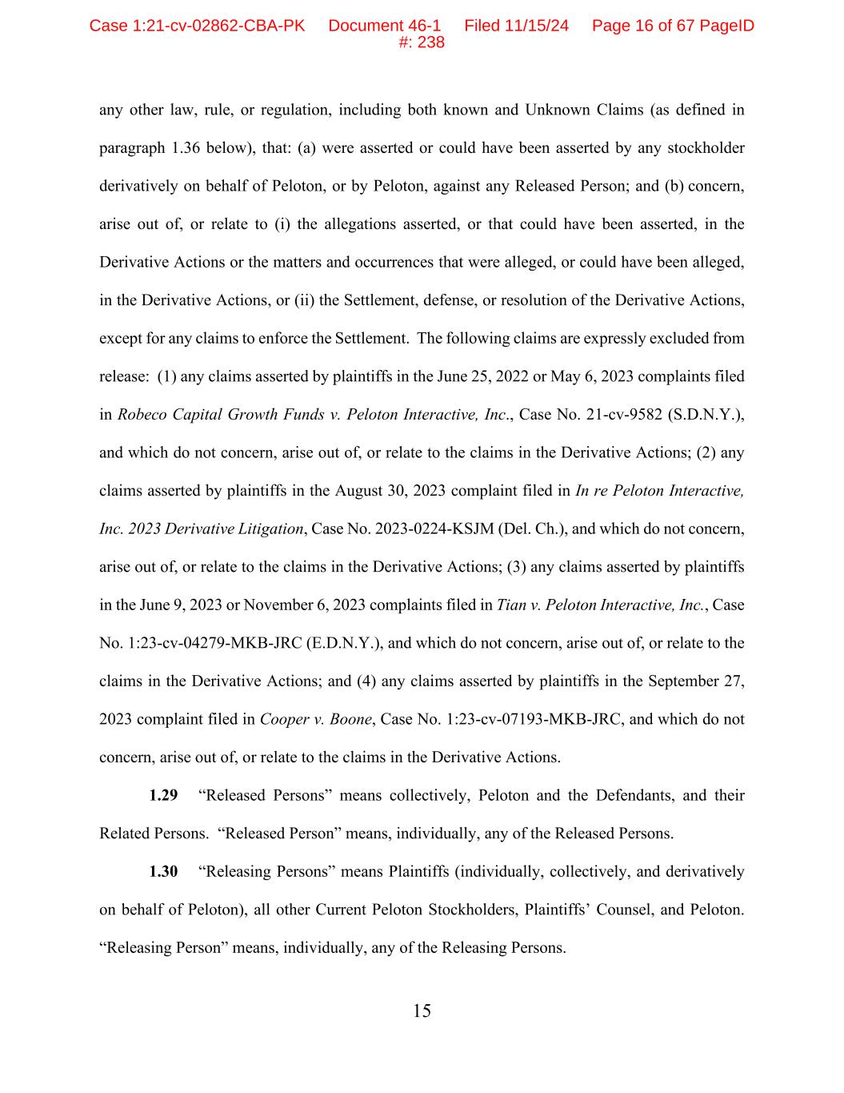
15 any other law, rule, or regulation, including both known and Unknown Claims (as defined in paragraph 1.36 below), that: (a) were asserted or could have been asserted by any stockholder derivatively on behalf of Peloton, or by Peloton, against any Released Person; and (b) concern, arise out of, or relate to (i) the allegations asserted, or that could have been asserted, in the Derivative Actions or the matters and occurrences that were alleged, or could have been alleged, in the Derivative Actions, or (ii) the Settlement, defense, or resolution of the Derivative Actions, except for any claims to enforce the Settlement. The following claims are expressly excluded from release: (1) any claims asserted by plaintiffs in the June 25, 2022 or May 6, 2023 complaints filed in Robeco Capital Growth Funds v. Peloton Interactive, Inc., Case No. 21-cv-9582 (S.D.N.Y.), and which do not concern, arise out of, or relate to the claims in the Derivative Actions; (2) any claims asserted by plaintiffs in the August 30, 2023 complaint filed in In re Peloton Interactive, Inc. 2023 Derivative Litigation, Case No. 2023-0224-KSJM (Del. Ch.), and which do not concern, arise out of, or relate to the claims in the Derivative Actions; (3) any claims asserted by plaintiffs in the June 9, 2023 or November 6, 2023 complaints filed in Tian v. Peloton Interactive, Inc., Case No. 1:23-cv-04279-MKB-JRC (E.D.N.Y.), and which do not concern, arise out of, or relate to the claims in the Derivative Actions; and (4) any claims asserted by plaintiffs in the September 27, 2023 complaint filed in Cooper v. Boone, Case No. 1:23-cv-07193-MKB-JRC, and which do not concern, arise out of, or relate to the claims in the Derivative Actions. 1.29 “Released Persons” means collectively, Peloton and the Defendants, and their Related Persons. “Released Person” means, individually, any of the Released Persons. 1.30 “Releasing Persons” means Plaintiffs (individually, collectively, and derivatively on behalf of Peloton), all other Current Peloton Stockholders, Plaintiffs’ Counsel, and Peloton. “Releasing Person” means, individually, any of the Releasing Persons. Case 1:21-cv-02862-CBA-PK Document 46-1 Filed 11/15/24 Page 16 of 67 PageID #: 238

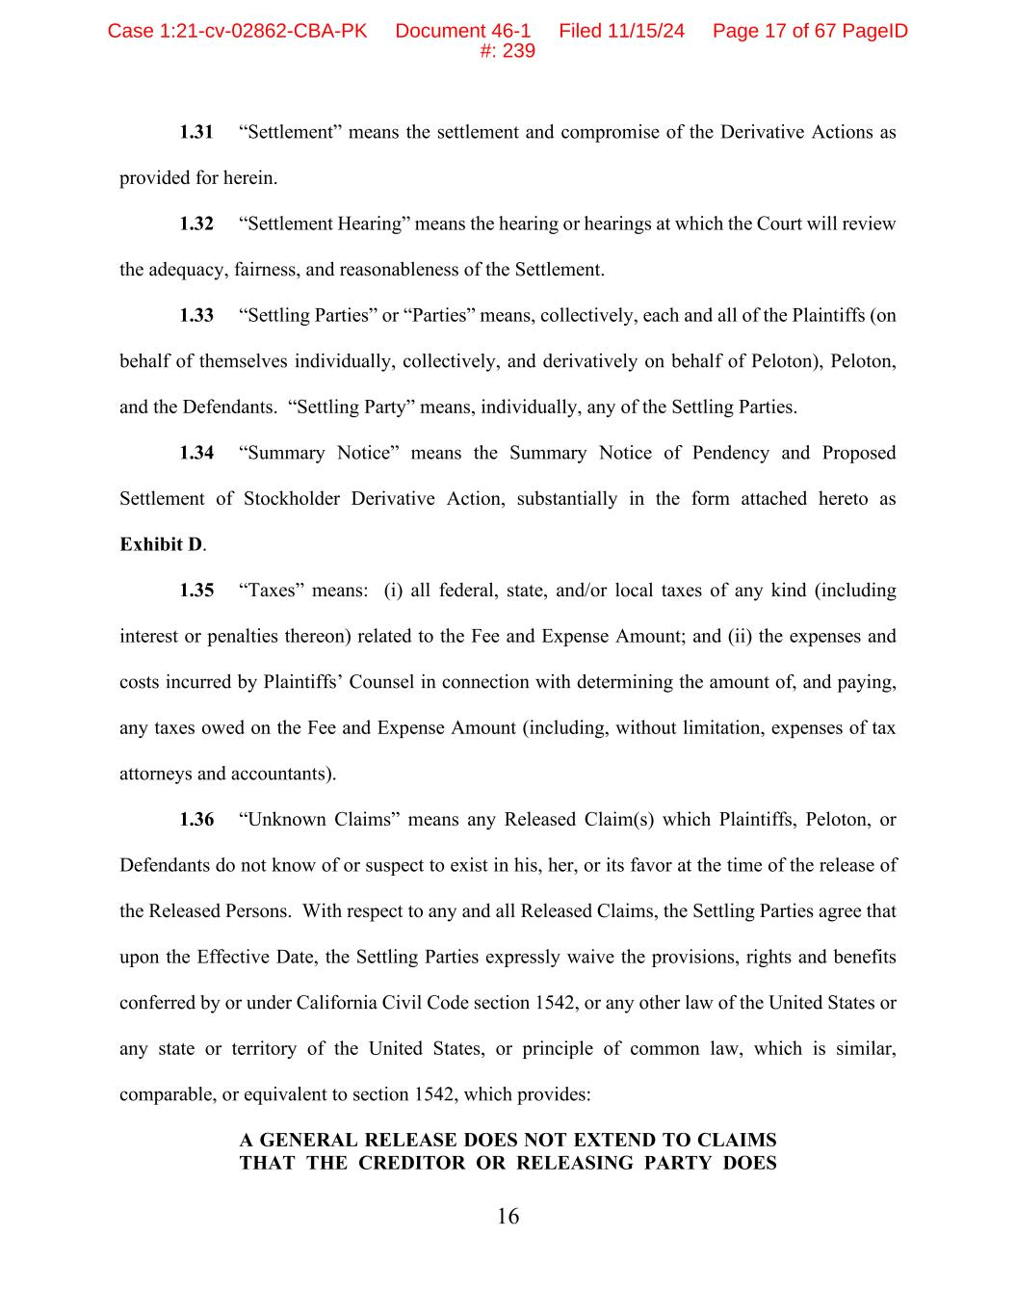
16 1.31 “Settlement” means the settlement and compromise of the Derivative Actions as provided for herein. 1.32 “Settlement Hearing” means the hearing or hearings at which the Court will review the adequacy, fairness, and reasonableness of the Settlement. 1.33 “Settling Parties” or “Parties” means, collectively, each and all of the Plaintiffs (on behalf of themselves individually, collectively, and derivatively on behalf of Peloton), Peloton, and the Defendants. “Settling Party” means, individually, any of the Settling Parties. 1.34 “Summary Notice” means the Summary Notice of Pendency and Proposed Settlement of Stockholder Derivative Action, substantially in the form attached hereto as Exhibit D. 1.35 “Taxes” means: (i) all federal, state, and/or local taxes of any kind (including interest or penalties thereon) related to the Fee and Expense Amount; and (ii) the expenses and costs incurred by Plaintiffs’ Counsel in connection with determining the amount of, and paying, any taxes owed on the Fee and Expense Amount (including, without limitation, expenses of tax attorneys and accountants). 1.36 “Unknown Claims” means any Released Claim(s) which Plaintiffs, Peloton, or Defendants do not know of or suspect to exist in his, her, or its favor at the time of the release of the Released Persons. With respect to any and all Released Claims, the Settling Parties agree that upon the Effective Date, the Settling Parties expressly waive the provisions, rights and benefits conferred by or under California Civil Code section 1542, or any other law of the United States or any state or territory of the United States, or principle of common law, which is similar, comparable, or equivalent to section 1542, which provides: A GENERAL RELEASE DOES NOT EXTEND TO CLAIMS THAT THE CREDITOR OR RELEASING PARTY DOES Case 1:21-cv-02862-CBA-PK Document 46-1 Filed 11/15/24 Page 17 of 67 PageID #: 239

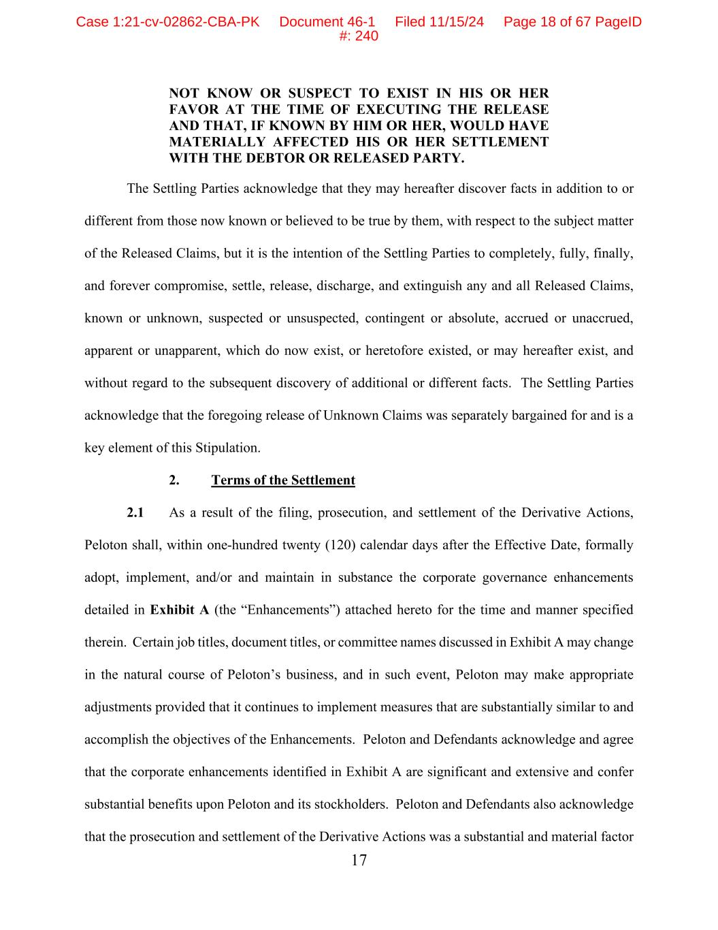
17 NOT KNOW OR SUSPECT TO EXIST IN HIS OR HER FAVOR AT THE TIME OF EXECUTING THE RELEASE AND THAT, IF KNOWN BY HIM OR HER, WOULD HAVE MATERIALLY AFFECTED HIS OR HER SETTLEMENT WITH THE DEBTOR OR RELEASED PARTY. The Settling Parties acknowledge that they may hereafter discover facts in addition to or different from those now known or believed to be true by them, with respect to the subject matter of the Released Claims, but it is the intention of the Settling Parties to completely, fully, finally, and forever compromise, settle, release, discharge, and extinguish any and all Released Claims, known or unknown, suspected or unsuspected, contingent or absolute, accrued or unaccrued, apparent or unapparent, which do now exist, or heretofore existed, or may hereafter exist, and without regard to the subsequent discovery of additional or different facts. The Settling Parties acknowledge that the foregoing release of Unknown Claims was separately bargained for and is a key element of this Stipulation. 2. Terms of the Settlement 2.1 As a result of the filing, prosecution, and settlement of the Derivative Actions, Peloton shall, within one-hundred twenty (120) calendar days after the Effective Date, formally adopt, implement, and/or and maintain in substance the corporate governance enhancements detailed in Exhibit A (the “Enhancements”) attached hereto for the time and manner specified therein. Certain job titles, document titles, or committee names discussed in Exhibit A may change in the natural course of Peloton’s business, and in such event, Peloton may make appropriate adjustments provided that it continues to implement measures that are substantially similar to and accomplish the objectives of the Enhancements. Peloton and Defendants acknowledge and agree that the corporate enhancements identified in Exhibit A are significant and extensive and confer substantial benefits upon Peloton and its stockholders. Peloton and Defendants also acknowledge that the prosecution and settlement of the Derivative Actions was a substantial and material factor Case 1:21-cv-02862-CBA-PK Document 46-1 Filed 11/15/24 Page 18 of 67 PageID #: 240

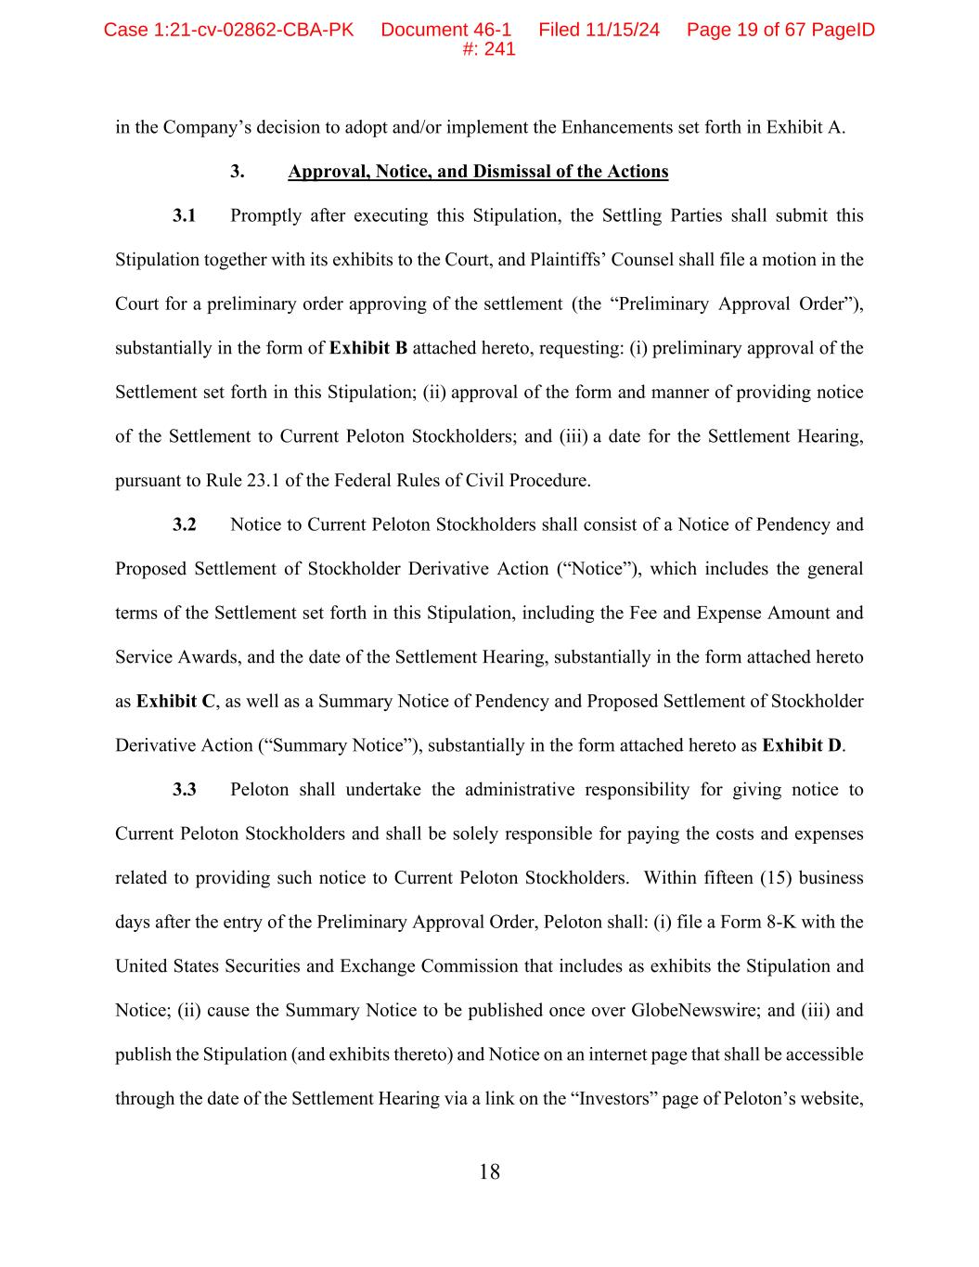
18 in the Company’s decision to adopt and/or implement the Enhancements set forth in Exhibit A. 3. Approval, Notice, and Dismissal of the Actions 3.1 Promptly after executing this Stipulation, the Settling Parties shall submit this Stipulation together with its exhibits to the Court, and Plaintiffs’ Counsel shall file a motion in the Court for a preliminary order approving of the settlement (the “Preliminary Approval Order”), substantially in the form of Exhibit B attached hereto, requesting: (i) preliminary approval of the Settlement set forth in this Stipulation; (ii) approval of the form and manner of providing notice of the Settlement to Current Peloton Stockholders; and (iii) a date for the Settlement Hearing, pursuant to Rule 23.1 of the Federal Rules of Civil Procedure. 3.2 Notice to Current Peloton Stockholders shall consist of a Notice of Pendency and Proposed Settlement of Stockholder Derivative Action (“Notice”), which includes the general terms of the Settlement set forth in this Stipulation, including the Fee and Expense Amount and Service Awards, and the date of the Settlement Hearing, substantially in the form attached hereto as Exhibit C, as well as a Summary Notice of Pendency and Proposed Settlement of Stockholder Derivative Action (“Summary Notice”), substantially in the form attached hereto as Exhibit D. 3.3 Peloton shall undertake the administrative responsibility for giving notice to Current Peloton Stockholders and shall be solely responsible for paying the costs and expenses related to providing such notice to Current Peloton Stockholders. Within fifteen (15) business days after the entry of the Preliminary Approval Order, Peloton shall: (i) file a Form 8-K with the United States Securities and Exchange Commission that includes as exhibits the Stipulation and Notice; (ii) cause the Summary Notice to be published once over GlobeNewswire; and (iii) and publish the Stipulation (and exhibits thereto) and Notice on an internet page that shall be accessible through the date of the Settlement Hearing via a link on the “Investors” page of Peloton’s website, Case 1:21-cv-02862-CBA-PK Document 46-1 Filed 11/15/24 Page 19 of 67 PageID #: 241

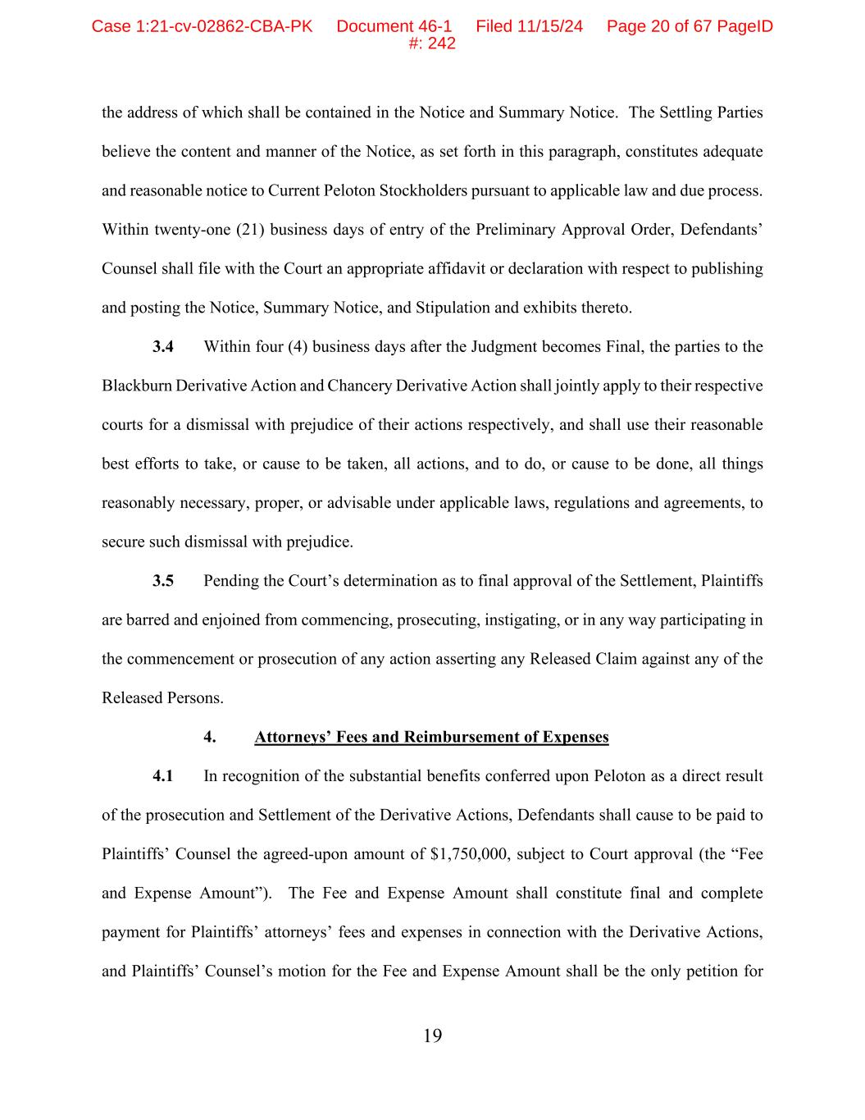
19 the address of which shall be contained in the Notice and Summary Notice. The Settling Parties believe the content and manner of the Notice, as set forth in this paragraph, constitutes adequate and reasonable notice to Current Peloton Stockholders pursuant to applicable law and due process. Within twenty-one (21) business days of entry of the Preliminary Approval Order, Defendants’ Counsel shall file with the Court an appropriate affidavit or declaration with respect to publishing and posting the Notice, Summary Notice, and Stipulation and exhibits thereto. 3.4 Within four (4) business days after the Judgment becomes Final, the parties to the Blackburn Derivative Action and Chancery Derivative Action shall jointly apply to their respective courts for a dismissal with prejudice of their actions respectively, and shall use their reasonable best efforts to take, or cause to be taken, all actions, and to do, or cause to be done, all things reasonably necessary, proper, or advisable under applicable laws, regulations and agreements, to secure such dismissal with prejudice. 3.5 Pending the Court’s determination as to final approval of the Settlement, Plaintiffs are barred and enjoined from commencing, prosecuting, instigating, or in any way participating in the commencement or prosecution of any action asserting any Released Claim against any of the Released Persons. 4. Attorneys’ Fees and Reimbursement of Expenses 4.1 In recognition of the substantial benefits conferred upon Peloton as a direct result of the prosecution and Settlement of the Derivative Actions, Defendants shall cause to be paid to Plaintiffs’ Counsel the agreed-upon amount of $1,750,000, subject to Court approval (the “Fee and Expense Amount”). The Fee and Expense Amount shall constitute final and complete payment for Plaintiffs’ attorneys’ fees and expenses in connection with the Derivative Actions, and Plaintiffs’ Counsel’s motion for the Fee and Expense Amount shall be the only petition for Case 1:21-cv-02862-CBA-PK Document 46-1 Filed 11/15/24 Page 20 of 67 PageID #: 242

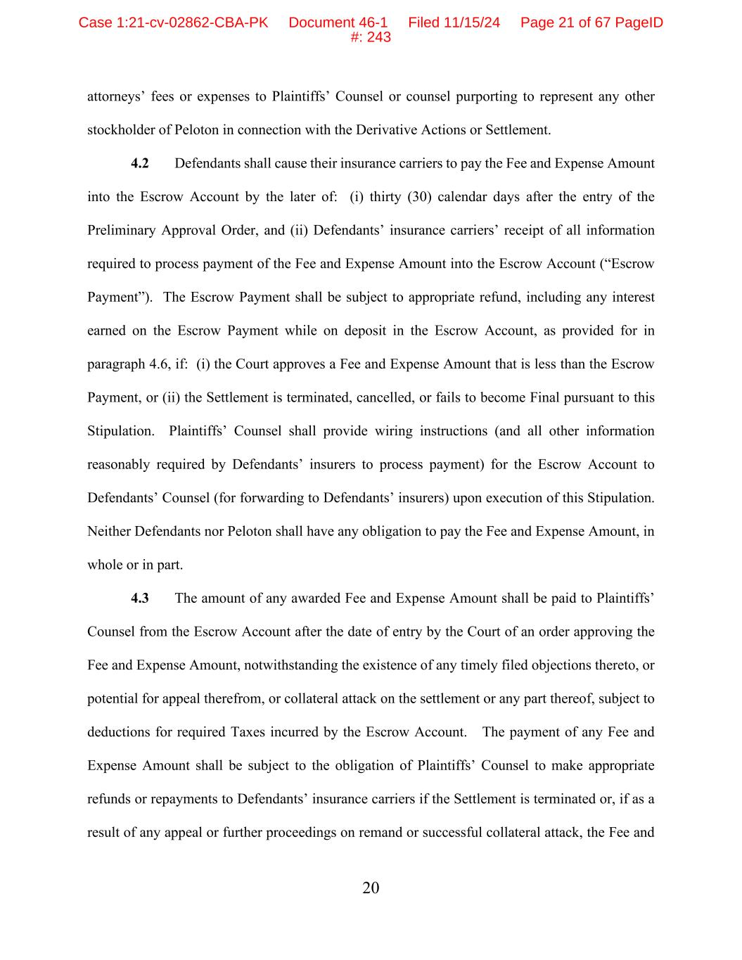
20 attorneys’ fees or expenses to Plaintiffs’ Counsel or counsel purporting to represent any other stockholder of Peloton in connection with the Derivative Actions or Settlement. 4.2 Defendants shall cause their insurance carriers to pay the Fee and Expense Amount into the Escrow Account by the later of: (i) thirty (30) calendar days after the entry of the Preliminary Approval Order, and (ii) Defendants’ insurance carriers’ receipt of all information required to process payment of the Fee and Expense Amount into the Escrow Account (“Escrow Payment”). The Escrow Payment shall be subject to appropriate refund, including any interest earned on the Escrow Payment while on deposit in the Escrow Account, as provided for in paragraph 4.6, if: (i) the Court approves a Fee and Expense Amount that is less than the Escrow Payment, or (ii) the Settlement is terminated, cancelled, or fails to become Final pursuant to this Stipulation. Plaintiffs’ Counsel shall provide wiring instructions (and all other information reasonably required by Defendants’ insurers to process payment) for the Escrow Account to Defendants’ Counsel (for forwarding to Defendants’ insurers) upon execution of this Stipulation. Neither Defendants nor Peloton shall have any obligation to pay the Fee and Expense Amount, in whole or in part. 4.3 The amount of any awarded Fee and Expense Amount shall be paid to Plaintiffs’ Counsel from the Escrow Account after the date of entry by the Court of an order approving the Fee and Expense Amount, notwithstanding the existence of any timely filed objections thereto, or potential for appeal therefrom, or collateral attack on the settlement or any part thereof, subject to deductions for required Taxes incurred by the Escrow Account. The payment of any Fee and Expense Amount shall be subject to the obligation of Plaintiffs’ Counsel to make appropriate refunds or repayments to Defendants’ insurance carriers if the Settlement is terminated or, if as a result of any appeal or further proceedings on remand or successful collateral attack, the Fee and Case 1:21-cv-02862-CBA-PK Document 46-1 Filed 11/15/24 Page 21 of 67 PageID #: 243

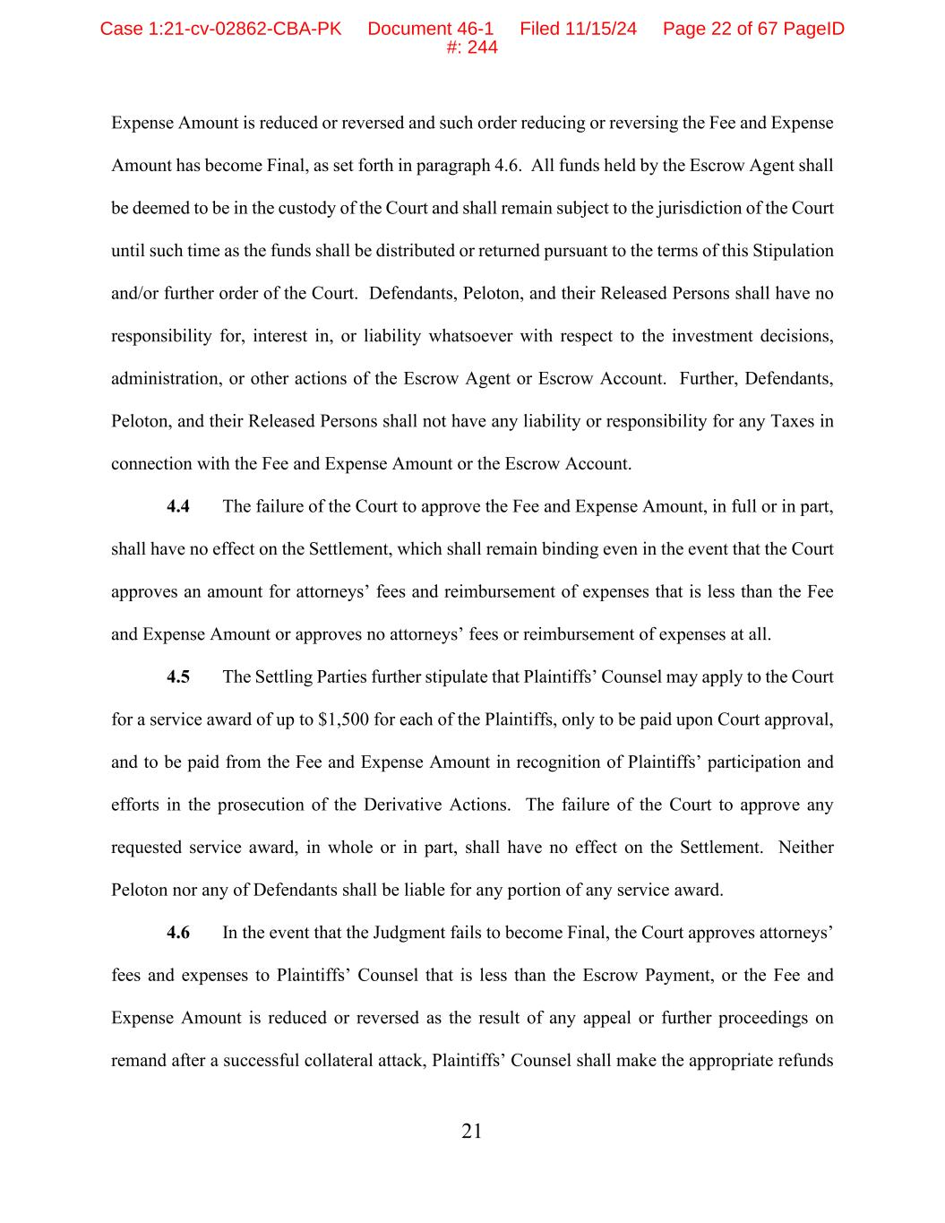
21 Expense Amount is reduced or reversed and such order reducing or reversing the Fee and Expense Amount has become Final, as set forth in paragraph 4.6. All funds held by the Escrow Agent shall be deemed to be in the custody of the Court and shall remain subject to the jurisdiction of the Court until such time as the funds shall be distributed or returned pursuant to the terms of this Stipulation and/or further order of the Court. Defendants, Peloton, and their Released Persons shall have no responsibility for, interest in, or liability whatsoever with respect to the investment decisions, administration, or other actions of the Escrow Agent or Escrow Account. Further, Defendants, Peloton, and their Released Persons shall not have any liability or responsibility for any Taxes in connection with the Fee and Expense Amount or the Escrow Account. 4.4 The failure of the Court to approve the Fee and Expense Amount, in full or in part, shall have no effect on the Settlement, which shall remain binding even in the event that the Court approves an amount for attorneys’ fees and reimbursement of expenses that is less than the Fee and Expense Amount or approves no attorneys’ fees or reimbursement of expenses at all. 4.5 The Settling Parties further stipulate that Plaintiffs’ Counsel may apply to the Court for a service award of up to $1,500 for each of the Plaintiffs, only to be paid upon Court approval, and to be paid from the Fee and Expense Amount in recognition of Plaintiffs’ participation and efforts in the prosecution of the Derivative Actions. The failure of the Court to approve any requested service award, in whole or in part, shall have no effect on the Settlement. Neither Peloton nor any of Defendants shall be liable for any portion of any service award. 4.6 In the event that the Judgment fails to become Final, the Court approves attorneys’ fees and expenses to Plaintiffs’ Counsel that is less than the Escrow Payment, or the Fee and Expense Amount is reduced or reversed as the result of any appeal or further proceedings on remand after a successful collateral attack, Plaintiffs’ Counsel shall make the appropriate refunds Case 1:21-cv-02862-CBA-PK Document 46-1 Filed 11/15/24 Page 22 of 67 PageID #: 244

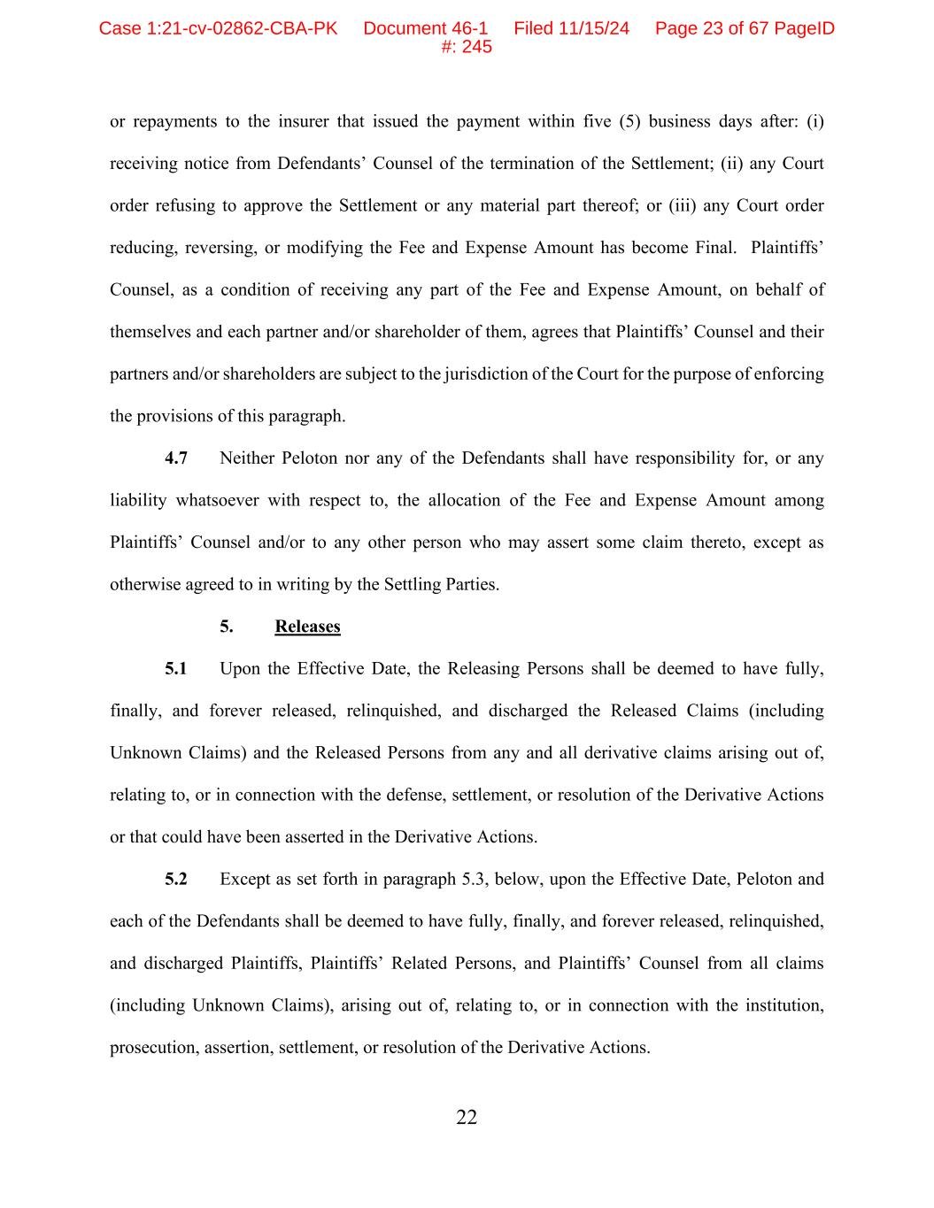
22 or repayments to the insurer that issued the payment within five (5) business days after: (i) receiving notice from Defendants’ Counsel of the termination of the Settlement; (ii) any Court order refusing to approve the Settlement or any material part thereof; or (iii) any Court order reducing, reversing, or modifying the Fee and Expense Amount has become Final. Plaintiffs’ Counsel, as a condition of receiving any part of the Fee and Expense Amount, on behalf of themselves and each partner and/or shareholder of them, agrees that Plaintiffs’ Counsel and their partners and/or shareholders are subject to the jurisdiction of the Court for the purpose of enforcing the provisions of this paragraph. 4.7 Neither Peloton nor any of the Defendants shall have responsibility for, or any liability whatsoever with respect to, the allocation of the Fee and Expense Amount among Plaintiffs’ Counsel and/or to any other person who may assert some claim thereto, except as otherwise agreed to in writing by the Settling Parties. 5. Releases 5.1 Upon the Effective Date, the Releasing Persons shall be deemed to have fully, finally, and forever released, relinquished, and discharged the Released Claims (including Unknown Claims) and the Released Persons from any and all derivative claims arising out of, relating to, or in connection with the defense, settlement, or resolution of the Derivative Actions or that could have been asserted in the Derivative Actions. 5.2 Except as set forth in paragraph 5.3, below, upon the Effective Date, Peloton and each of the Defendants shall be deemed to have fully, finally, and forever released, relinquished, and discharged Plaintiffs, Plaintiffs’ Related Persons, and Plaintiffs’ Counsel from all claims (including Unknown Claims), arising out of, relating to, or in connection with the institution, prosecution, assertion, settlement, or resolution of the Derivative Actions. Case 1:21-cv-02862-CBA-PK Document 46-1 Filed 11/15/24 Page 23 of 67 PageID #: 245

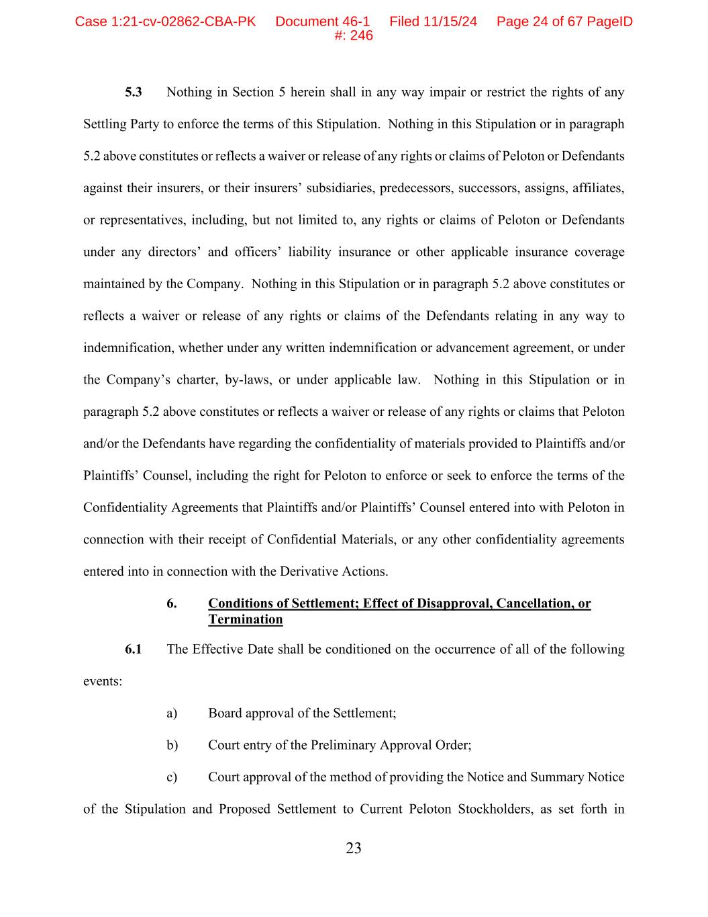
23 5.3 Nothing in Section 5 herein shall in any way impair or restrict the rights of any Settling Party to enforce the terms of this Stipulation. Nothing in this Stipulation or in paragraph 5.2 above constitutes or reflects a waiver or release of any rights or claims of Peloton or Defendants against their insurers, or their insurers’ subsidiaries, predecessors, successors, assigns, affiliates, or representatives, including, but not limited to, any rights or claims of Peloton or Defendants under any directors’ and officers’ liability insurance or other applicable insurance coverage maintained by the Company. Nothing in this Stipulation or in paragraph 5.2 above constitutes or reflects a waiver or release of any rights or claims of the Defendants relating in any way to indemnification, whether under any written indemnification or advancement agreement, or under the Company’s charter, by-laws, or under applicable law. Nothing in this Stipulation or in paragraph 5.2 above constitutes or reflects a waiver or release of any rights or claims that Peloton and/or the Defendants have regarding the confidentiality of materials provided to Plaintiffs and/or Plaintiffs’ Counsel, including the right for Peloton to enforce or seek to enforce the terms of the Confidentiality Agreements that Plaintiffs and/or Plaintiffs’ Counsel entered into with Peloton in connection with their receipt of Confidential Materials, or any other confidentiality agreements entered into in connection with the Derivative Actions. 6. Conditions of Settlement; Effect of Disapproval, Cancellation, or Termination 6.1 The Effective Date shall be conditioned on the occurrence of all of the following events: a) Board approval of the Settlement; b) Court entry of the Preliminary Approval Order; c) Court approval of the method of providing the Notice and Summary Notice of the Stipulation and Proposed Settlement to Current Peloton Stockholders, as set forth in Case 1:21-cv-02862-CBA-PK Document 46-1 Filed 11/15/24 Page 24 of 67 PageID #: 246

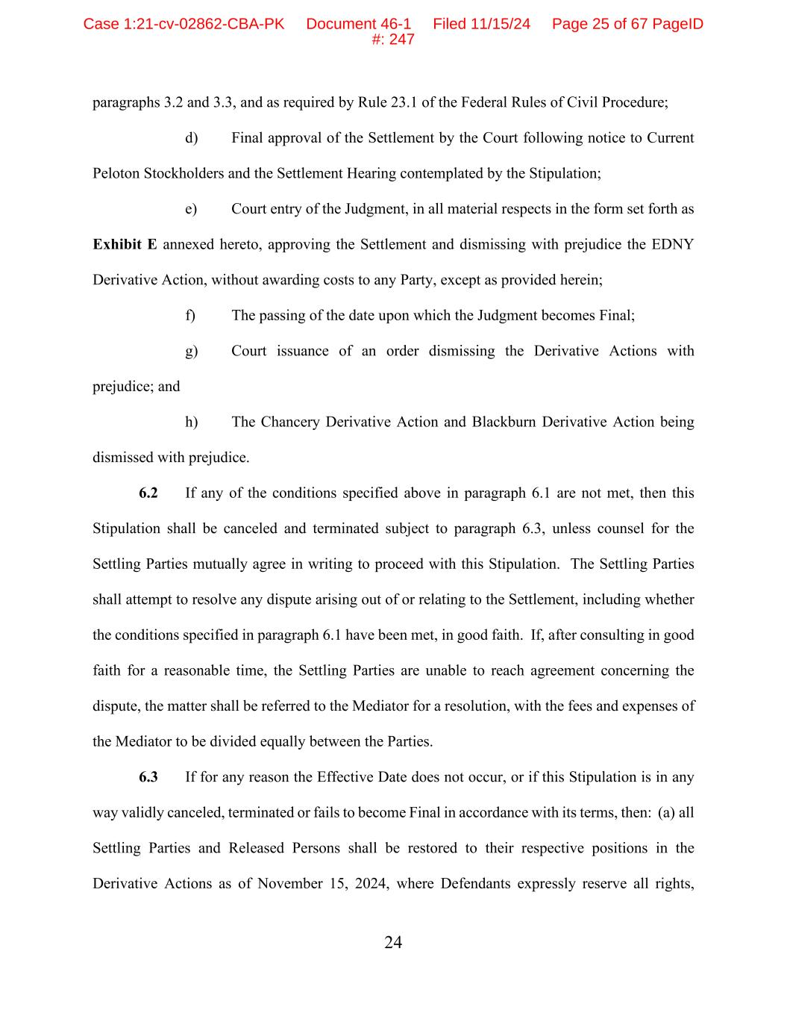
24 paragraphs 3.2 and 3.3, and as required by Rule 23.1 of the Federal Rules of Civil Procedure; d) Final approval of the Settlement by the Court following notice to Current Peloton Stockholders and the Settlement Hearing contemplated by the Stipulation; e) Court entry of the Judgment, in all material respects in the form set forth as Exhibit E annexed hereto, approving the Settlement and dismissing with prejudice the EDNY Derivative Action, without awarding costs to any Party, except as provided herein; f) The passing of the date upon which the Judgment becomes Final; g) Court issuance of an order dismissing the Derivative Actions with prejudice; and h) The Chancery Derivative Action and Blackburn Derivative Action being dismissed with prejudice. 6.2 If any of the conditions specified above in paragraph 6.1 are not met, then this Stipulation shall be canceled and terminated subject to paragraph 6.3, unless counsel for the Settling Parties mutually agree in writing to proceed with this Stipulation. The Settling Parties shall attempt to resolve any dispute arising out of or relating to the Settlement, including whether the conditions specified in paragraph 6.1 have been met, in good faith. If, after consulting in good faith for a reasonable time, the Settling Parties are unable to reach agreement concerning the dispute, the matter shall be referred to the Mediator for a resolution, with the fees and expenses of the Mediator to be divided equally between the Parties. 6.3 If for any reason the Effective Date does not occur, or if this Stipulation is in any way validly canceled, terminated or fails to become Final in accordance with its terms, then: (a) all Settling Parties and Released Persons shall be restored to their respective positions in the Derivative Actions as of November 15, 2024, where Defendants expressly reserve all rights, Case 1:21-cv-02862-CBA-PK Document 46-1 Filed 11/15/24 Page 25 of 67 PageID #: 247

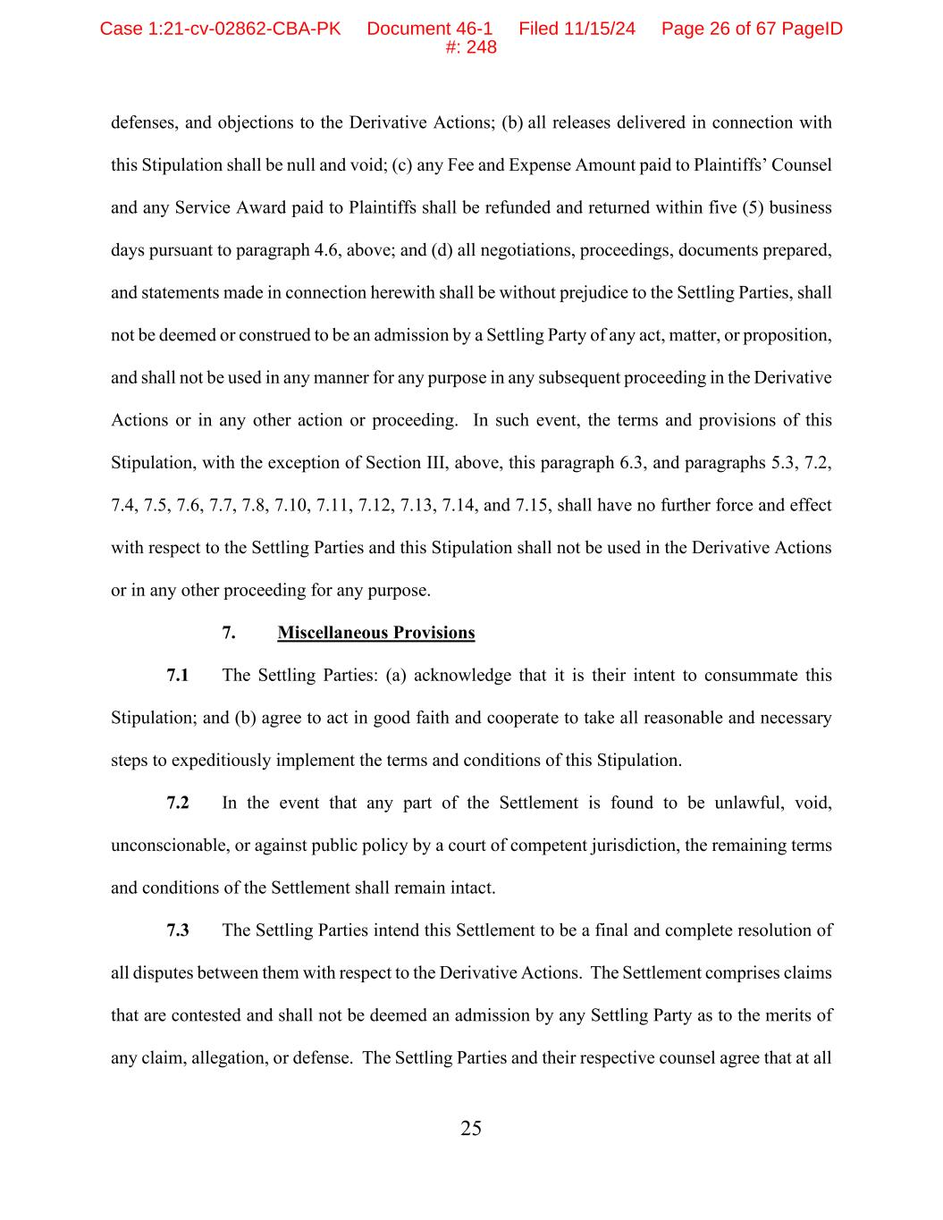
25 defenses, and objections to the Derivative Actions; (b) all releases delivered in connection with this Stipulation shall be null and void; (c) any Fee and Expense Amount paid to Plaintiffs’ Counsel and any Service Award paid to Plaintiffs shall be refunded and returned within five (5) business days pursuant to paragraph 4.6, above; and (d) all negotiations, proceedings, documents prepared, and statements made in connection herewith shall be without prejudice to the Settling Parties, shall not be deemed or construed to be an admission by a Settling Party of any act, matter, or proposition, and shall not be used in any manner for any purpose in any subsequent proceeding in the Derivative Actions or in any other action or proceeding. In such event, the terms and provisions of this Stipulation, with the exception of Section III, above, this paragraph 6.3, and paragraphs 5.3, 7.2, 7.4, 7.5, 7.6, 7.7, 7.8, 7.10, 7.11, 7.12, 7.13, 7.14, and 7.15, shall have no further force and effect with respect to the Settling Parties and this Stipulation shall not be used in the Derivative Actions or in any other proceeding for any purpose. 7. Miscellaneous Provisions 7.1 The Settling Parties: (a) acknowledge that it is their intent to consummate this Stipulation; and (b) agree to act in good faith and cooperate to take all reasonable and necessary steps to expeditiously implement the terms and conditions of this Stipulation. 7.2 In the event that any part of the Settlement is found to be unlawful, void, unconscionable, or against public policy by a court of competent jurisdiction, the remaining terms and conditions of the Settlement shall remain intact. 7.3 The Settling Parties intend this Settlement to be a final and complete resolution of all disputes between them with respect to the Derivative Actions. The Settlement comprises claims that are contested and shall not be deemed an admission by any Settling Party as to the merits of any claim, allegation, or defense. The Settling Parties and their respective counsel agree that at all Case 1:21-cv-02862-CBA-PK Document 46-1 Filed 11/15/24 Page 26 of 67 PageID #: 248

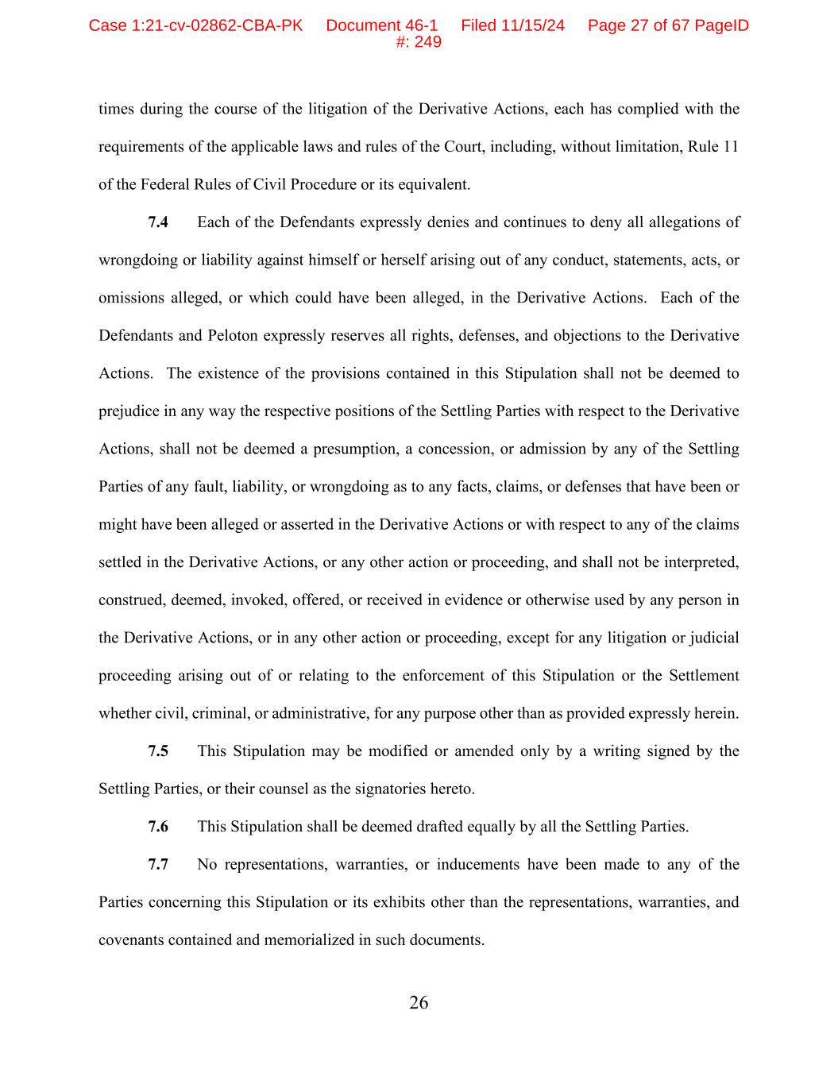
26 times during the course of the litigation of the Derivative Actions, each has complied with the requirements of the applicable laws and rules of the Court, including, without limitation, Rule 11 of the Federal Rules of Civil Procedure or its equivalent. 7.4 Each of the Defendants expressly denies and continues to deny all allegations of wrongdoing or liability against himself or herself arising out of any conduct, statements, acts, or omissions alleged, or which could have been alleged, in the Derivative Actions. Each of the Defendants and Peloton expressly reserves all rights, defenses, and objections to the Derivative Actions. The existence of the provisions contained in this Stipulation shall not be deemed to prejudice in any way the respective positions of the Settling Parties with respect to the Derivative Actions, shall not be deemed a presumption, a concession, or admission by any of the Settling Parties of any fault, liability, or wrongdoing as to any facts, claims, or defenses that have been or might have been alleged or asserted in the Derivative Actions or with respect to any of the claims settled in the Derivative Actions, or any other action or proceeding, and shall not be interpreted, construed, deemed, invoked, offered, or received in evidence or otherwise used by any person in the Derivative Actions, or in any other action or proceeding, except for any litigation or judicial proceeding arising out of or relating to the enforcement of this Stipulation or the Settlement whether civil, criminal, or administrative, for any purpose other than as provided expressly herein. 7.5 This Stipulation may be modified or amended only by a writing signed by the Settling Parties, or their counsel as the signatories hereto. 7.6 This Stipulation shall be deemed drafted equally by all the Settling Parties. 7.7 No representations, warranties, or inducements have been made to any of the Parties concerning this Stipulation or its exhibits other than the representations, warranties, and covenants contained and memorialized in such documents. Case 1:21-cv-02862-CBA-PK Document 46-1 Filed 11/15/24 Page 27 of 67 PageID #: 249

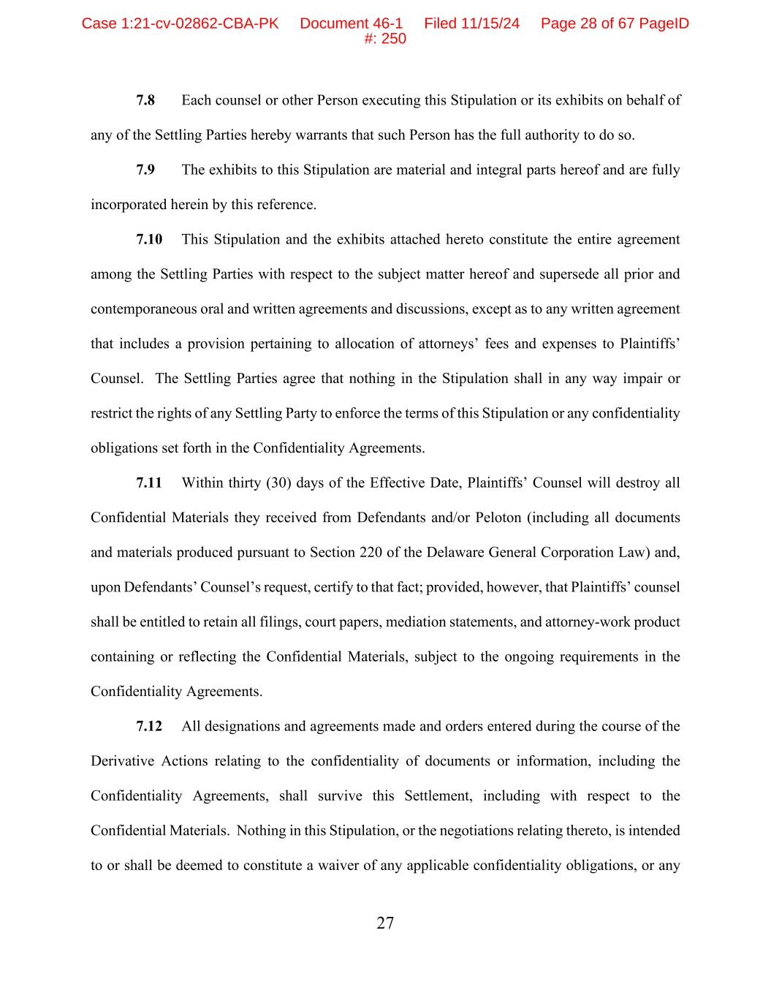
27 7.8 Each counsel or other Person executing this Stipulation or its exhibits on behalf of any of the Settling Parties hereby warrants that such Person has the full authority to do so. 7.9 The exhibits to this Stipulation are material and integral parts hereof and are fully incorporated herein by this reference. 7.10 This Stipulation and the exhibits attached hereto constitute the entire agreement among the Settling Parties with respect to the subject matter hereof and supersede all prior and contemporaneous oral and written agreements and discussions, except as to any written agreement that includes a provision pertaining to allocation of attorneys’ fees and expenses to Plaintiffs’ Counsel. The Settling Parties agree that nothing in the Stipulation shall in any way impair or restrict the rights of any Settling Party to enforce the terms of this Stipulation or any confidentiality obligations set forth in the Confidentiality Agreements. 7.11 Within thirty (30) days of the Effective Date, Plaintiffs’ Counsel will destroy all Confidential Materials they received from Defendants and/or Peloton (including all documents and materials produced pursuant to Section 220 of the Delaware General Corporation Law) and, upon Defendants’ Counsel’s request, certify to that fact; provided, however, that Plaintiffs’ counsel shall be entitled to retain all filings, court papers, mediation statements, and attorney-work product containing or reflecting the Confidential Materials, subject to the ongoing requirements in the Confidentiality Agreements. 7.12 All designations and agreements made and orders entered during the course of the Derivative Actions relating to the confidentiality of documents or information, including the Confidentiality Agreements, shall survive this Settlement, including with respect to the Confidential Materials. Nothing in this Stipulation, or the negotiations relating thereto, is intended to or shall be deemed to constitute a waiver of any applicable confidentiality obligations, or any Case 1:21-cv-02862-CBA-PK Document 46-1 Filed 11/15/24 Page 28 of 67 PageID #: 250

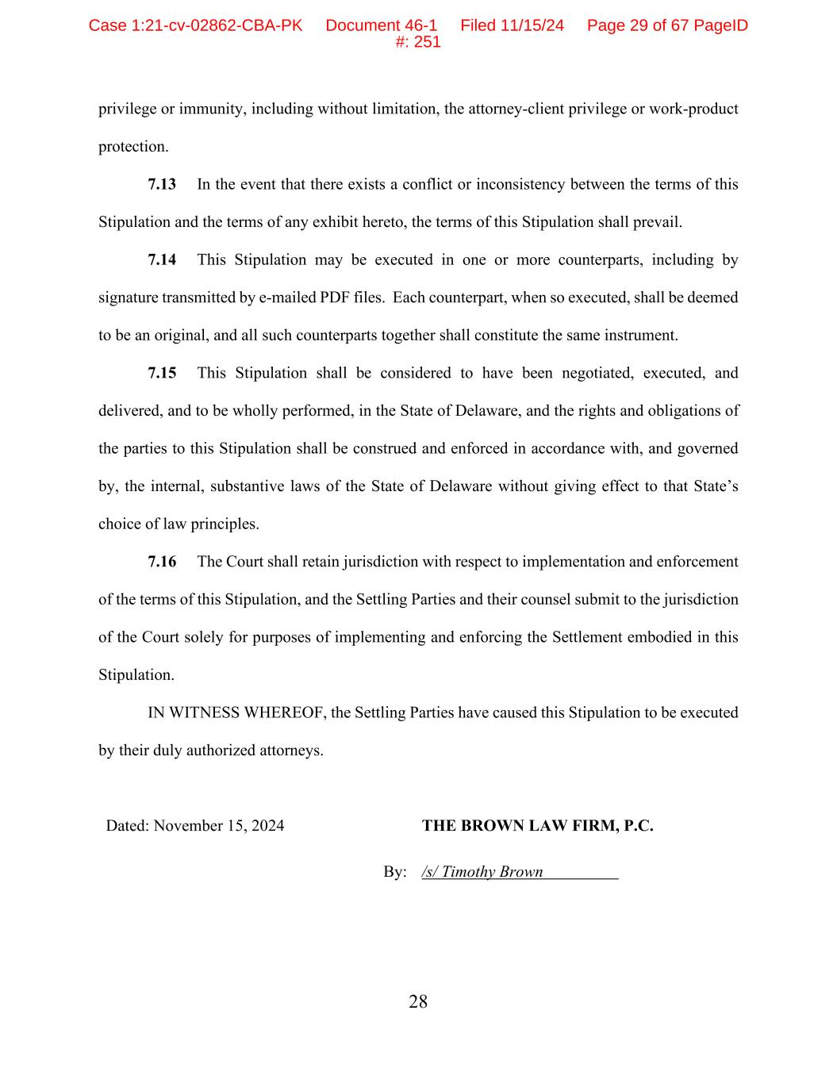
28 privilege or immunity, including without limitation, the attorney-client privilege or work-product protection. 7.13 In the event that there exists a conflict or inconsistency between the terms of this Stipulation and the terms of any exhibit hereto, the terms of this Stipulation shall prevail. 7.14 This Stipulation may be executed in one or more counterparts, including by signature transmitted by e-mailed PDF files. Each counterpart, when so executed, shall be deemed to be an original, and all such counterparts together shall constitute the same instrument. 7.15 This Stipulation shall be considered to have been negotiated, executed, and delivered, and to be wholly performed, in the State of Delaware, and the rights and obligations of the parties to this Stipulation shall be construed and enforced in accordance with, and governed by, the internal, substantive laws of the State of Delaware without giving effect to that State’s choice of law principles. 7.16 The Court shall retain jurisdiction with respect to implementation and enforcement of the terms of this Stipulation, and the Settling Parties and their counsel submit to the jurisdiction of the Court solely for purposes of implementing and enforcing the Settlement embodied in this Stipulation. IN WITNESS WHEREOF, the Settling Parties have caused this Stipulation to be executed by their duly authorized attorneys. Dated: November 15, 2024 THE BROWN LAW FIRM, P.C. By: /s/ Timothy Brown Case 1:21-cv-02862-CBA-PK Document 46-1 Filed 11/15/24 Page 29 of 67 PageID #: 251

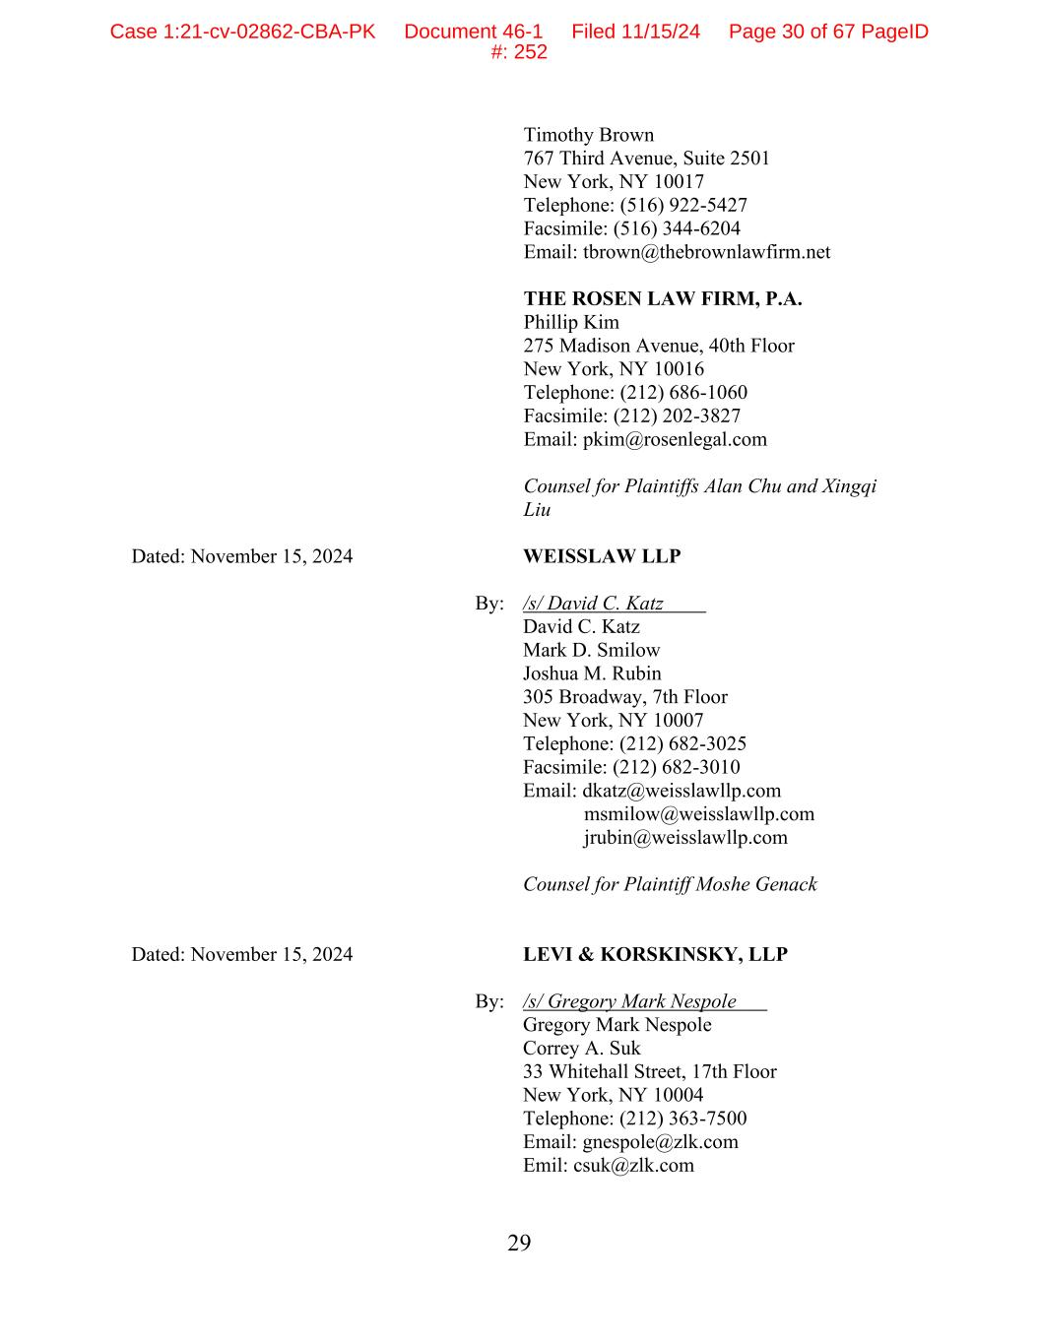
29 Timothy Brown 767 Third Avenue, Suite 2501 New York, NY 10017 Telephone: (516) 922-5427 Facsimile: (516) 344-6204 Email: tbrown@thebrownlawfirm.net THE ROSEN LAW FIRM, P.A. Phillip Kim 275 Madison Avenue, 40th Floor New York, NY 10016 Telephone: (212) 686-1060 Facsimile: (212) 202-3827 Email: pkim@rosenlegal.com Counsel for Plaintiffs Alan Chu and Xingqi Liu Dated: November 15, 2024 WEISSLAW LLP By: /s/ David C. Katz David C. Katz Mark D. Smilow Joshua M. Rubin 305 Broadway, 7th Floor New York, NY 10007 Telephone: (212) 682-3025 Facsimile: (212) 682-3010 Email: dkatz@weisslawllp.com msmilow@weisslawllp.com jrubin@weisslawllp.com Counsel for Plaintiff Moshe Genack Dated: November 15, 2024 LEVI & KORSKINSKY, LLP By: /s/ Gregory Mark Nespole Gregory Mark Nespole Correy A. Suk 33 Whitehall Street, 17th Floor New York, NY 10004 Telephone: (212) 363-7500 Email: gnespole@zlk.com Emil: csuk@zlk.com Case 1:21-cv-02862-CBA-PK Document 46-1 Filed 11/15/24 Page 30 of 67 PageID #: 252

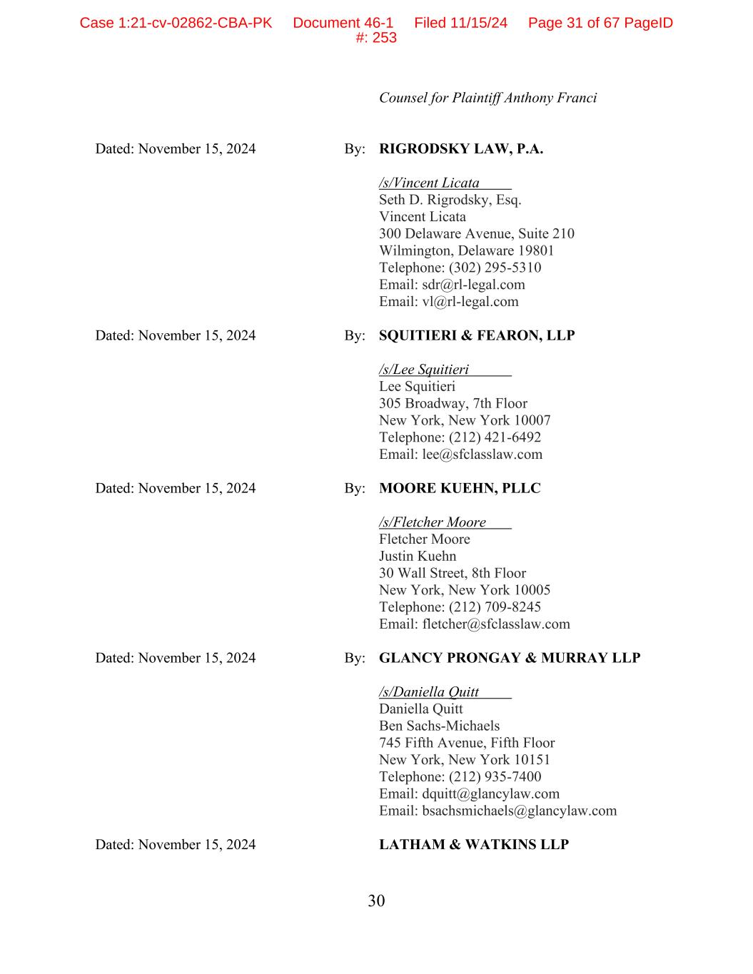
30 Counsel for Plaintiff Anthony Franci Dated: November 15, 2024 By: RIGRODSKY LAW, P.A. /s/Vincent Licata Seth D. Rigrodsky, Esq. Vincent Licata 300 Delaware Avenue, Suite 210 Wilmington, Delaware 19801 Telephone: (302) 295-5310 Email: sdr@rl-legal.com Email: vl@rl-legal.com Dated: November 15, 2024 By: SQUITIERI & FEARON, LLP /s/Lee Squitieri Lee Squitieri 305 Broadway, 7th Floor New York, New York 10007 Telephone: (212) 421-6492 Email: lee@sfclasslaw.com Dated: November 15, 2024 By: MOORE KUEHN, PLLC /s/Fletcher Moore Fletcher Moore Justin Kuehn 30 Wall Street, 8th Floor New York, New York 10005 Telephone: (212) 709-8245 Email: fletcher@sfclasslaw.com Dated: November 15, 2024 By: GLANCY PRONGAY & MURRAY LLP /s/Daniella Quitt Daniella Quitt Ben Sachs-Michaels 745 Fifth Avenue, Fifth Floor New York, New York 10151 Telephone: (212) 935-7400 Email: dquitt@glancylaw.com Email: bsachsmichaels@glancylaw.com Dated: November 15, 2024 LATHAM & WATKINS LLP Case 1:21-cv-02862-CBA-PK Document 46-1 Filed 11/15/24 Page 31 of 67 PageID #: 253

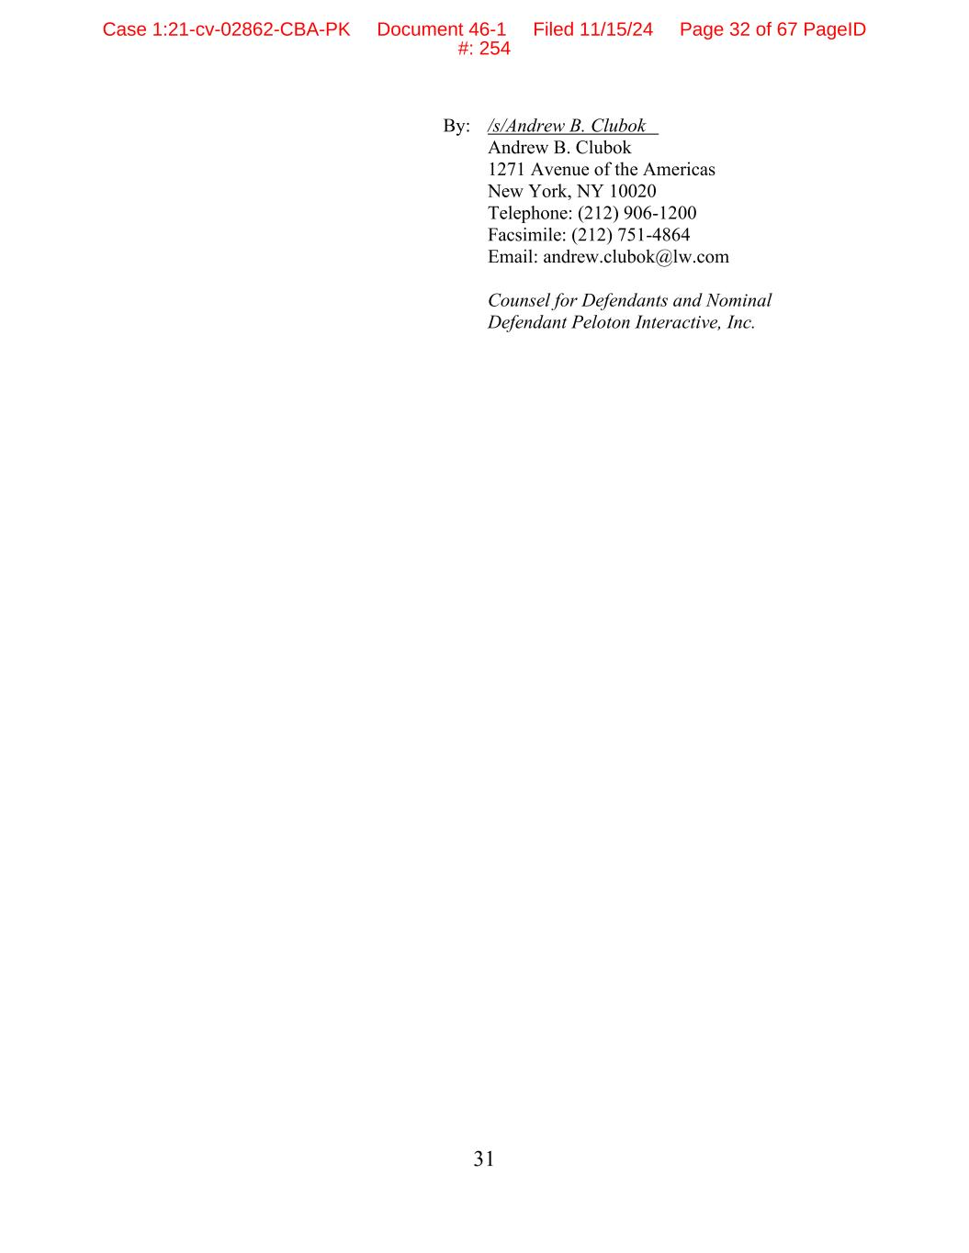
31 By: /s/Andrew B. Clubok Andrew B. Clubok 1271 Avenue of the Americas New York, NY 10020 Telephone: (212) 906-1200 Facsimile: (212) 751-4864 Email: andrew.clubok@lw.com Counsel for Defendants and Nominal Defendant Peloton Interactive, Inc. Case 1:21-cv-02862-CBA-PK Document 46-1 Filed 11/15/24 Page 32 of 67 PageID #: 254

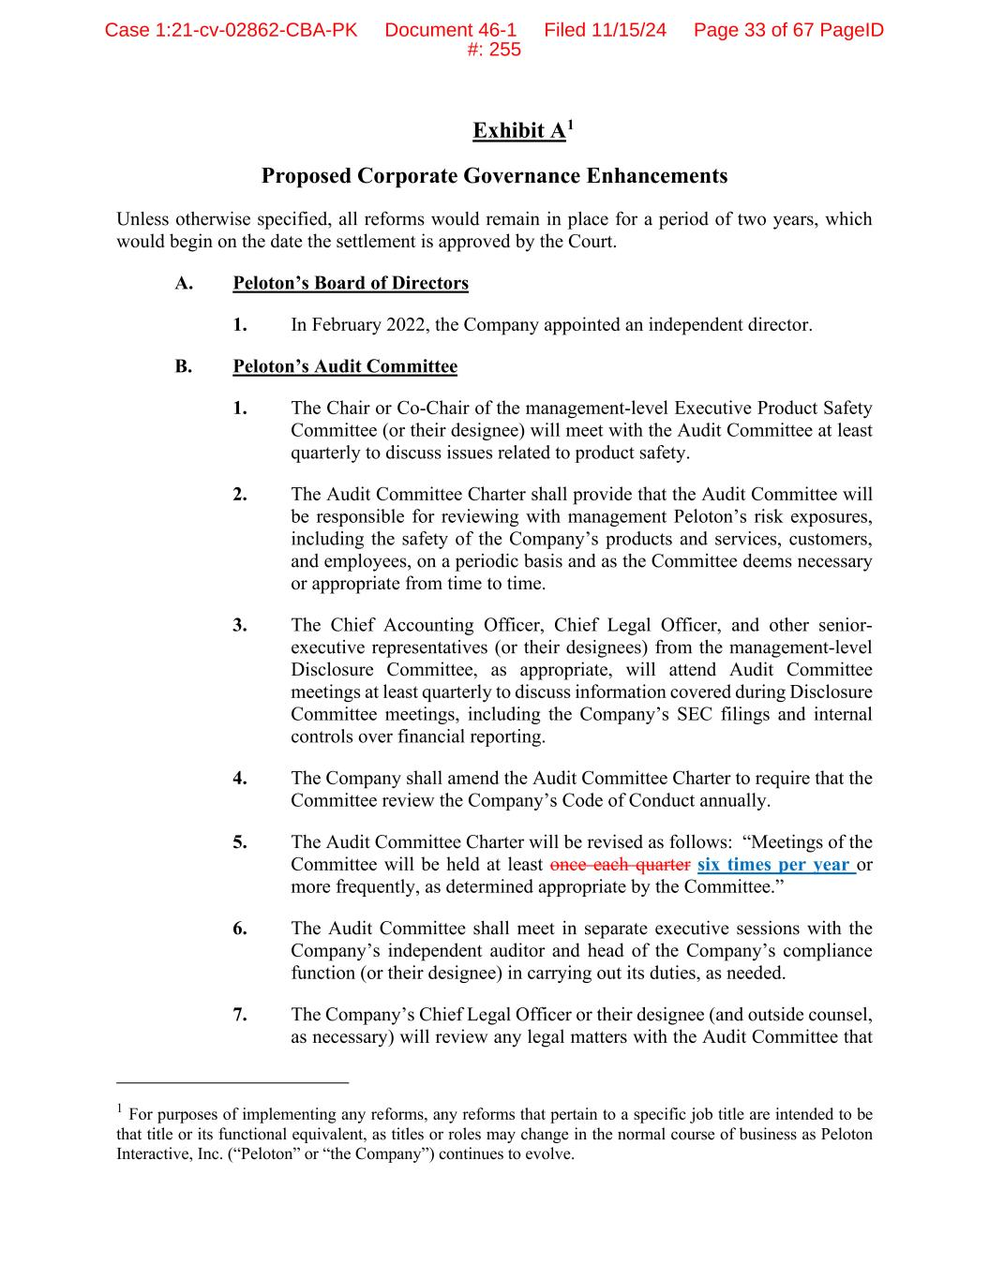
Exhibit A1 Proposed Corporate Governance Enhancements Unless otherwise specified, all reforms would remain in place for a period of two years, which would begin on the date the settlement is approved by the Court. A. Peloton’s Board of Directors 1. In February 2022, the Company appointed an independent director. B. Peloton’s Audit Committee 1. The Chair or Co-Chair of the management-level Executive Product Safety Committee (or their designee) will meet with the Audit Committee at least quarterly to discuss issues related to product safety. 2. The Audit Committee Charter shall provide that the Audit Committee will be responsible for reviewing with management Peloton’s risk exposures, including the safety of the Company’s products and services, customers, and employees, on a periodic basis and as the Committee deems necessary or appropriate from time to time. 3. The Chief Accounting Officer, Chief Legal Officer, and other senior- executive representatives (or their designees) from the management-level Disclosure Committee, as appropriate, will attend Audit Committee meetings at least quarterly to discuss information covered during Disclosure Committee meetings, including the Company’s SEC filings and internal controls over financial reporting. 4. The Company shall amend the Audit Committee Charter to require that the Committee review the Company’s Code of Conduct annually. 5. The Audit Committee Charter will be revised as follows: “Meetings of the Committee will be held at least once each quarter six times per year or more frequently, as determined appropriate by the Committee.” 6. The Audit Committee shall meet in separate executive sessions with the Company’s independent auditor and head of the Company’s compliance function (or their designee) in carrying out its duties, as needed. 7. The Company’s Chief Legal Officer or their designee (and outside counsel, as necessary) will review any legal matters with the Audit Committee that 1 For purposes of implementing any reforms, any reforms that pertain to a specific job title are intended to be that title or its functional equivalent, as titles or roles may change in the normal course of business as Peloton Interactive, Inc. (“Peloton” or “the Company”) continues to evolve. Case 1:21-cv-02862-CBA-PK Document 46-1 Filed 11/15/24 Page 33 of 67 PageID #: 255

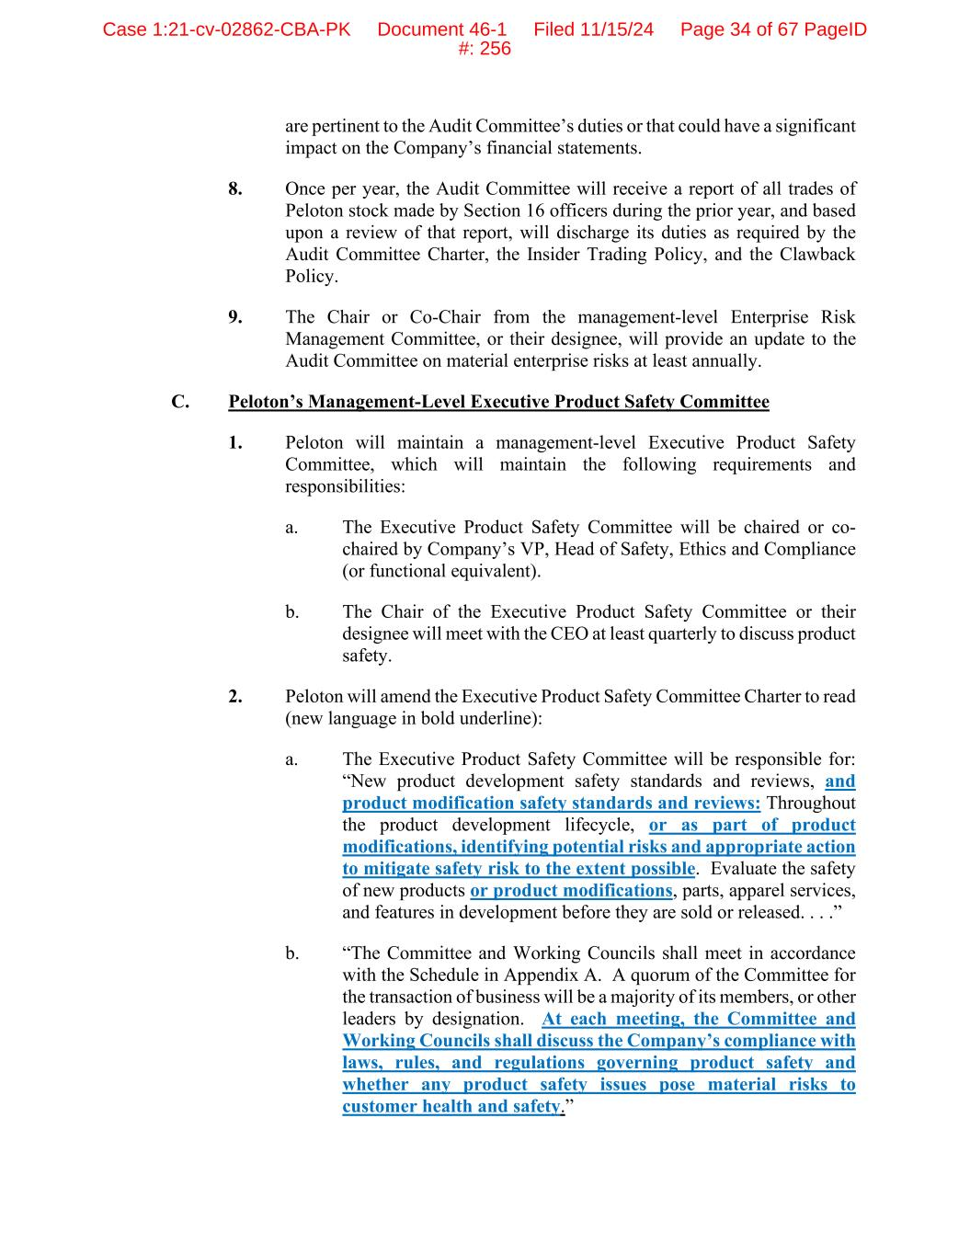
are pertinent to the Audit Committee’s duties or that could have a significant impact on the Company’s financial statements. 8. Once per year, the Audit Committee will receive a report of all trades of Peloton stock made by Section 16 officers during the prior year, and based upon a review of that report, will discharge its duties as required by the Audit Committee Charter, the Insider Trading Policy, and the Clawback Policy. 9. The Chair or Co-Chair from the management-level Enterprise Risk Management Committee, or their designee, will provide an update to the Audit Committee on material enterprise risks at least annually. C. Peloton’s Management-Level Executive Product Safety Committee 1. Peloton will maintain a management-level Executive Product Safety Committee, which will maintain the following requirements and responsibilities: a. The Executive Product Safety Committee will be chaired or co- chaired by Company’s VP, Head of Safety, Ethics and Compliance (or functional equivalent). b. The Chair of the Executive Product Safety Committee or their designee will meet with the CEO at least quarterly to discuss product safety. 2. Peloton will amend the Executive Product Safety Committee Charter to read (new language in bold underline): a. The Executive Product Safety Committee will be responsible for: “New product development safety standards and reviews, and product modification safety standards and reviews: Throughout the product development lifecycle, or as part of product modifications, identifying potential risks and appropriate action to mitigate safety risk to the extent possible. Evaluate the safety of new products or product modifications, parts, apparel services, and features in development before they are sold or released. . . .” b. “The Committee and Working Councils shall meet in accordance with the Schedule in Appendix A. A quorum of the Committee for the transaction of business will be a majority of its members, or other leaders by designation. At each meeting, the Committee and Working Councils shall discuss the Company’s compliance with laws, rules, and regulations governing product safety and whether any product safety issues pose material risks to customer health and safety.” Case 1:21-cv-02862-CBA-PK Document 46-1 Filed 11/15/24 Page 34 of 67 PageID #: 256

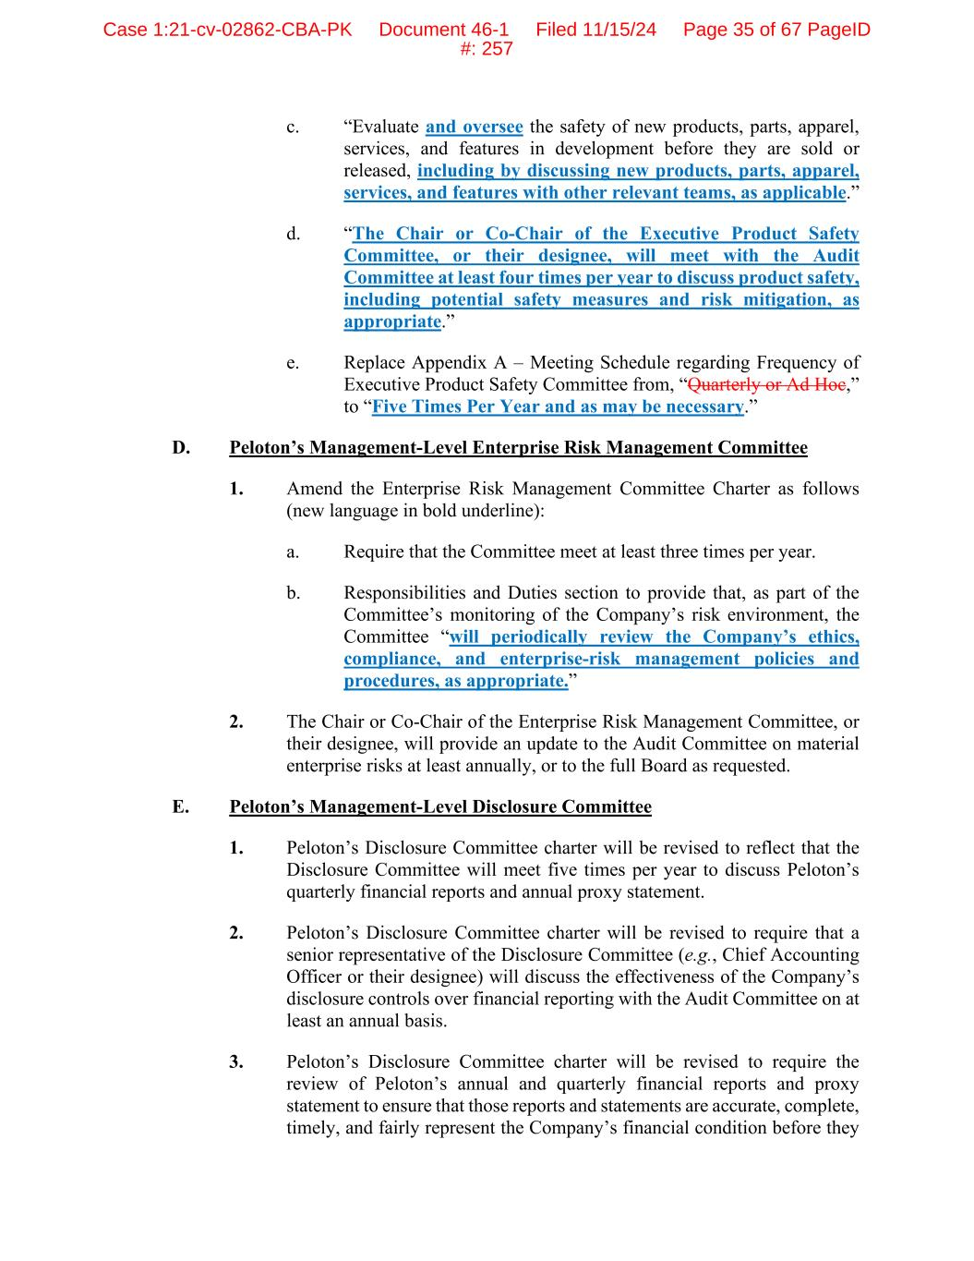
c. “Evaluate and oversee the safety of new products, parts, apparel, services, and features in development before they are sold or released, including by discussing new products, parts, apparel, services, and features with other relevant teams, as applicable.” d. “The Chair or Co-Chair of the Executive Product Safety Committee, or their designee, will meet with the Audit Committee at least four times per year to discuss product safety, including potential safety measures and risk mitigation, as appropriate.” e. Replace Appendix A – Meeting Schedule regarding Frequency of Executive Product Safety Committee from, “Quarterly or Ad Hoc,” to “Five Times Per Year and as may be necessary.” D. Peloton’s Management-Level Enterprise Risk Management Committee 1. Amend the Enterprise Risk Management Committee Charter as follows (new language in bold underline): a. Require that the Committee meet at least three times per year. b. Responsibilities and Duties section to provide that, as part of the Committee’s monitoring of the Company’s risk environment, the Committee “will periodically review the Company’s ethics, compliance, and enterprise-risk management policies and procedures, as appropriate.” 2. The Chair or Co-Chair of the Enterprise Risk Management Committee, or their designee, will provide an update to the Audit Committee on material enterprise risks at least annually, or to the full Board as requested. E. Peloton’s Management-Level Disclosure Committee 1. Peloton’s Disclosure Committee charter will be revised to reflect that the Disclosure Committee will meet five times per year to discuss Peloton’s quarterly financial reports and annual proxy statement. 2. Peloton’s Disclosure Committee charter will be revised to require that a senior representative of the Disclosure Committee (e.g., Chief Accounting Officer or their designee) will discuss the effectiveness of the Company’s disclosure controls over financial reporting with the Audit Committee on at least an annual basis. 3. Peloton’s Disclosure Committee charter will be revised to require the review of Peloton’s annual and quarterly financial reports and proxy statement to ensure that those reports and statements are accurate, complete, timely, and fairly represent the Company’s financial condition before they Case 1:21-cv-02862-CBA-PK Document 46-1 Filed 11/15/24 Page 35 of 67 PageID #: 257

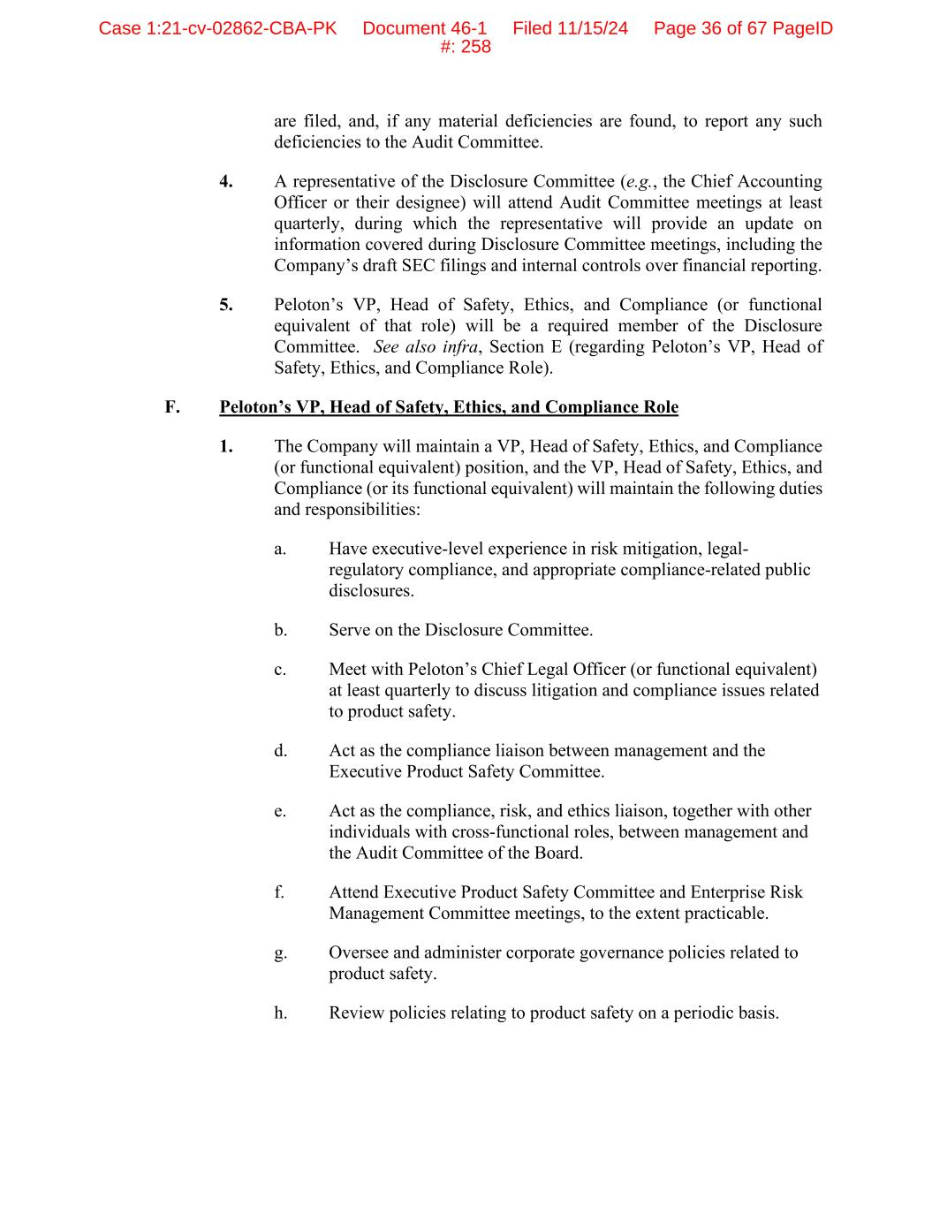
are filed, and, if any material deficiencies are found, to report any such deficiencies to the Audit Committee. 4. A representative of the Disclosure Committee (e.g., the Chief Accounting Officer or their designee) will attend Audit Committee meetings at least quarterly, during which the representative will provide an update on information covered during Disclosure Committee meetings, including the Company’s draft SEC filings and internal controls over financial reporting. 5. Peloton’s VP, Head of Safety, Ethics, and Compliance (or functional equivalent of that role) will be a required member of the Disclosure Committee. See also infra, Section E (regarding Peloton’s VP, Head of Safety, Ethics, and Compliance Role). F. Peloton’s VP, Head of Safety, Ethics, and Compliance Role 1. The Company will maintain a VP, Head of Safety, Ethics, and Compliance (or functional equivalent) position, and the VP, Head of Safety, Ethics, and Compliance (or its functional equivalent) will maintain the following duties and responsibilities: a. Have executive-level experience in risk mitigation, legal- regulatory compliance, and appropriate compliance-related public disclosures. b. Serve on the Disclosure Committee. c. Meet with Peloton’s Chief Legal Officer (or functional equivalent) at least quarterly to discuss litigation and compliance issues related to product safety. d. Act as the compliance liaison between management and the Executive Product Safety Committee. e. Act as the compliance, risk, and ethics liaison, together with other individuals with cross-functional roles, between management and the Audit Committee of the Board. f. Attend Executive Product Safety Committee and Enterprise Risk Management Committee meetings, to the extent practicable. g. Oversee and administer corporate governance policies related to product safety. h. Review policies relating to product safety on a periodic basis. Case 1:21-cv-02862-CBA-PK Document 46-1 Filed 11/15/24 Page 36 of 67 PageID #: 258

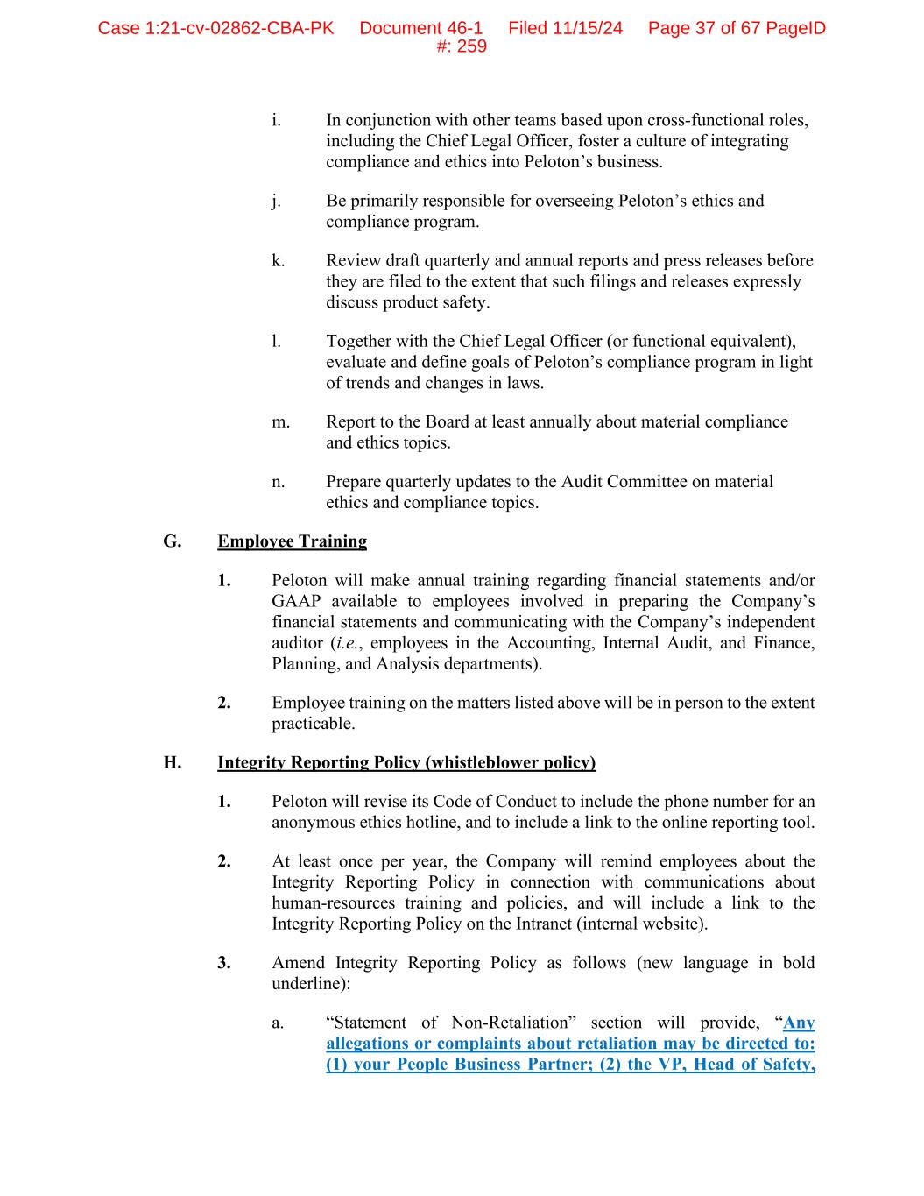
i. In conjunction with other teams based upon cross-functional roles, including the Chief Legal Officer, foster a culture of integrating compliance and ethics into Peloton’s business. j. Be primarily responsible for overseeing Peloton’s ethics and compliance program. k. Review draft quarterly and annual reports and press releases before they are filed to the extent that such filings and releases expressly discuss product safety. l. Together with the Chief Legal Officer (or functional equivalent), evaluate and define goals of Peloton’s compliance program in light of trends and changes in laws. m. Report to the Board at least annually about material compliance and ethics topics. n. Prepare quarterly updates to the Audit Committee on material ethics and compliance topics. G. Employee Training 1. Peloton will make annual training regarding financial statements and/or GAAP available to employees involved in preparing the Company’s financial statements and communicating with the Company’s independent auditor (i.e., employees in the Accounting, Internal Audit, and Finance, Planning, and Analysis departments). 2. Employee training on the matters listed above will be in person to the extent practicable. H. Integrity Reporting Policy (whistleblower policy) 1. Peloton will revise its Code of Conduct to include the phone number for an anonymous ethics hotline, and to include a link to the online reporting tool. 2. At least once per year, the Company will remind employees about the Integrity Reporting Policy in connection with communications about human-resources training and policies, and will include a link to the Integrity Reporting Policy on the Intranet (internal website). 3. Amend Integrity Reporting Policy as follows (new language in bold underline): a. “Statement of Non-Retaliation” section will provide, “Any allegations or complaints about retaliation may be directed to: (1) your People Business Partner; (2) the VP, Head of Safety, Case 1:21-cv-02862-CBA-PK Document 46-1 Filed 11/15/24 Page 37 of 67 PageID #: 259


Ethics, and Compliance; (3) the Chief Legal Officer; (4) the Chair of Peloton’s Audit Committee; or (5) the Integrity Helpline.” Case 1:21-cv-02862-CBA-PK Document 46-1 Filed 11/15/24 Page 38 of 67 PageID #: 260

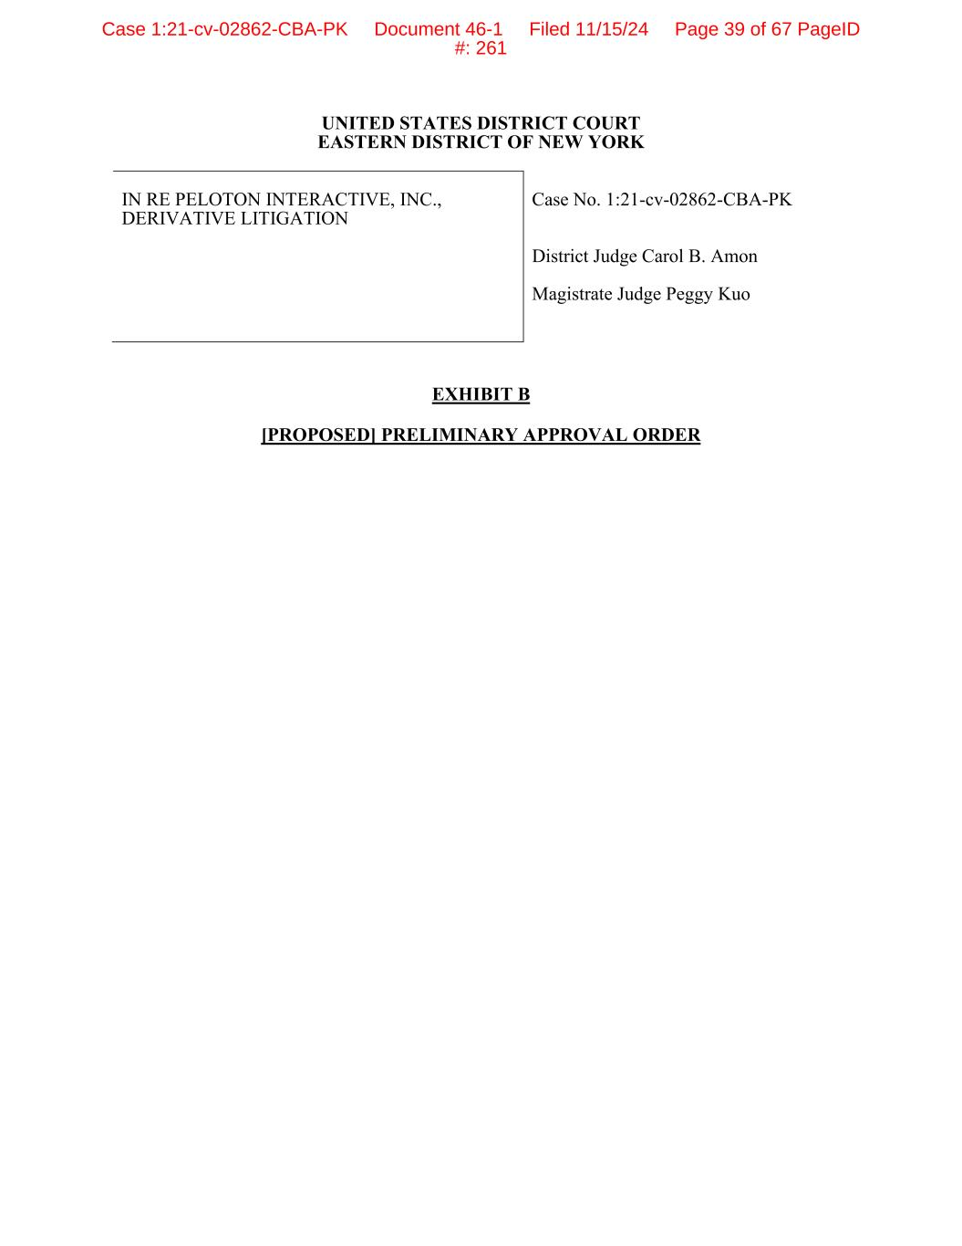
UNITED STATES DISTRICT COURT EASTERN DISTRICT OF NEW YORK IN RE PELOTON INTERACTIVE, INC., DERIVATIVE LITIGATION Case No. 1:21-cv-02862-CBA-PK District Judge Carol B. Amon Magistrate Judge Peggy Kuo EXHIBIT B [PROPOSED] PRELIMINARY APPROVAL ORDER Case 1:21-cv-02862-CBA-PK Document 46-1 Filed 11/15/24 Page 39 of 67 PageID #: 261

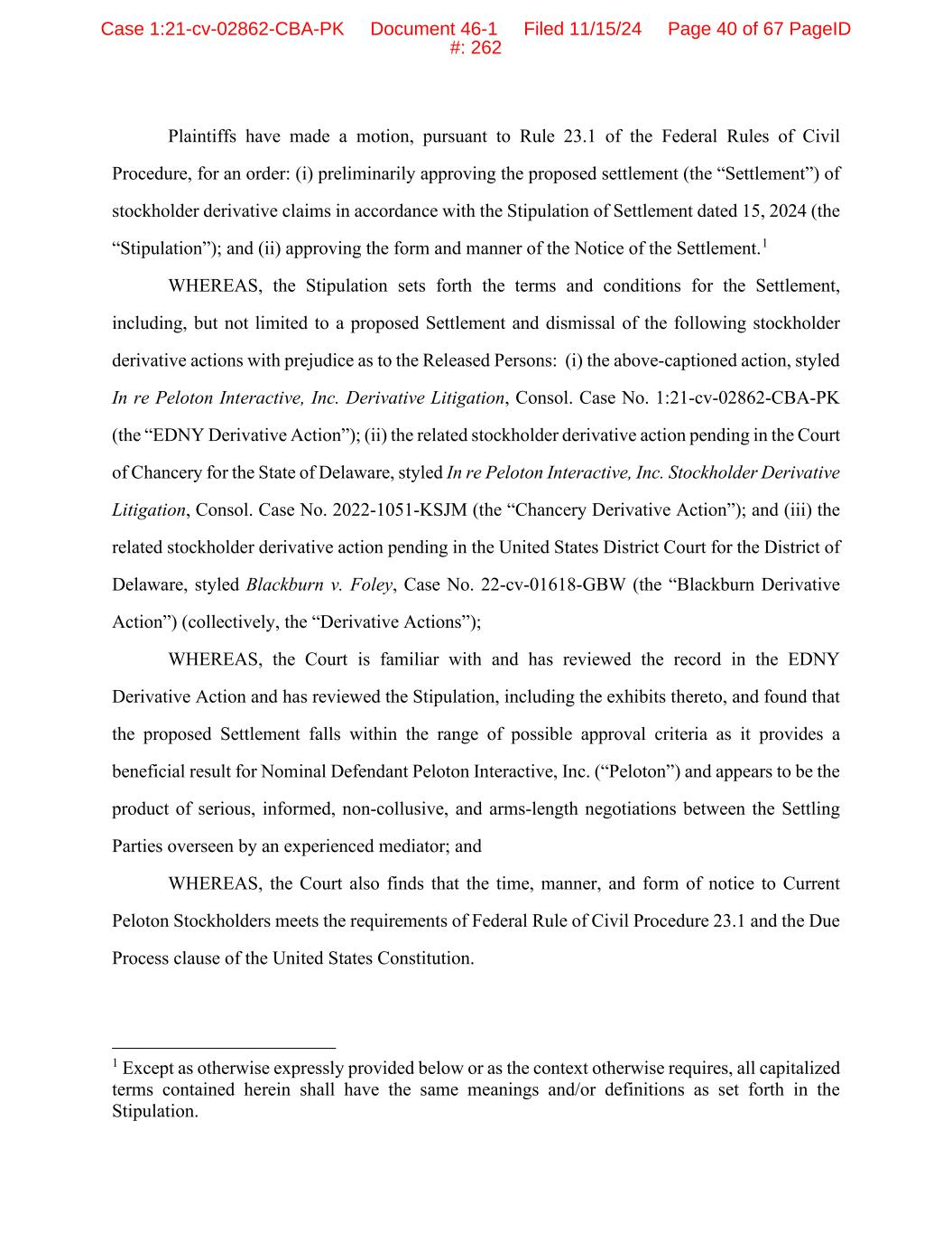
Plaintiffs have made a motion, pursuant to Rule 23.1 of the Federal Rules of Civil Procedure, for an order: (i) preliminarily approving the proposed settlement (the “Settlement”) of stockholder derivative claims in accordance with the Stipulation of Settlement dated 15, 2024 (the “Stipulation”); and (ii) approving the form and manner of the Notice of the Settlement.1 WHEREAS, the Stipulation sets forth the terms and conditions for the Settlement, including, but not limited to a proposed Settlement and dismissal of the following stockholder derivative actions with prejudice as to the Released Persons: (i) the above-captioned action, styled In re Peloton Interactive, Inc. Derivative Litigation, Consol. Case No. 1:21-cv-02862-CBA-PK (the “EDNY Derivative Action”); (ii) the related stockholder derivative action pending in the Court of Chancery for the State of Delaware, styled In re Peloton Interactive, Inc. Stockholder Derivative Litigation, Consol. Case No. 2022-1051-KSJM (the “Chancery Derivative Action”); and (iii) the related stockholder derivative action pending in the United States District Court for the District of Delaware, styled Blackburn v. Foley, Case No. 22-cv-01618-GBW (the “Blackburn Derivative Action”) (collectively, the “Derivative Actions”); WHEREAS, the Court is familiar with and has reviewed the record in the EDNY Derivative Action and has reviewed the Stipulation, including the exhibits thereto, and found that the proposed Settlement falls within the range of possible approval criteria as it provides a beneficial result for Nominal Defendant Peloton Interactive, Inc. (“Peloton”) and appears to be the product of serious, informed, non-collusive, and arms-length negotiations between the Settling Parties overseen by an experienced mediator; and WHEREAS, the Court also finds that the time, manner, and form of notice to Current Peloton Stockholders meets the requirements of Federal Rule of Civil Procedure 23.1 and the Due Process clause of the United States Constitution. 1 Except as otherwise expressly provided below or as the context otherwise requires, all capitalized terms contained herein shall have the same meanings and/or definitions as set forth in the Stipulation. Case 1:21-cv-02862-CBA-PK Document 46-1 Filed 11/15/24 Page 40 of 67 PageID #: 262

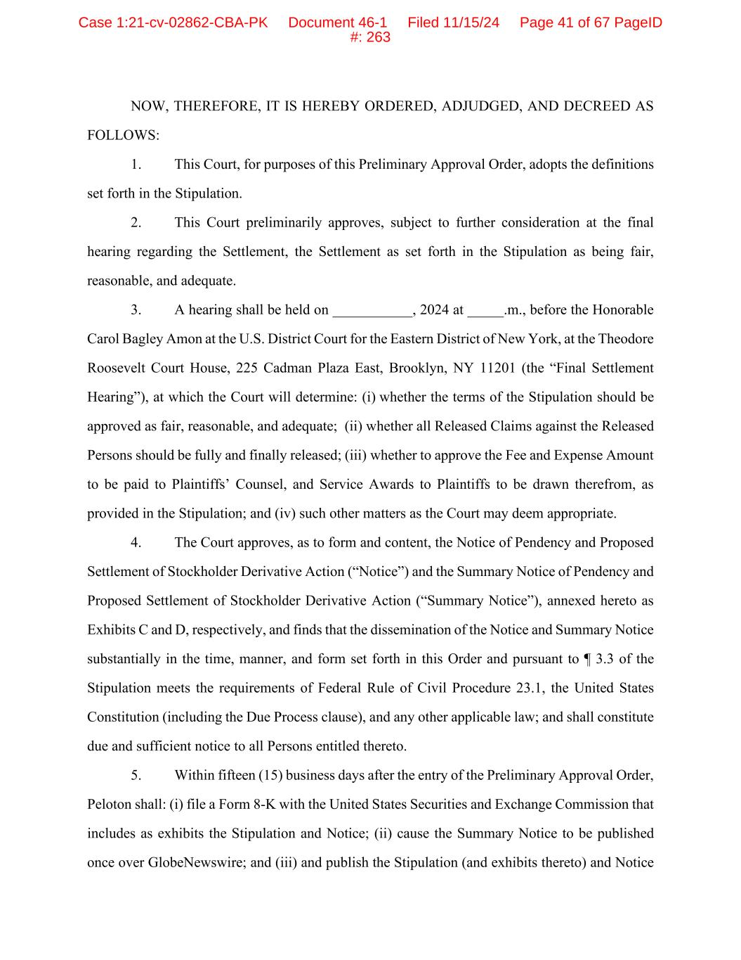
NOW, THEREFORE, IT IS HEREBY ORDERED, ADJUDGED, AND DECREED AS FOLLOWS: 1. This Court, for purposes of this Preliminary Approval Order, adopts the definitions set forth in the Stipulation. 2. This Court preliminarily approves, subject to further consideration at the final hearing regarding the Settlement, the Settlement as set forth in the Stipulation as being fair, reasonable, and adequate. 3. A hearing shall be held on ___________, 2024 at _____.m., before the Honorable Carol Bagley Amon at the U.S. District Court for the Eastern District of New York, at the Theodore Roosevelt Court House, 225 Cadman Plaza East, Brooklyn, NY 11201 (the “Final Settlement Hearing”), at which the Court will determine: (i) whether the terms of the Stipulation should be approved as fair, reasonable, and adequate; (ii) whether all Released Claims against the Released Persons should be fully and finally released; (iii) whether to approve the Fee and Expense Amount to be paid to Plaintiffs’ Counsel, and Service Awards to Plaintiffs to be drawn therefrom, as provided in the Stipulation; and (iv) such other matters as the Court may deem appropriate. 4. The Court approves, as to form and content, the Notice of Pendency and Proposed Settlement of Stockholder Derivative Action (“Notice”) and the Summary Notice of Pendency and Proposed Settlement of Stockholder Derivative Action (“Summary Notice”), annexed hereto as Exhibits C and D, respectively, and finds that the dissemination of the Notice and Summary Notice substantially in the time, manner, and form set forth in this Order and pursuant to ¶ 3.3 of the Stipulation meets the requirements of Federal Rule of Civil Procedure 23.1, the United States Constitution (including the Due Process clause), and any other applicable law; and shall constitute due and sufficient notice to all Persons entitled thereto. 5. Within fifteen (15) business days after the entry of the Preliminary Approval Order, Peloton shall: (i) file a Form 8-K with the United States Securities and Exchange Commission that includes as exhibits the Stipulation and Notice; (ii) cause the Summary Notice to be published once over GlobeNewswire; and (iii) and publish the Stipulation (and exhibits thereto) and Notice Case 1:21-cv-02862-CBA-PK Document 46-1 Filed 11/15/24 Page 41 of 67 PageID #: 263

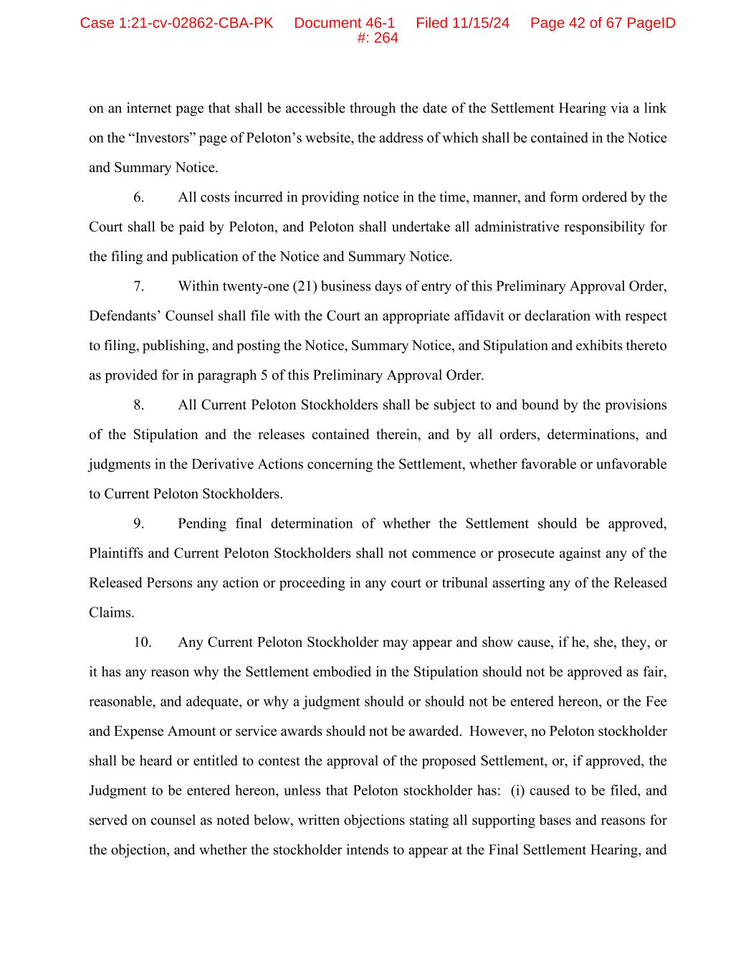
on an internet page that shall be accessible through the date of the Settlement Hearing via a link on the “Investors” page of Peloton’s website, the address of which shall be contained in the Notice and Summary Notice. 6. All costs incurred in providing notice in the time, manner, and form ordered by the Court shall be paid by Peloton, and Peloton shall undertake all administrative responsibility for the filing and publication of the Notice and Summary Notice. 7. Within twenty-one (21) business days of entry of this Preliminary Approval Order, Defendants’ Counsel shall file with the Court an appropriate affidavit or declaration with respect to filing, publishing, and posting the Notice, Summary Notice, and Stipulation and exhibits thereto as provided for in paragraph 5 of this Preliminary Approval Order. 8. All Current Peloton Stockholders shall be subject to and bound by the provisions of the Stipulation and the releases contained therein, and by all orders, determinations, and judgments in the Derivative Actions concerning the Settlement, whether favorable or unfavorable to Current Peloton Stockholders. 9. Pending final determination of whether the Settlement should be approved, Plaintiffs and Current Peloton Stockholders shall not commence or prosecute against any of the Released Persons any action or proceeding in any court or tribunal asserting any of the Released Claims. 10. Any Current Peloton Stockholder may appear and show cause, if he, she, they, or it has any reason why the Settlement embodied in the Stipulation should not be approved as fair, reasonable, and adequate, or why a judgment should or should not be entered hereon, or the Fee and Expense Amount or service awards should not be awarded. However, no Peloton stockholder shall be heard or entitled to contest the approval of the proposed Settlement, or, if approved, the Judgment to be entered hereon, unless that Peloton stockholder has: (i) caused to be filed, and served on counsel as noted below, written objections stating all supporting bases and reasons for the objection, and whether the stockholder intends to appear at the Final Settlement Hearing, and Case 1:21-cv-02862-CBA-PK Document 46-1 Filed 11/15/24 Page 42 of 67 PageID #: 264

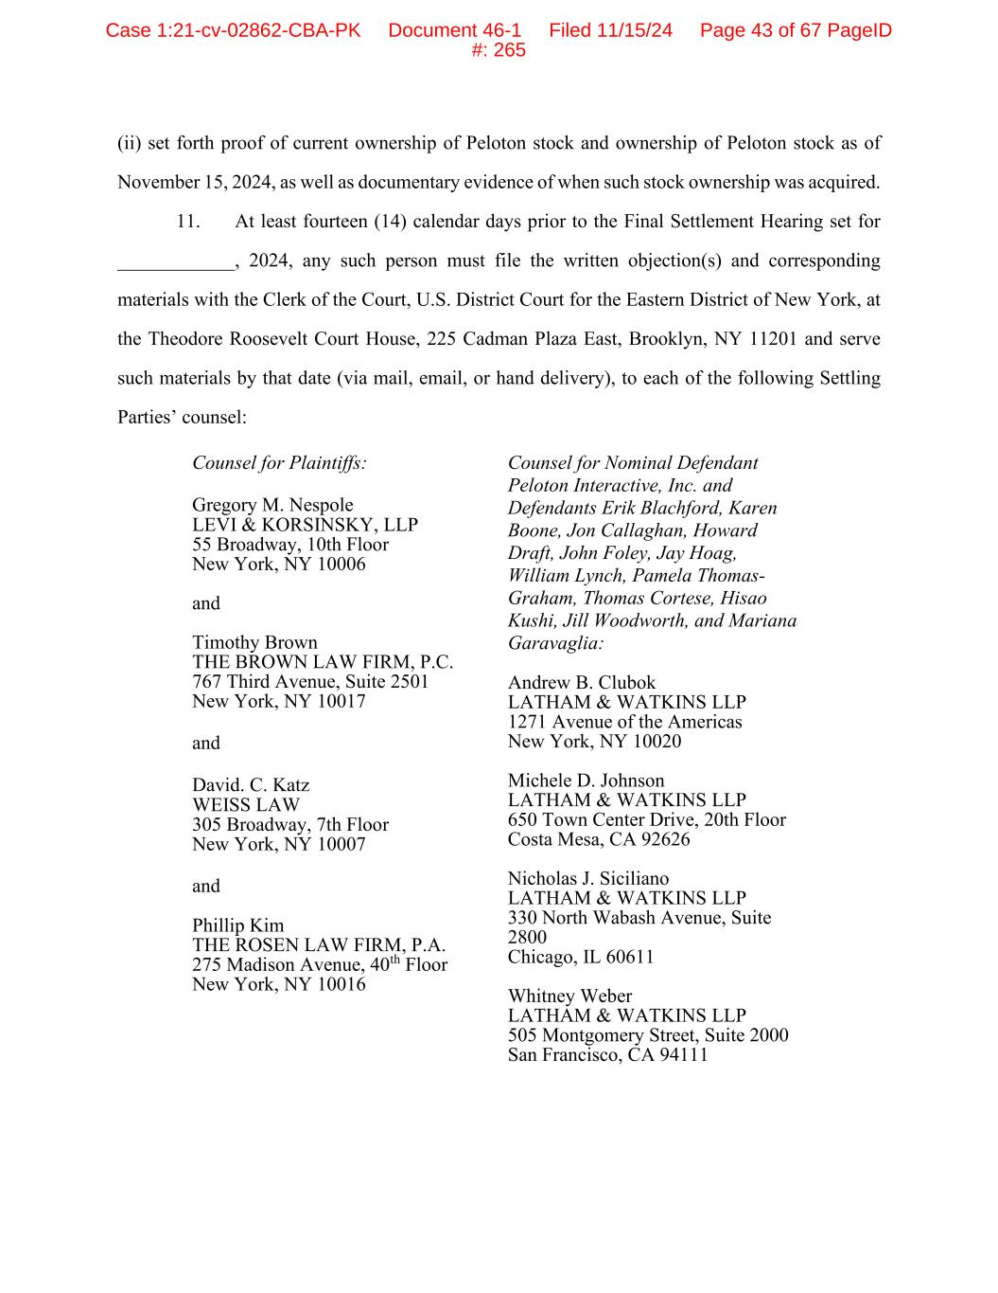
(ii) set forth proof of current ownership of Peloton stock and ownership of Peloton stock as of November 15, 2024, as well as documentary evidence of when such stock ownership was acquired. 11. At least fourteen (14) calendar days prior to the Final Settlement Hearing set for ____________, 2024, any such person must file the written objection(s) and corresponding materials with the Clerk of the Court, U.S. District Court for the Eastern District of New York, at the Theodore Roosevelt Court House, 225 Cadman Plaza East, Brooklyn, NY 11201 and serve such materials by that date (via mail, email, or hand delivery), to each of the following Settling Parties’ counsel: Counsel for Plaintiffs: Gregory M. Nespole LEVI & KORSINSKY, LLP 55 Broadway, 10th Floor New York, NY 10006 and Timothy Brown THE BROWN LAW FIRM, P.C. 767 Third Avenue, Suite 2501 New York, NY 10017 and David. C. Katz WEISS LAW 305 Broadway, 7th Floor New York, NY 10007 and Phillip Kim THE ROSEN LAW FIRM, P.A. 275 Madison Avenue, 40th Floor New York, NY 10016 Counsel for Nominal Defendant Peloton Interactive, Inc. and Defendants Erik Blachford, Karen Boone, Jon Callaghan, Howard Draft, John Foley, Jay Hoag, William Lynch, Pamela Thomas- Graham, Thomas Cortese, Hisao Kushi, Jill Woodworth, and Mariana Garavaglia: Andrew B. Clubok LATHAM & WATKINS LLP 1271 Avenue of the Americas New York, NY 10020 Michele D. Johnson LATHAM & WATKINS LLP 650 Town Center Drive, 20th Floor Costa Mesa, CA 92626 Nicholas J. Siciliano LATHAM & WATKINS LLP 330 North Wabash Avenue, Suite 2800 Chicago, IL 60611 Whitney Weber LATHAM & WATKINS LLP 505 Montgomery Street, Suite 2000 San Francisco, CA 94111 Case 1:21-cv-02862-CBA-PK Document 46-1 Filed 11/15/24 Page 43 of 67 PageID #: 265

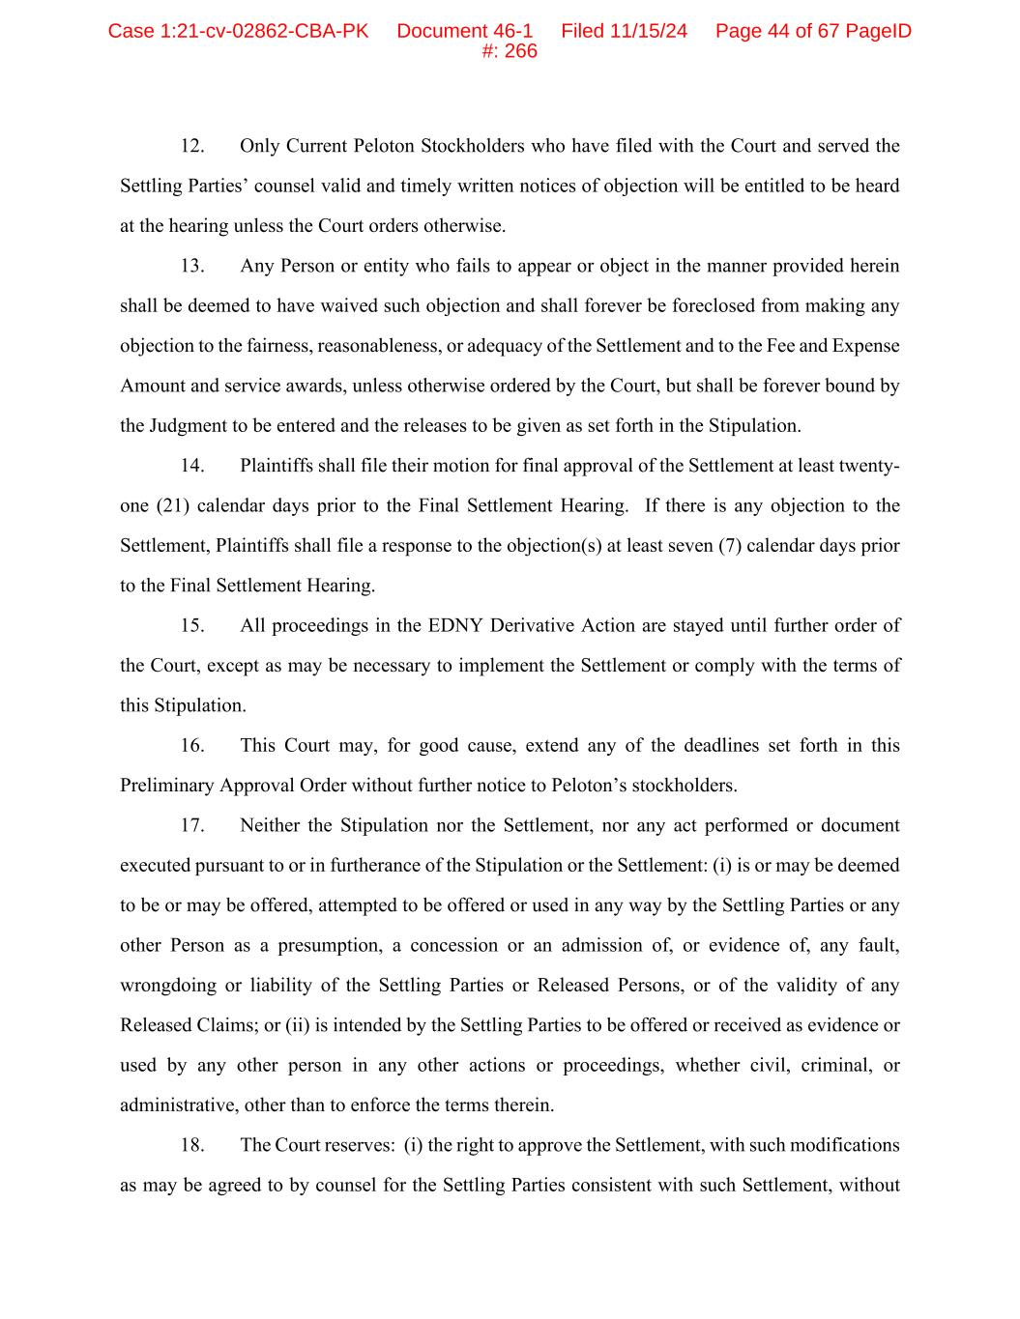
12. Only Current Peloton Stockholders who have filed with the Court and served the Settling Parties’ counsel valid and timely written notices of objection will be entitled to be heard at the hearing unless the Court orders otherwise. 13. Any Person or entity who fails to appear or object in the manner provided herein shall be deemed to have waived such objection and shall forever be foreclosed from making any objection to the fairness, reasonableness, or adequacy of the Settlement and to the Fee and Expense Amount and service awards, unless otherwise ordered by the Court, but shall be forever bound by the Judgment to be entered and the releases to be given as set forth in the Stipulation. 14. Plaintiffs shall file their motion for final approval of the Settlement at least twenty- one (21) calendar days prior to the Final Settlement Hearing. If there is any objection to the Settlement, Plaintiffs shall file a response to the objection(s) at least seven (7) calendar days prior to the Final Settlement Hearing. 15. All proceedings in the EDNY Derivative Action are stayed until further order of the Court, except as may be necessary to implement the Settlement or comply with the terms of this Stipulation. 16. This Court may, for good cause, extend any of the deadlines set forth in this Preliminary Approval Order without further notice to Peloton’s stockholders. 17. Neither the Stipulation nor the Settlement, nor any act performed or document executed pursuant to or in furtherance of the Stipulation or the Settlement: (i) is or may be deemed to be or may be offered, attempted to be offered or used in any way by the Settling Parties or any other Person as a presumption, a concession or an admission of, or evidence of, any fault, wrongdoing or liability of the Settling Parties or Released Persons, or of the validity of any Released Claims; or (ii) is intended by the Settling Parties to be offered or received as evidence or used by any other person in any other actions or proceedings, whether civil, criminal, or administrative, other than to enforce the terms therein. 18. The Court reserves: (i) the right to approve the Settlement, with such modifications as may be agreed to by counsel for the Settling Parties consistent with such Settlement, without Case 1:21-cv-02862-CBA-PK Document 46-1 Filed 11/15/24 Page 44 of 67 PageID #: 266

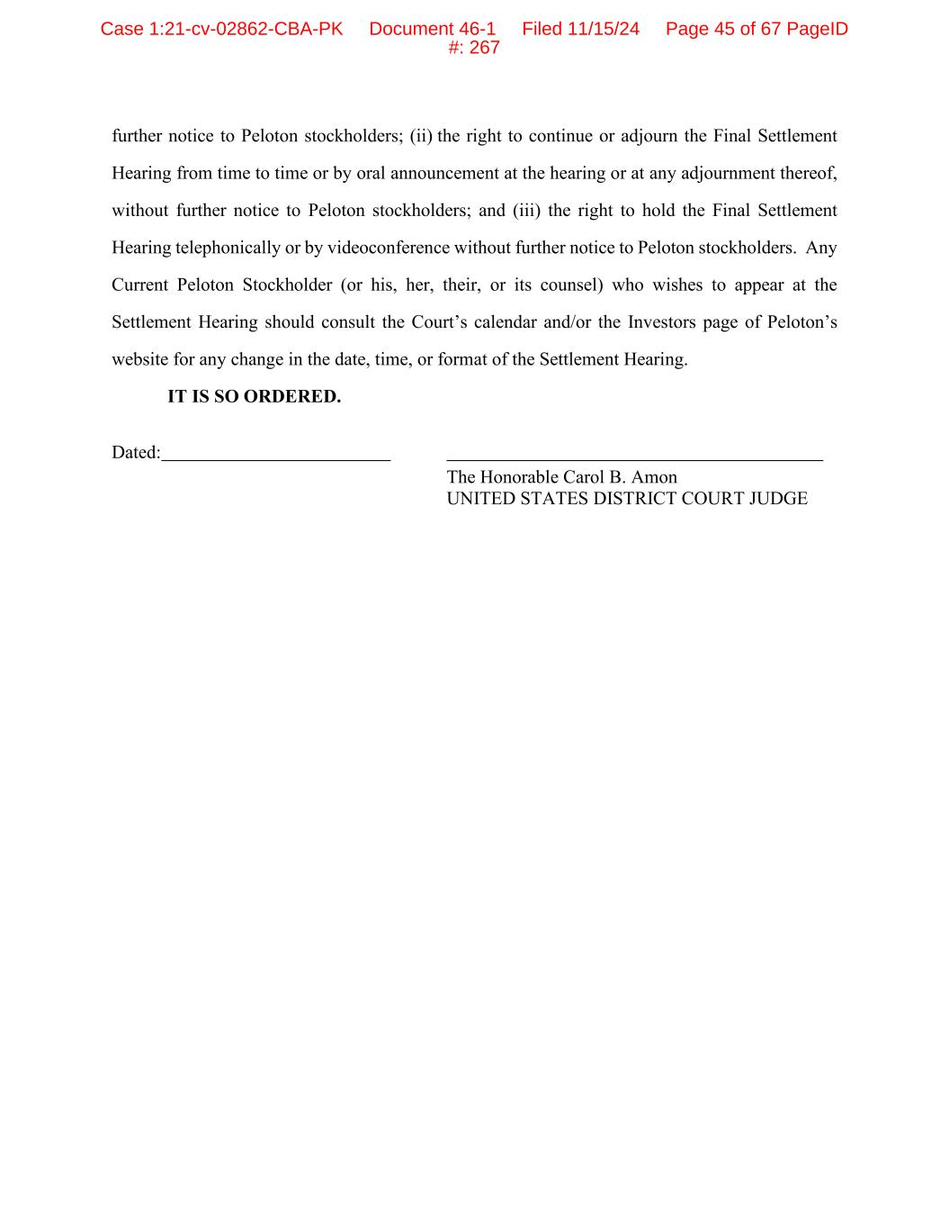
further notice to Peloton stockholders; (ii) the right to continue or adjourn the Final Settlement Hearing from time to time or by oral announcement at the hearing or at any adjournment thereof, without further notice to Peloton stockholders; and (iii) the right to hold the Final Settlement Hearing telephonically or by videoconference without further notice to Peloton stockholders. Any Current Peloton Stockholder (or his, her, their, or its counsel) who wishes to appear at the Settlement Hearing should consult the Court’s calendar and/or the Investors page of Peloton’s website for any change in the date, time, or format of the Settlement Hearing. IT IS SO ORDERED. Dated: The Honorable Carol B. Amon UNITED STATES DISTRICT COURT JUDGE Case 1:21-cv-02862-CBA-PK Document 46-1 Filed 11/15/24 Page 45 of 67 PageID #: 267

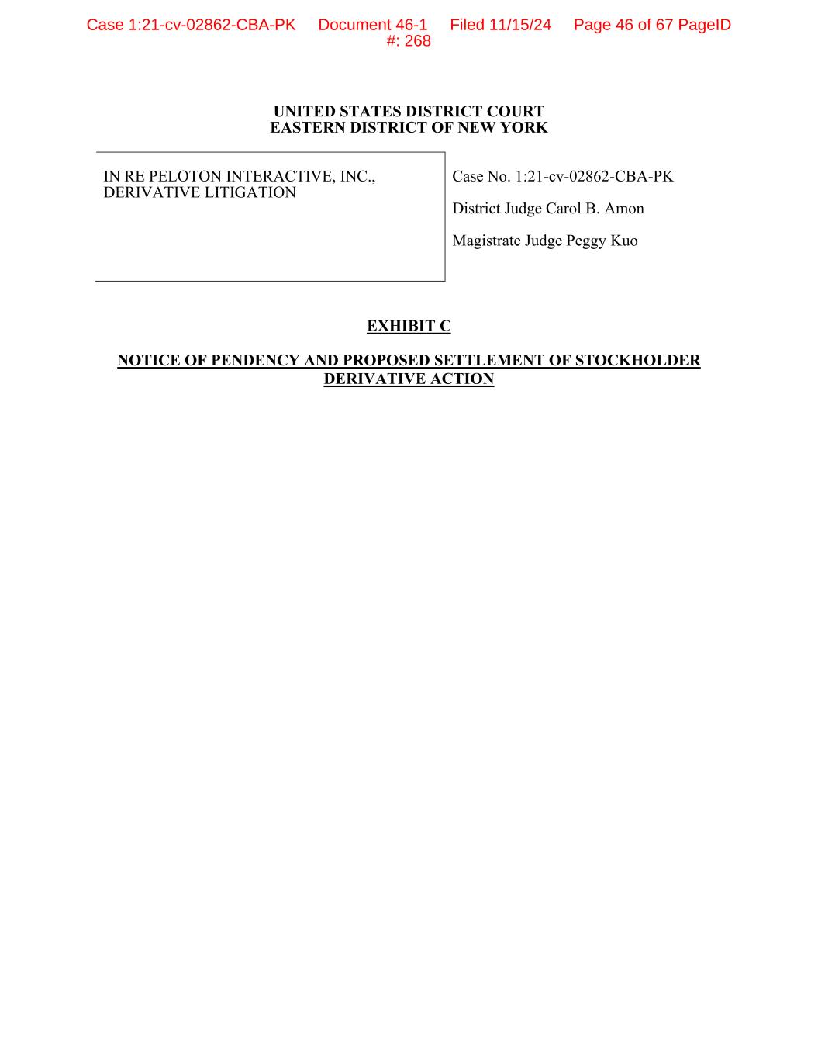
UNITED STATES DISTRICT COURT EASTERN DISTRICT OF NEW YORK IN RE PELOTON INTERACTIVE, INC., DERIVATIVE LITIGATION Case No. 1:21-cv-02862-CBA-PK District Judge Carol B. Amon Magistrate Judge Peggy Kuo EXHIBIT C NOTICE OF PENDENCY AND PROPOSED SETTLEMENT OF STOCKHOLDER DERIVATIVE ACTION Case 1:21-cv-02862-CBA-PK Document 46-1 Filed 11/15/24 Page 46 of 67 PageID #: 268

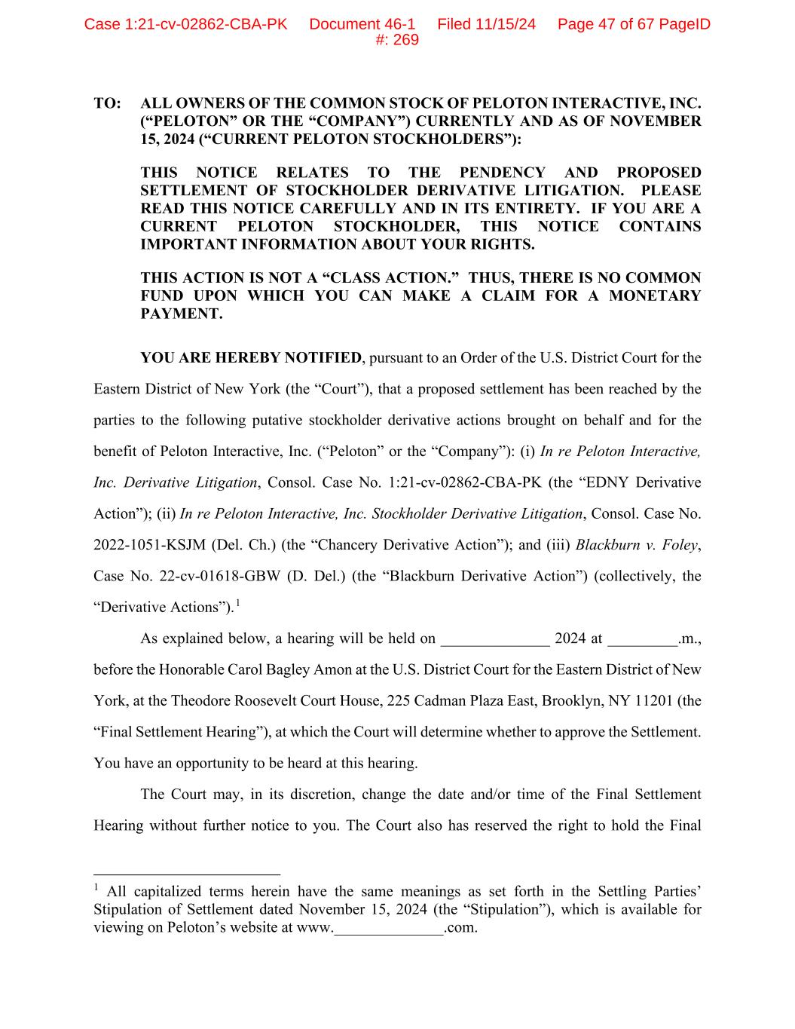
TO: ALL OWNERS OF THE COMMON STOCK OF PELOTON INTERACTIVE, INC. (“PELOTON” OR THE “COMPANY”) CURRENTLY AND AS OF NOVEMBER 15, 2024 (“CURRENT PELOTON STOCKHOLDERS”): THIS NOTICE RELATES TO THE PENDENCY AND PROPOSED SETTLEMENT OF STOCKHOLDER DERIVATIVE LITIGATION. PLEASE READ THIS NOTICE CAREFULLY AND IN ITS ENTIRETY. IF YOU ARE A CURRENT PELOTON STOCKHOLDER, THIS NOTICE CONTAINS IMPORTANT INFORMATION ABOUT YOUR RIGHTS. THIS ACTION IS NOT A “CLASS ACTION.” THUS, THERE IS NO COMMON FUND UPON WHICH YOU CAN MAKE A CLAIM FOR A MONETARY PAYMENT. YOU ARE HEREBY NOTIFIED, pursuant to an Order of the U.S. District Court for the Eastern District of New York (the “Court”), that a proposed settlement has been reached by the parties to the following putative stockholder derivative actions brought on behalf and for the benefit of Peloton Interactive, Inc. (“Peloton” or the “Company”): (i) In re Peloton Interactive, Inc. Derivative Litigation, Consol. Case No. 1:21-cv-02862-CBA-PK (the “EDNY Derivative Action”); (ii) In re Peloton Interactive, Inc. Stockholder Derivative Litigation, Consol. Case No. 2022-1051-KSJM (Del. Ch.) (the “Chancery Derivative Action”); and (iii) Blackburn v. Foley, Case No. 22-cv-01618-GBW (D. Del.) (the “Blackburn Derivative Action”) (collectively, the “Derivative Actions”).1 As explained below, a hearing will be held on ______________ 2024 at _________.m., before the Honorable Carol Bagley Amon at the U.S. District Court for the Eastern District of New York, at the Theodore Roosevelt Court House, 225 Cadman Plaza East, Brooklyn, NY 11201 (the “Final Settlement Hearing”), at which the Court will determine whether to approve the Settlement. You have an opportunity to be heard at this hearing. The Court may, in its discretion, change the date and/or time of the Final Settlement Hearing without further notice to you. The Court also has reserved the right to hold the Final 1 All capitalized terms herein have the same meanings as set forth in the Settling Parties’ Stipulation of Settlement dated November 15, 2024 (the “Stipulation”), which is available for viewing on Peloton’s website at www.______________.com. Case 1:21-cv-02862-CBA-PK Document 46-1 Filed 11/15/24 Page 47 of 67 PageID #: 269

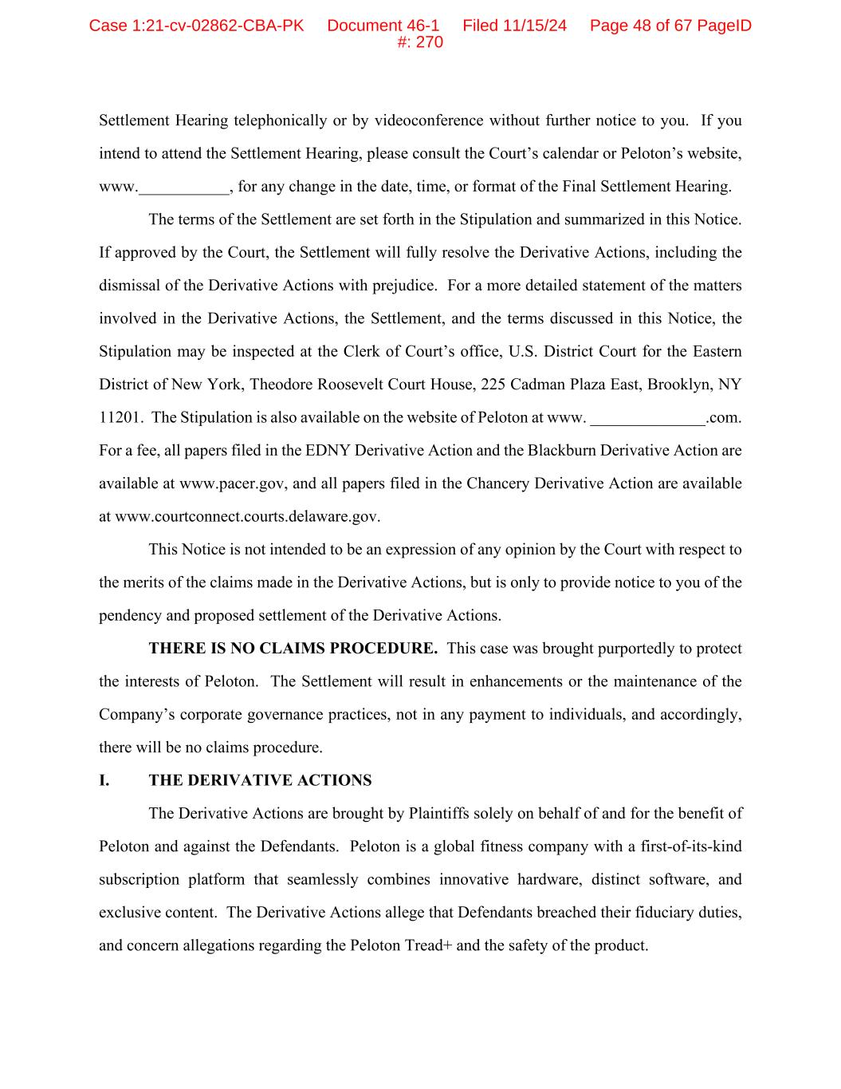
Settlement Hearing telephonically or by videoconference without further notice to you. If you intend to attend the Settlement Hearing, please consult the Court’s calendar or Peloton’s website, www.___________, for any change in the date, time, or format of the Final Settlement Hearing. The terms of the Settlement are set forth in the Stipulation and summarized in this Notice. If approved by the Court, the Settlement will fully resolve the Derivative Actions, including the dismissal of the Derivative Actions with prejudice. For a more detailed statement of the matters involved in the Derivative Actions, the Settlement, and the terms discussed in this Notice, the Stipulation may be inspected at the Clerk of Court’s office, U.S. District Court for the Eastern District of New York, Theodore Roosevelt Court House, 225 Cadman Plaza East, Brooklyn, NY 11201. The Stipulation is also available on the website of Peloton at www. ______________.com. For a fee, all papers filed in the EDNY Derivative Action and the Blackburn Derivative Action are available at www.pacer.gov, and all papers filed in the Chancery Derivative Action are available at www.courtconnect.courts.delaware.gov. This Notice is not intended to be an expression of any opinion by the Court with respect to the merits of the claims made in the Derivative Actions, but is only to provide notice to you of the pendency and proposed settlement of the Derivative Actions. THERE IS NO CLAIMS PROCEDURE. This case was brought purportedly to protect the interests of Peloton. The Settlement will result in enhancements or the maintenance of the Company’s corporate governance practices, not in any payment to individuals, and accordingly, there will be no claims procedure. I. THE DERIVATIVE ACTIONS The Derivative Actions are brought by Plaintiffs solely on behalf of and for the benefit of Peloton and against the Defendants. Peloton is a global fitness company with a first-of-its-kind subscription platform that seamlessly combines innovative hardware, distinct software, and exclusive content. The Derivative Actions allege that Defendants breached their fiduciary duties, and concern allegations regarding the Peloton Tread+ and the safety of the product. Case 1:21-cv-02862-CBA-PK Document 46-1 Filed 11/15/24 Page 48 of 67 PageID #: 270

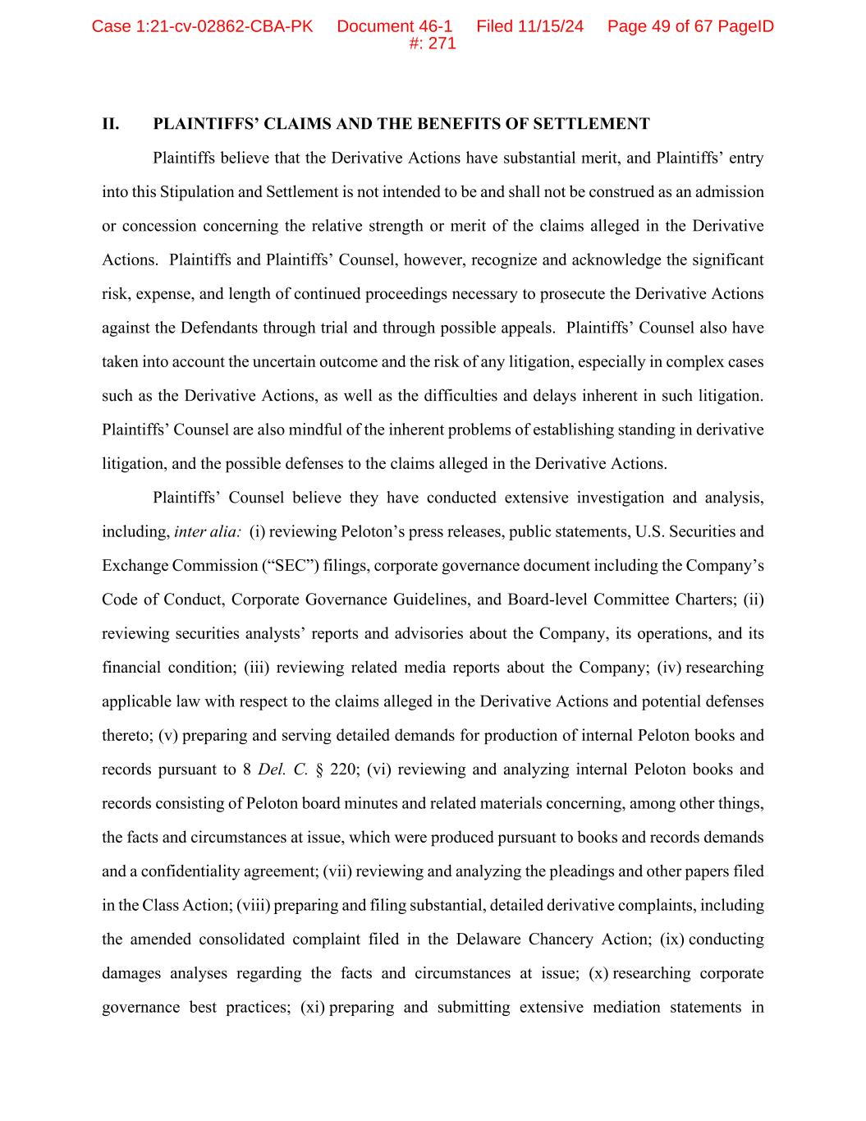
II. PLAINTIFFS’ CLAIMS AND THE BENEFITS OF SETTLEMENT Plaintiffs believe that the Derivative Actions have substantial merit, and Plaintiffs’ entry into this Stipulation and Settlement is not intended to be and shall not be construed as an admission or concession concerning the relative strength or merit of the claims alleged in the Derivative Actions. Plaintiffs and Plaintiffs’ Counsel, however, recognize and acknowledge the significant risk, expense, and length of continued proceedings necessary to prosecute the Derivative Actions against the Defendants through trial and through possible appeals. Plaintiffs’ Counsel also have taken into account the uncertain outcome and the risk of any litigation, especially in complex cases such as the Derivative Actions, as well as the difficulties and delays inherent in such litigation. Plaintiffs’ Counsel are also mindful of the inherent problems of establishing standing in derivative litigation, and the possible defenses to the claims alleged in the Derivative Actions. Plaintiffs’ Counsel believe they have conducted extensive investigation and analysis, including, inter alia: (i) reviewing Peloton’s press releases, public statements, U.S. Securities and Exchange Commission (“SEC”) filings, corporate governance document including the Company’s Code of Conduct, Corporate Governance Guidelines, and Board-level Committee Charters; (ii) reviewing securities analysts’ reports and advisories about the Company, its operations, and its financial condition; (iii) reviewing related media reports about the Company; (iv) researching applicable law with respect to the claims alleged in the Derivative Actions and potential defenses thereto; (v) preparing and serving detailed demands for production of internal Peloton books and records pursuant to 8 Del. C. § 220; (vi) reviewing and analyzing internal Peloton books and records consisting of Peloton board minutes and related materials concerning, among other things, the facts and circumstances at issue, which were produced pursuant to books and records demands and a confidentiality agreement; (vii) reviewing and analyzing the pleadings and other papers filed in the Class Action; (viii) preparing and filing substantial, detailed derivative complaints, including the amended consolidated complaint filed in the Delaware Chancery Action; (ix) conducting damages analyses regarding the facts and circumstances at issue; (x) researching corporate governance best practices; (xi) preparing and submitting extensive mediation statements in Case 1:21-cv-02862-CBA-PK Document 46-1 Filed 11/15/24 Page 49 of 67 PageID #: 271

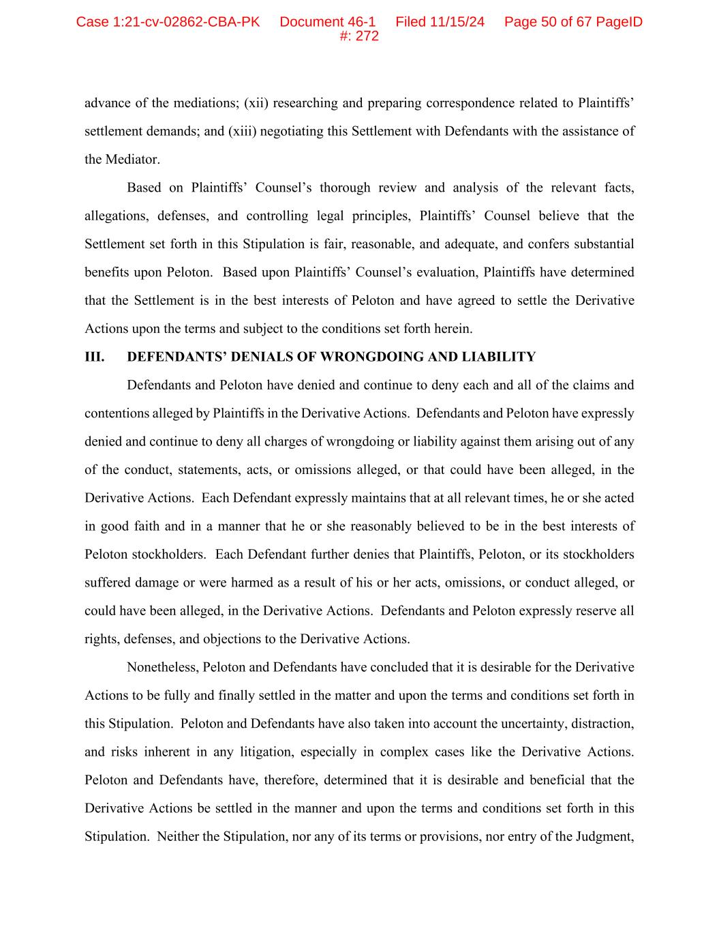
advance of the mediations; (xii) researching and preparing correspondence related to Plaintiffs’ settlement demands; and (xiii) negotiating this Settlement with Defendants with the assistance of the Mediator. Based on Plaintiffs’ Counsel’s thorough review and analysis of the relevant facts, allegations, defenses, and controlling legal principles, Plaintiffs’ Counsel believe that the Settlement set forth in this Stipulation is fair, reasonable, and adequate, and confers substantial benefits upon Peloton. Based upon Plaintiffs’ Counsel’s evaluation, Plaintiffs have determined that the Settlement is in the best interests of Peloton and have agreed to settle the Derivative Actions upon the terms and subject to the conditions set forth herein. III. DEFENDANTS’ DENIALS OF WRONGDOING AND LIABILITY Defendants and Peloton have denied and continue to deny each and all of the claims and contentions alleged by Plaintiffs in the Derivative Actions. Defendants and Peloton have expressly denied and continue to deny all charges of wrongdoing or liability against them arising out of any of the conduct, statements, acts, or omissions alleged, or that could have been alleged, in the Derivative Actions. Each Defendant expressly maintains that at all relevant times, he or she acted in good faith and in a manner that he or she reasonably believed to be in the best interests of Peloton stockholders. Each Defendant further denies that Plaintiffs, Peloton, or its stockholders suffered damage or were harmed as a result of his or her acts, omissions, or conduct alleged, or could have been alleged, in the Derivative Actions. Defendants and Peloton expressly reserve all rights, defenses, and objections to the Derivative Actions. Nonetheless, Peloton and Defendants have concluded that it is desirable for the Derivative Actions to be fully and finally settled in the matter and upon the terms and conditions set forth in this Stipulation. Peloton and Defendants have also taken into account the uncertainty, distraction, and risks inherent in any litigation, especially in complex cases like the Derivative Actions. Peloton and Defendants have, therefore, determined that it is desirable and beneficial that the Derivative Actions be settled in the manner and upon the terms and conditions set forth in this Stipulation. Neither the Stipulation, nor any of its terms or provisions, nor entry of the Judgment, Case 1:21-cv-02862-CBA-PK Document 46-1 Filed 11/15/24 Page 50 of 67 PageID #: 272

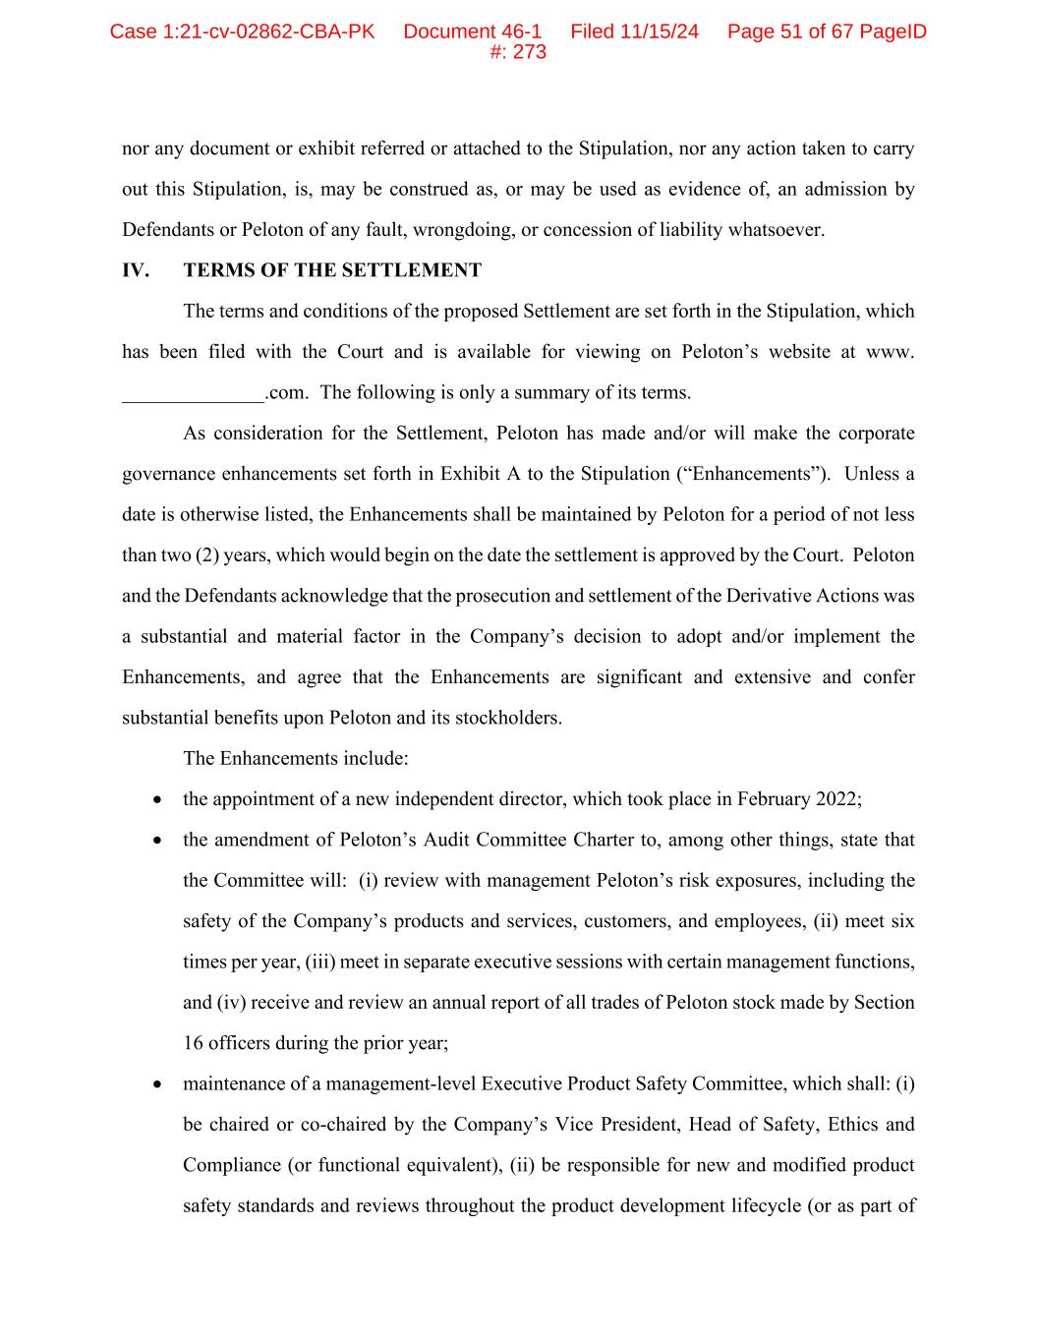
nor any document or exhibit referred or attached to the Stipulation, nor any action taken to carry out this Stipulation, is, may be construed as, or may be used as evidence of, an admission by Defendants or Peloton of any fault, wrongdoing, or concession of liability whatsoever. IV. TERMS OF THE SETTLEMENT The terms and conditions of the proposed Settlement are set forth in the Stipulation, which has been filed with the Court and is available for viewing on Peloton’s website at www. ______________.com. The following is only a summary of its terms. As consideration for the Settlement, Peloton has made and/or will make the corporate governance enhancements set forth in Exhibit A to the Stipulation (“Enhancements”). Unless a date is otherwise listed, the Enhancements shall be maintained by Peloton for a period of not less than two (2) years, which would begin on the date the settlement is approved by the Court. Peloton and the Defendants acknowledge that the prosecution and settlement of the Derivative Actions was a substantial and material factor in the Company’s decision to adopt and/or implement the Enhancements, and agree that the Enhancements are significant and extensive and confer substantial benefits upon Peloton and its stockholders. The Enhancements include: • the appointment of a new independent director, which took place in February 2022; • the amendment of Peloton’s Audit Committee Charter to, among other things, state that the Committee will: (i) review with management Peloton’s risk exposures, including the safety of the Company’s products and services, customers, and employees, (ii) meet six times per year, (iii) meet in separate executive sessions with certain management functions, and (iv) receive and review an annual report of all trades of Peloton stock made by Section 16 officers during the prior year; • maintenance of a management-level Executive Product Safety Committee, which shall: (i) be chaired or co-chaired by the Company’s Vice President, Head of Safety, Ethics and Compliance (or functional equivalent), (ii) be responsible for new and modified product safety standards and reviews throughout the product development lifecycle (or as part of Case 1:21-cv-02862-CBA-PK Document 46-1 Filed 11/15/24 Page 51 of 67 PageID #: 273

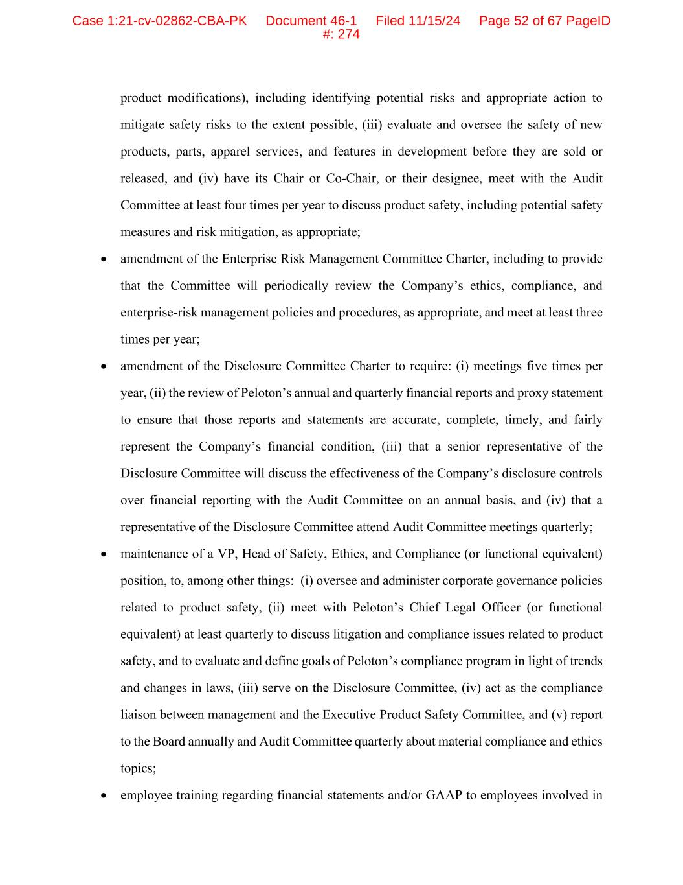
product modifications), including identifying potential risks and appropriate action to mitigate safety risks to the extent possible, (iii) evaluate and oversee the safety of new products, parts, apparel services, and features in development before they are sold or released, and (iv) have its Chair or Co-Chair, or their designee, meet with the Audit Committee at least four times per year to discuss product safety, including potential safety measures and risk mitigation, as appropriate; • amendment of the Enterprise Risk Management Committee Charter, including to provide that the Committee will periodically review the Company’s ethics, compliance, and enterprise-risk management policies and procedures, as appropriate, and meet at least three times per year; • amendment of the Disclosure Committee Charter to require: (i) meetings five times per year, (ii) the review of Peloton’s annual and quarterly financial reports and proxy statement to ensure that those reports and statements are accurate, complete, timely, and fairly represent the Company’s financial condition, (iii) that a senior representative of the Disclosure Committee will discuss the effectiveness of the Company’s disclosure controls over financial reporting with the Audit Committee on an annual basis, and (iv) that a representative of the Disclosure Committee attend Audit Committee meetings quarterly; • maintenance of a VP, Head of Safety, Ethics, and Compliance (or functional equivalent) position, to, among other things: (i) oversee and administer corporate governance policies related to product safety, (ii) meet with Peloton’s Chief Legal Officer (or functional equivalent) at least quarterly to discuss litigation and compliance issues related to product safety, and to evaluate and define goals of Peloton’s compliance program in light of trends and changes in laws, (iii) serve on the Disclosure Committee, (iv) act as the compliance liaison between management and the Executive Product Safety Committee, and (v) report to the Board annually and Audit Committee quarterly about material compliance and ethics topics; • employee training regarding financial statements and/or GAAP to employees involved in Case 1:21-cv-02862-CBA-PK Document 46-1 Filed 11/15/24 Page 52 of 67 PageID #: 274

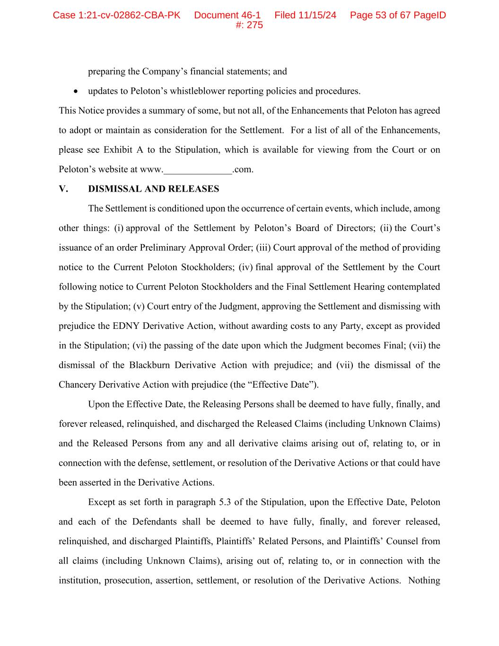
preparing the Company’s financial statements; and • updates to Peloton’s whistleblower reporting policies and procedures. This Notice provides a summary of some, but not all, of the Enhancements that Peloton has agreed to adopt or maintain as consideration for the Settlement. For a list of all of the Enhancements, please see Exhibit A to the Stipulation, which is available for viewing from the Court or on Peloton’s website at www.______________.com. V. DISMISSAL AND RELEASES The Settlement is conditioned upon the occurrence of certain events, which include, among other things: (i) approval of the Settlement by Peloton’s Board of Directors; (ii) the Court’s issuance of an order Preliminary Approval Order; (iii) Court approval of the method of providing notice to the Current Peloton Stockholders; (iv) final approval of the Settlement by the Court following notice to Current Peloton Stockholders and the Final Settlement Hearing contemplated by the Stipulation; (v) Court entry of the Judgment, approving the Settlement and dismissing with prejudice the EDNY Derivative Action, without awarding costs to any Party, except as provided in the Stipulation; (vi) the passing of the date upon which the Judgment becomes Final; (vii) the dismissal of the Blackburn Derivative Action with prejudice; and (vii) the dismissal of the Chancery Derivative Action with prejudice (the “Effective Date”). Upon the Effective Date, the Releasing Persons shall be deemed to have fully, finally, and forever released, relinquished, and discharged the Released Claims (including Unknown Claims) and the Released Persons from any and all derivative claims arising out of, relating to, or in connection with the defense, settlement, or resolution of the Derivative Actions or that could have been asserted in the Derivative Actions. Except as set forth in paragraph 5.3 of the Stipulation, upon the Effective Date, Peloton and each of the Defendants shall be deemed to have fully, finally, and forever released, relinquished, and discharged Plaintiffs, Plaintiffs’ Related Persons, and Plaintiffs’ Counsel from all claims (including Unknown Claims), arising out of, relating to, or in connection with the institution, prosecution, assertion, settlement, or resolution of the Derivative Actions. Nothing Case 1:21-cv-02862-CBA-PK Document 46-1 Filed 11/15/24 Page 53 of 67 PageID #: 275

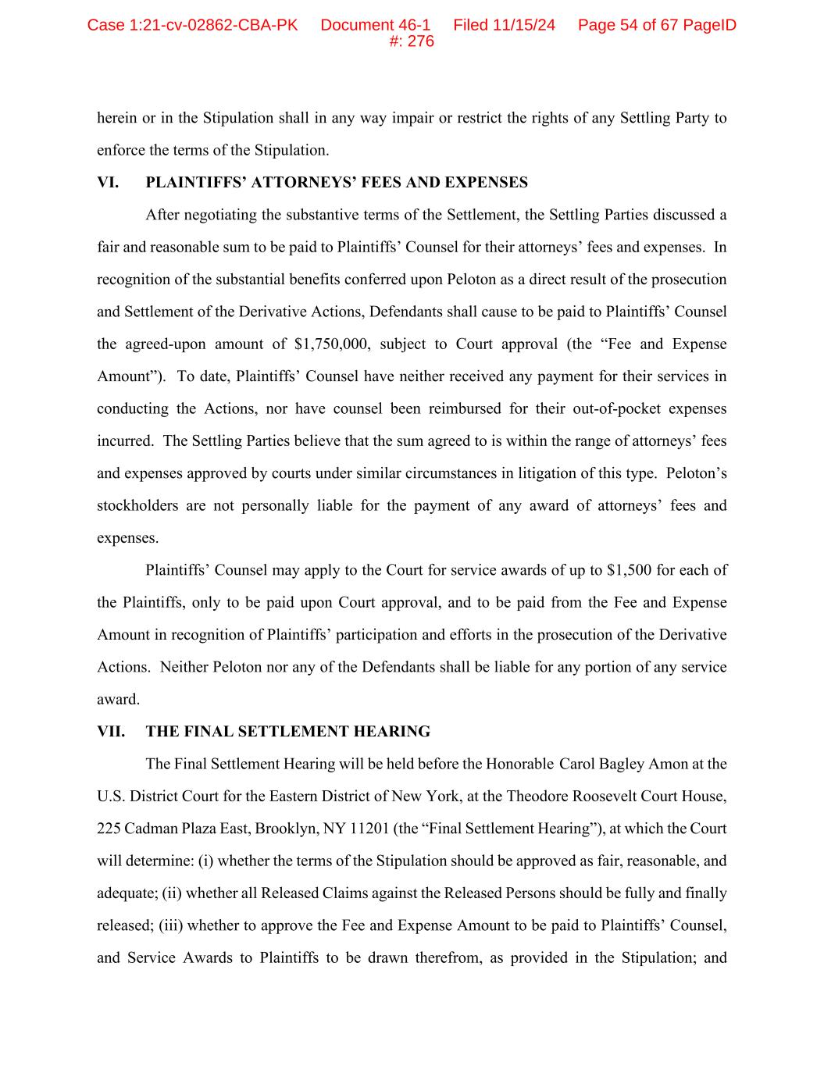
herein or in the Stipulation shall in any way impair or restrict the rights of any Settling Party to enforce the terms of the Stipulation. VI. PLAINTIFFS’ ATTORNEYS’ FEES AND EXPENSES After negotiating the substantive terms of the Settlement, the Settling Parties discussed a fair and reasonable sum to be paid to Plaintiffs’ Counsel for their attorneys’ fees and expenses. In recognition of the substantial benefits conferred upon Peloton as a direct result of the prosecution and Settlement of the Derivative Actions, Defendants shall cause to be paid to Plaintiffs’ Counsel the agreed-upon amount of $1,750,000, subject to Court approval (the “Fee and Expense Amount”). To date, Plaintiffs’ Counsel have neither received any payment for their services in conducting the Actions, nor have counsel been reimbursed for their out-of-pocket expenses incurred. The Settling Parties believe that the sum agreed to is within the range of attorneys’ fees and expenses approved by courts under similar circumstances in litigation of this type. Peloton’s stockholders are not personally liable for the payment of any award of attorneys’ fees and expenses. Plaintiffs’ Counsel may apply to the Court for service awards of up to $1,500 for each of the Plaintiffs, only to be paid upon Court approval, and to be paid from the Fee and Expense Amount in recognition of Plaintiffs’ participation and efforts in the prosecution of the Derivative Actions. Neither Peloton nor any of the Defendants shall be liable for any portion of any service award. VII. THE FINAL SETTLEMENT HEARING The Final Settlement Hearing will be held before the Honorable Carol Bagley Amon at the U.S. District Court for the Eastern District of New York, at the Theodore Roosevelt Court House, 225 Cadman Plaza East, Brooklyn, NY 11201 (the “Final Settlement Hearing”), at which the Court will determine: (i) whether the terms of the Stipulation should be approved as fair, reasonable, and adequate; (ii) whether all Released Claims against the Released Persons should be fully and finally released; (iii) whether to approve the Fee and Expense Amount to be paid to Plaintiffs’ Counsel, and Service Awards to Plaintiffs to be drawn therefrom, as provided in the Stipulation; and Case 1:21-cv-02862-CBA-PK Document 46-1 Filed 11/15/24 Page 54 of 67 PageID #: 276

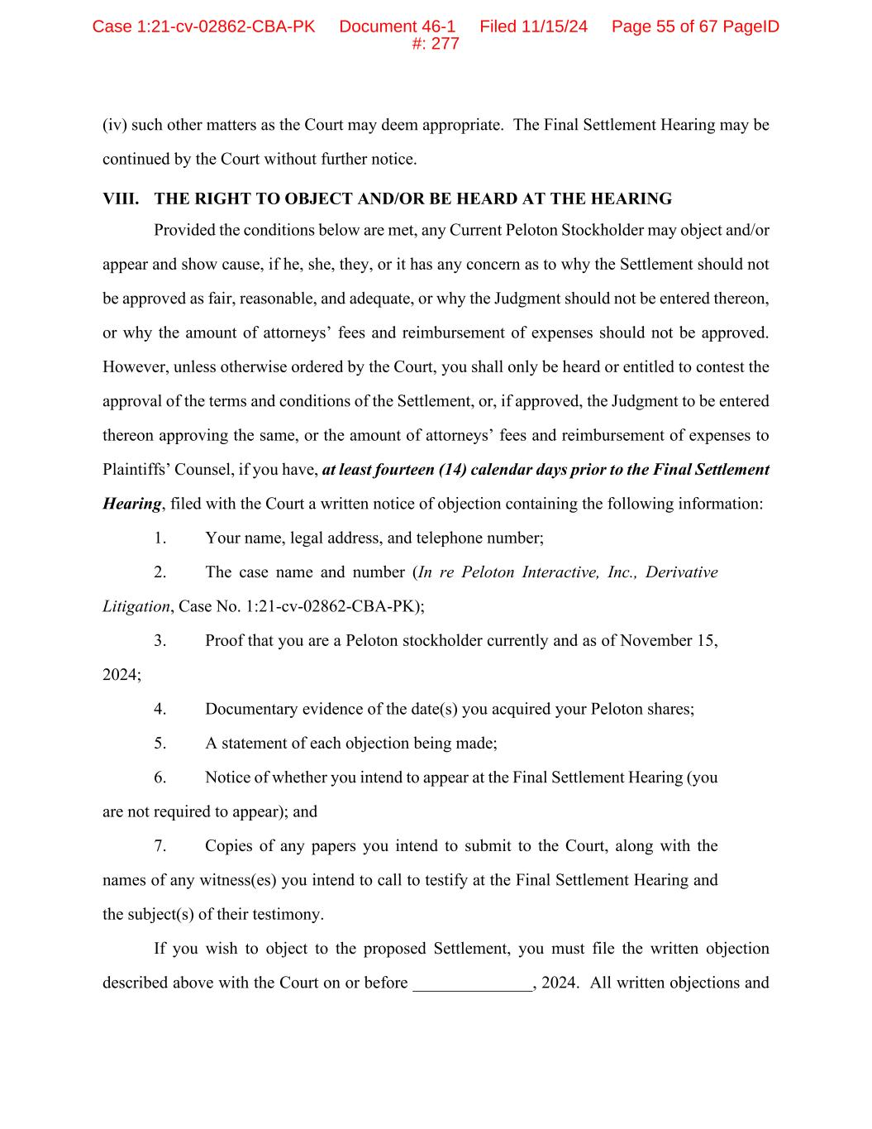
(iv) such other matters as the Court may deem appropriate. The Final Settlement Hearing may be continued by the Court without further notice. VIII. THE RIGHT TO OBJECT AND/OR BE HEARD AT THE HEARING Provided the conditions below are met, any Current Peloton Stockholder may object and/or appear and show cause, if he, she, they, or it has any concern as to why the Settlement should not be approved as fair, reasonable, and adequate, or why the Judgment should not be entered thereon, or why the amount of attorneys’ fees and reimbursement of expenses should not be approved. However, unless otherwise ordered by the Court, you shall only be heard or entitled to contest the approval of the terms and conditions of the Settlement, or, if approved, the Judgment to be entered thereon approving the same, or the amount of attorneys’ fees and reimbursement of expenses to Plaintiffs’ Counsel, if you have, at least fourteen (14) calendar days prior to the Final Settlement Hearing, filed with the Court a written notice of objection containing the following information: 1. Your name, legal address, and telephone number; 2. The case name and number (In re Peloton Interactive, Inc., Derivative Litigation, Case No. 1:21-cv-02862-CBA-PK); 3. Proof that you are a Peloton stockholder currently and as of November 15, 2024; 4. Documentary evidence of the date(s) you acquired your Peloton shares; 5. A statement of each objection being made; 6. Notice of whether you intend to appear at the Final Settlement Hearing (you are not required to appear); and 7. Copies of any papers you intend to submit to the Court, along with the names of any witness(es) you intend to call to testify at the Final Settlement Hearing and the subject(s) of their testimony. If you wish to object to the proposed Settlement, you must file the written objection described above with the Court on or before ______________, 2024. All written objections and Case 1:21-cv-02862-CBA-PK Document 46-1 Filed 11/15/24 Page 55 of 67 PageID #: 277

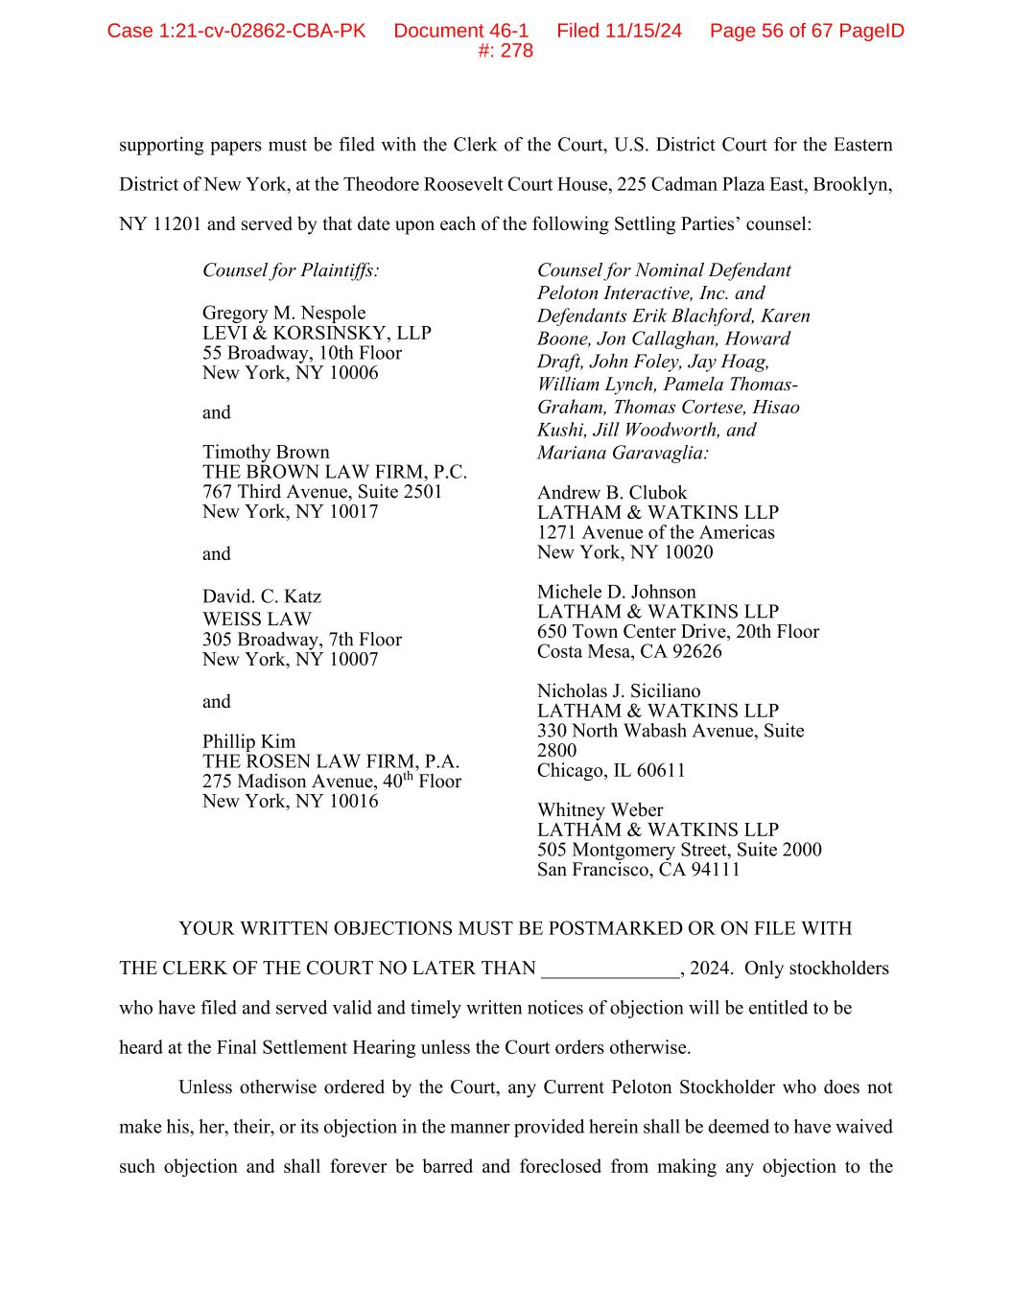
supporting papers must be filed with the Clerk of the Court, U.S. District Court for the Eastern District of New York, at the Theodore Roosevelt Court House, 225 Cadman Plaza East, Brooklyn, NY 11201 and served by that date upon each of the following Settling Parties’ counsel: Counsel for Plaintiffs: Gregory M. Nespole LEVI & KORSINSKY, LLP 55 Broadway, 10th Floor New York, NY 10006 and Timothy Brown THE BROWN LAW FIRM, P.C. 767 Third Avenue, Suite 2501 New York, NY 10017 and David. C. Katz WEISS LAW 305 Broadway, 7th Floor New York, NY 10007 and Phillip Kim THE ROSEN LAW FIRM, P.A. 275 Madison Avenue, 40th Floor New York, NY 10016 Counsel for Nominal Defendant Peloton Interactive, Inc. and Defendants Erik Blachford, Karen Boone, Jon Callaghan, Howard Draft, John Foley, Jay Hoag, William Lynch, Pamela Thomas- Graham, Thomas Cortese, Hisao Kushi, Jill Woodworth, and Mariana Garavaglia: Andrew B. Clubok LATHAM & WATKINS LLP 1271 Avenue of the Americas New York, NY 10020 Michele D. Johnson LATHAM & WATKINS LLP 650 Town Center Drive, 20th Floor Costa Mesa, CA 92626 Nicholas J. Siciliano LATHAM & WATKINS LLP 330 North Wabash Avenue, Suite 2800 Chicago, IL 60611 Whitney Weber LATHAM & WATKINS LLP 505 Montgomery Street, Suite 2000 San Francisco, CA 94111 YOUR WRITTEN OBJECTIONS MUST BE POSTMARKED OR ON FILE WITH THE CLERK OF THE COURT NO LATER THAN ______________, 2024. Only stockholders who have filed and served valid and timely written notices of objection will be entitled to be heard at the Final Settlement Hearing unless the Court orders otherwise. Unless otherwise ordered by the Court, any Current Peloton Stockholder who does not make his, her, their, or its objection in the manner provided herein shall be deemed to have waived such objection and shall forever be barred and foreclosed from making any objection to the Case 1:21-cv-02862-CBA-PK Document 46-1 Filed 11/15/24 Page 56 of 67 PageID #: 278

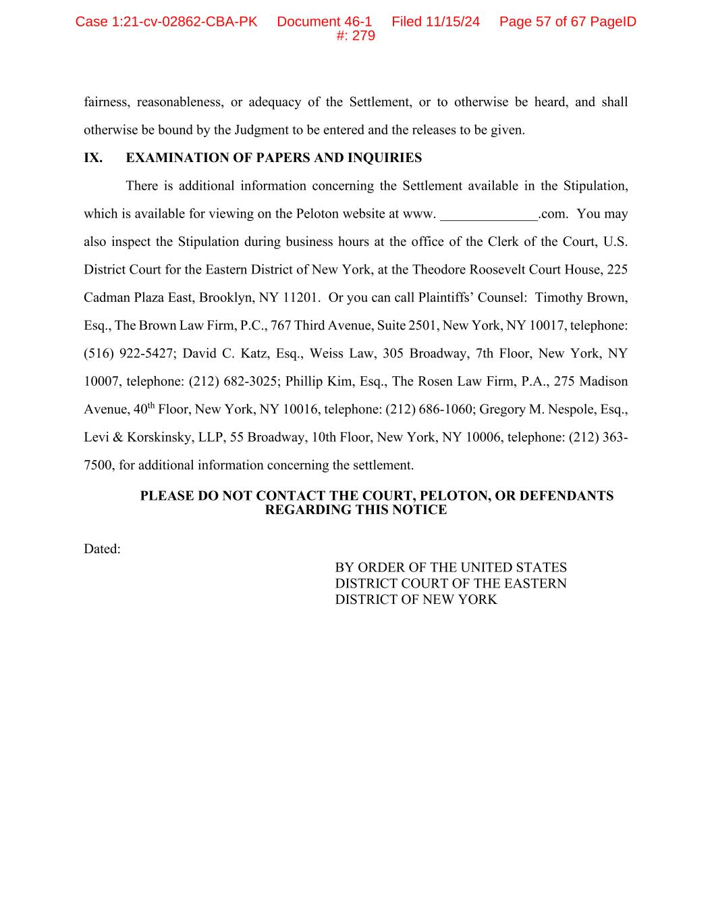
fairness, reasonableness, or adequacy of the Settlement, or to otherwise be heard, and shall otherwise be bound by the Judgment to be entered and the releases to be given. IX. EXAMINATION OF PAPERS AND INQUIRIES There is additional information concerning the Settlement available in the Stipulation, which is available for viewing on the Peloton website at www. ______________.com. You may also inspect the Stipulation during business hours at the office of the Clerk of the Court, U.S. District Court for the Eastern District of New York, at the Theodore Roosevelt Court House, 225 Cadman Plaza East, Brooklyn, NY 11201. Or you can call Plaintiffs’ Counsel: Timothy Brown, Esq., The Brown Law Firm, P.C., 767 Third Avenue, Suite 2501, New York, NY 10017, telephone: (516) 922-5427; David C. Katz, Esq., Weiss Law, 305 Broadway, 7th Floor, New York, NY 10007, telephone: (212) 682-3025; Phillip Kim, Esq., The Rosen Law Firm, P.A., 275 Madison Avenue, 40th Floor, New York, NY 10016, telephone: (212) 686-1060; Gregory M. Nespole, Esq., Levi & Korskinsky, LLP, 55 Broadway, 10th Floor, New York, NY 10006, telephone: (212) 363- 7500, for additional information concerning the settlement. PLEASE DO NOT CONTACT THE COURT, PELOTON, OR DEFENDANTS REGARDING THIS NOTICE Dated: BY ORDER OF THE UNITED STATES DISTRICT COURT OF THE EASTERN DISTRICT OF NEW YORK Case 1:21-cv-02862-CBA-PK Document 46-1 Filed 11/15/24 Page 57 of 67 PageID #: 279

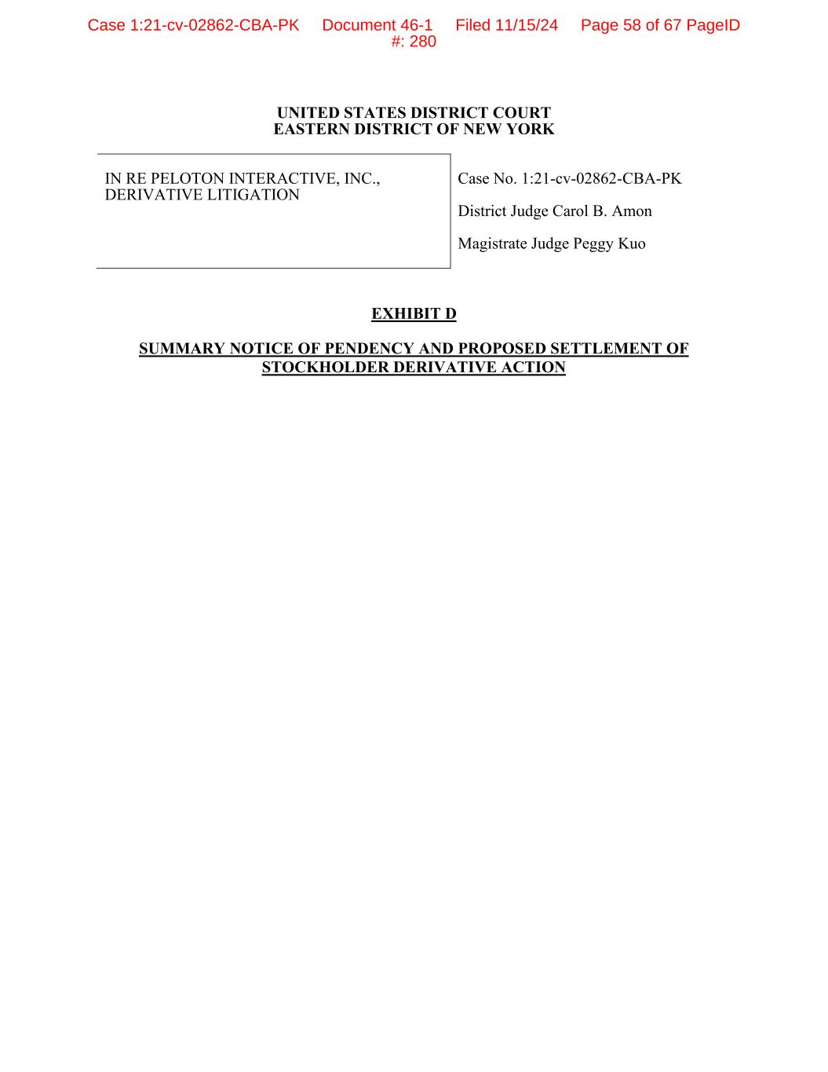
UNITED STATES DISTRICT COURT EASTERN DISTRICT OF NEW YORK IN RE PELOTON INTERACTIVE, INC., DERIVATIVE LITIGATION Case No. 1:21-cv-02862-CBA-PK District Judge Carol B. Amon Magistrate Judge Peggy Kuo EXHIBIT D SUMMARY NOTICE OF PENDENCY AND PROPOSED SETTLEMENT OF STOCKHOLDER DERIVATIVE ACTION Case 1:21-cv-02862-CBA-PK Document 46-1 Filed 11/15/24 Page 58 of 67 PageID #: 280

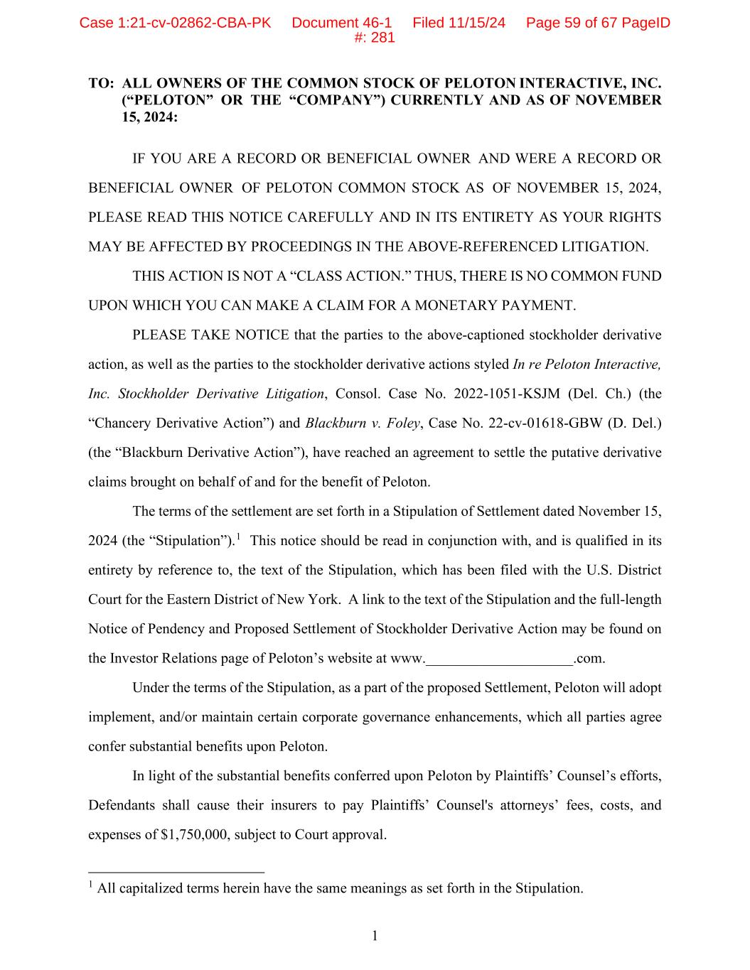
1 TO: ALL OWNERS OF THE COMMON STOCK OF PELOTON INTERACTIVE, INC. (“PELOTON” OR THE “COMPANY”) CURRENTLY AND AS OF NOVEMBER 15, 2024: IF YOU ARE A RECORD OR BENEFICIAL OWNER AND WERE A RECORD OR BENEFICIAL OWNER OF PELOTON COMMON STOCK AS OF NOVEMBER 15, 2024, PLEASE READ THIS NOTICE CAREFULLY AND IN ITS ENTIRETY AS YOUR RIGHTS MAY BE AFFECTED BY PROCEEDINGS IN THE ABOVE-REFERENCED LITIGATION. THIS ACTION IS NOT A “CLASS ACTION.” THUS, THERE IS NO COMMON FUND UPON WHICH YOU CAN MAKE A CLAIM FOR A MONETARY PAYMENT. PLEASE TAKE NOTICE that the parties to the above-captioned stockholder derivative action, as well as the parties to the stockholder derivative actions styled In re Peloton Interactive, Inc. Stockholder Derivative Litigation, Consol. Case No. 2022-1051-KSJM (Del. Ch.) (the “Chancery Derivative Action”) and Blackburn v. Foley, Case No. 22-cv-01618-GBW (D. Del.) (the “Blackburn Derivative Action”), have reached an agreement to settle the putative derivative claims brought on behalf of and for the benefit of Peloton. The terms of the settlement are set forth in a Stipulation of Settlement dated November 15, 2024 (the “Stipulation”).1 This notice should be read in conjunction with, and is qualified in its entirety by reference to, the text of the Stipulation, which has been filed with the U.S. District Court for the Eastern District of New York. A link to the text of the Stipulation and the full-length Notice of Pendency and Proposed Settlement of Stockholder Derivative Action may be found on the Investor Relations page of Peloton’s website at www.____________________.com. Under the terms of the Stipulation, as a part of the proposed Settlement, Peloton will adopt implement, and/or maintain certain corporate governance enhancements, which all parties agree confer substantial benefits upon Peloton. In light of the substantial benefits conferred upon Peloton by Plaintiffs’ Counsel’s efforts, Defendants shall cause their insurers to pay Plaintiffs’ Counsel's attorneys’ fees, costs, and expenses of $1,750,000, subject to Court approval. 1 All capitalized terms herein have the same meanings as set forth in the Stipulation. Case 1:21-cv-02862-CBA-PK Document 46-1 Filed 11/15/24 Page 59 of 67 PageID #: 281

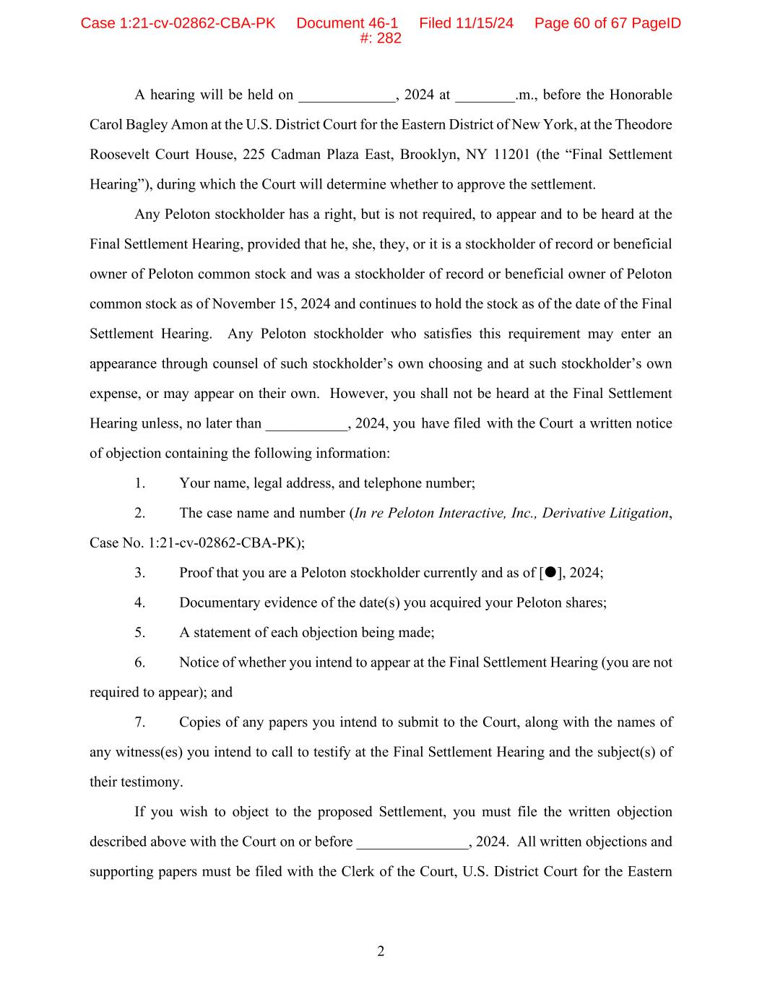
2 A hearing will be held on _____________, 2024 at ________.m., before the Honorable Carol Bagley Amon at the U.S. District Court for the Eastern District of New York, at the Theodore Roosevelt Court House, 225 Cadman Plaza East, Brooklyn, NY 11201 (the “Final Settlement Hearing”), during which the Court will determine whether to approve the settlement. Any Peloton stockholder has a right, but is not required, to appear and to be heard at the Final Settlement Hearing, provided that he, she, they, or it is a stockholder of record or beneficial owner of Peloton common stock and was a stockholder of record or beneficial owner of Peloton common stock as of November 15, 2024 and continues to hold the stock as of the date of the Final Settlement Hearing. Any Peloton stockholder who satisfies this requirement may enter an appearance through counsel of such stockholder’s own choosing and at such stockholder’s own expense, or may appear on their own. However, you shall not be heard at the Final Settlement Hearing unless, no later than ___________, 2024, you have filed with the Court a written notice of objection containing the following information: 1. Your name, legal address, and telephone number; 2. The case name and number (In re Peloton Interactive, Inc., Derivative Litigation, Case No. 1:21-cv-02862-CBA-PK); 3. Proof that you are a Peloton stockholder currently and as of [], 2024; 4. Documentary evidence of the date(s) you acquired your Peloton shares; 5. A statement of each objection being made; 6. Notice of whether you intend to appear at the Final Settlement Hearing (you are not required to appear); and 7. Copies of any papers you intend to submit to the Court, along with the names of any witness(es) you intend to call to testify at the Final Settlement Hearing and the subject(s) of their testimony. If you wish to object to the proposed Settlement, you must file the written objection described above with the Court on or before _______________, 2024. All written objections and supporting papers must be filed with the Clerk of the Court, U.S. District Court for the Eastern Case 1:21-cv-02862-CBA-PK Document 46-1 Filed 11/15/24 Page 60 of 67 PageID #: 282

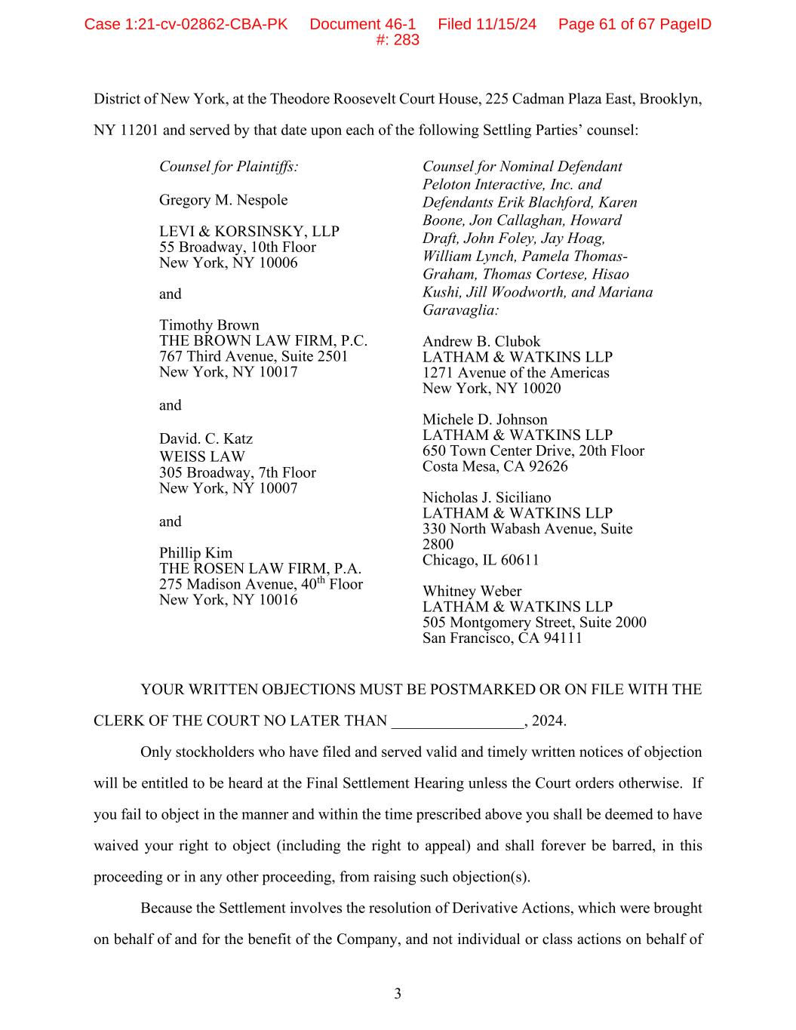
3 District of New York, at the Theodore Roosevelt Court House, 225 Cadman Plaza East, Brooklyn, NY 11201 and served by that date upon each of the following Settling Parties’ counsel: Counsel for Plaintiffs: Gregory M. Nespole LEVI & KORSINSKY, LLP 55 Broadway, 10th Floor New York, NY 10006 and Timothy Brown THE BROWN LAW FIRM, P.C. 767 Third Avenue, Suite 2501 New York, NY 10017 and David. C. Katz WEISS LAW 305 Broadway, 7th Floor New York, NY 10007 and Phillip Kim THE ROSEN LAW FIRM, P.A. 275 Madison Avenue, 40th Floor New York, NY 10016 Counsel for Nominal Defendant Peloton Interactive, Inc. and Defendants Erik Blachford, Karen Boone, Jon Callaghan, Howard Draft, John Foley, Jay Hoag, William Lynch, Pamela Thomas- Graham, Thomas Cortese, Hisao Kushi, Jill Woodworth, and Mariana Garavaglia: Andrew B. Clubok LATHAM & WATKINS LLP 1271 Avenue of the Americas New York, NY 10020 Michele D. Johnson LATHAM & WATKINS LLP 650 Town Center Drive, 20th Floor Costa Mesa, CA 92626 Nicholas J. Siciliano LATHAM & WATKINS LLP 330 North Wabash Avenue, Suite 2800 Chicago, IL 60611 Whitney Weber LATHAM & WATKINS LLP 505 Montgomery Street, Suite 2000 San Francisco, CA 94111 YOUR WRITTEN OBJECTIONS MUST BE POSTMARKED OR ON FILE WITH THE CLERK OF THE COURT NO LATER THAN _________________, 2024. Only stockholders who have filed and served valid and timely written notices of objection will be entitled to be heard at the Final Settlement Hearing unless the Court orders otherwise. If you fail to object in the manner and within the time prescribed above you shall be deemed to have waived your right to object (including the right to appeal) and shall forever be barred, in this proceeding or in any other proceeding, from raising such objection(s). Because the Settlement involves the resolution of Derivative Actions, which were brought on behalf of and for the benefit of the Company, and not individual or class actions on behalf of Case 1:21-cv-02862-CBA-PK Document 46-1 Filed 11/15/24 Page 61 of 67 PageID #: 283

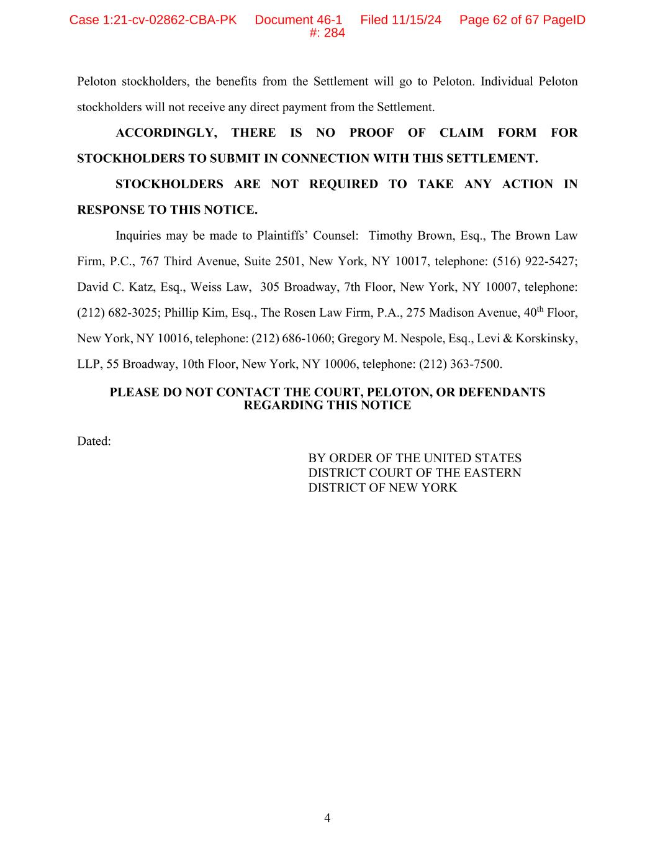
4 Peloton stockholders, the benefits from the Settlement will go to Peloton. Individual Peloton stockholders will not receive any direct payment from the Settlement. ACCORDINGLY, THERE IS NO PROOF OF CLAIM FORM FOR STOCKHOLDERS TO SUBMIT IN CONNECTION WITH THIS SETTLEMENT. STOCKHOLDERS ARE NOT REQUIRED TO TAKE ANY ACTION IN RESPONSE TO THIS NOTICE. Inquiries may be made to Plaintiffs’ Counsel: Timothy Brown, Esq., The Brown Law Firm, P.C., 767 Third Avenue, Suite 2501, New York, NY 10017, telephone: (516) 922-5427; David C. Katz, Esq., Weiss Law, 305 Broadway, 7th Floor, New York, NY 10007, telephone: (212) 682-3025; Phillip Kim, Esq., The Rosen Law Firm, P.A., 275 Madison Avenue, 40th Floor, New York, NY 10016, telephone: (212) 686-1060; Gregory M. Nespole, Esq., Levi & Korskinsky, LLP, 55 Broadway, 10th Floor, New York, NY 10006, telephone: (212) 363-7500. PLEASE DO NOT CONTACT THE COURT, PELOTON, OR DEFENDANTS REGARDING THIS NOTICE Dated: BY ORDER OF THE UNITED STATES DISTRICT COURT OF THE EASTERN DISTRICT OF NEW YORK Case 1:21-cv-02862-CBA-PK Document 46-1 Filed 11/15/24 Page 62 of 67 PageID #: 284

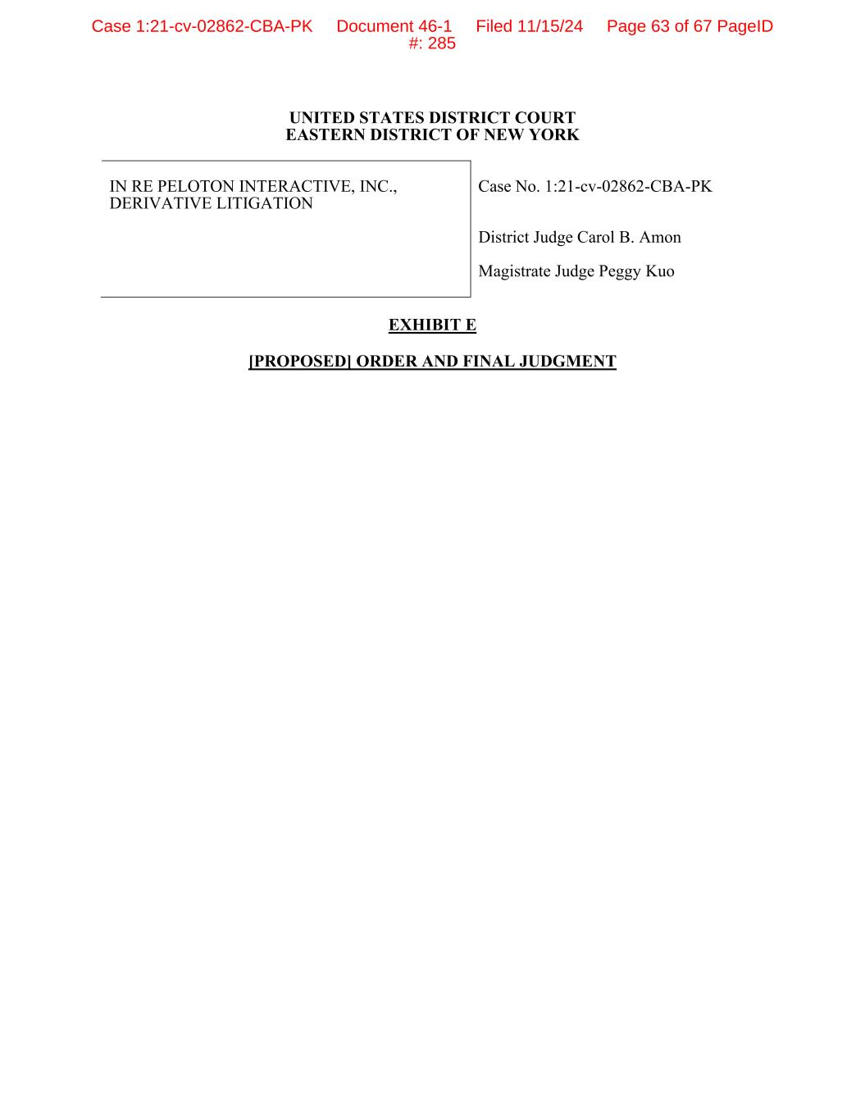
UNITED STATES DISTRICT COURT EASTERN DISTRICT OF NEW YORK IN RE PELOTON INTERACTIVE, INC., DERIVATIVE LITIGATION Case No. 1:21-cv-02862-CBA-PK District Judge Carol B. Amon Magistrate Judge Peggy Kuo EXHIBIT E [PROPOSED] ORDER AND FINAL JUDGMENT Case 1:21-cv-02862-CBA-PK Document 46-1 Filed 11/15/24 Page 63 of 67 PageID #: 285

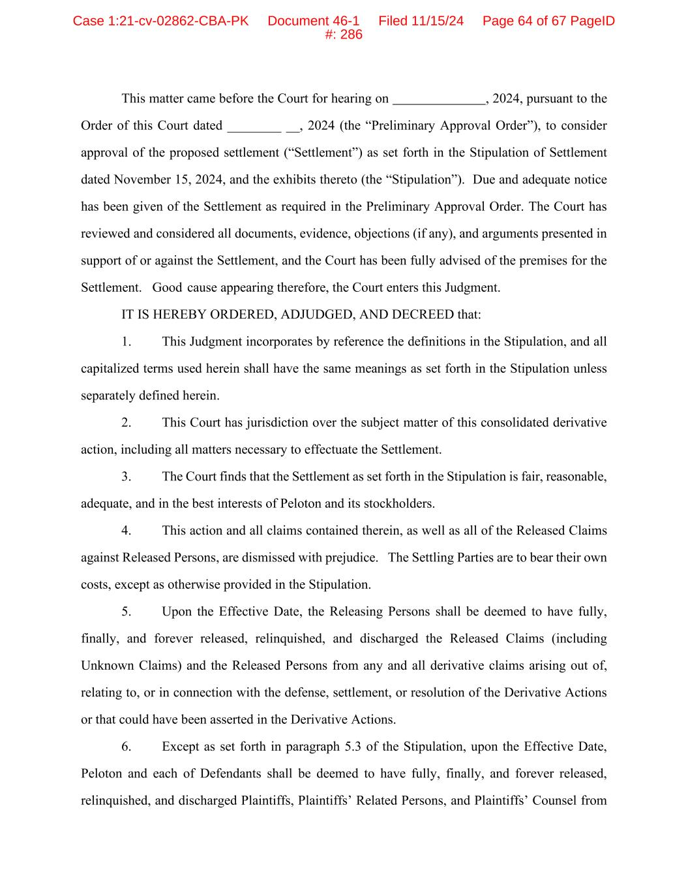
This matter came before the Court for hearing on , 2024, pursuant to the Order of this Court dated ________ __, 2024 (the “Preliminary Approval Order”), to consider approval of the proposed settlement (“Settlement”) as set forth in the Stipulation of Settlement dated November 15, 2024, and the exhibits thereto (the “Stipulation”). Due and adequate notice has been given of the Settlement as required in the Preliminary Approval Order. The Court has reviewed and considered all documents, evidence, objections (if any), and arguments presented in support of or against the Settlement, and the Court has been fully advised of the premises for the Settlement. Good cause appearing therefore, the Court enters this Judgment. IT IS HEREBY ORDERED, ADJUDGED, AND DECREED that: 1. This Judgment incorporates by reference the definitions in the Stipulation, and all capitalized terms used herein shall have the same meanings as set forth in the Stipulation unless separately defined herein. 2. This Court has jurisdiction over the subject matter of this consolidated derivative action, including all matters necessary to effectuate the Settlement. 3. The Court finds that the Settlement as set forth in the Stipulation is fair, reasonable, adequate, and in the best interests of Peloton and its stockholders. 4. This action and all claims contained therein, as well as all of the Released Claims against Released Persons, are dismissed with prejudice. The Settling Parties are to bear their own costs, except as otherwise provided in the Stipulation. 5. Upon the Effective Date, the Releasing Persons shall be deemed to have fully, finally, and forever released, relinquished, and discharged the Released Claims (including Unknown Claims) and the Released Persons from any and all derivative claims arising out of, relating to, or in connection with the defense, settlement, or resolution of the Derivative Actions or that could have been asserted in the Derivative Actions. 6. Except as set forth in paragraph 5.3 of the Stipulation, upon the Effective Date, Peloton and each of Defendants shall be deemed to have fully, finally, and forever released, relinquished, and discharged Plaintiffs, Plaintiffs’ Related Persons, and Plaintiffs’ Counsel from Case 1:21-cv-02862-CBA-PK Document 46-1 Filed 11/15/24 Page 64 of 67 PageID #: 286

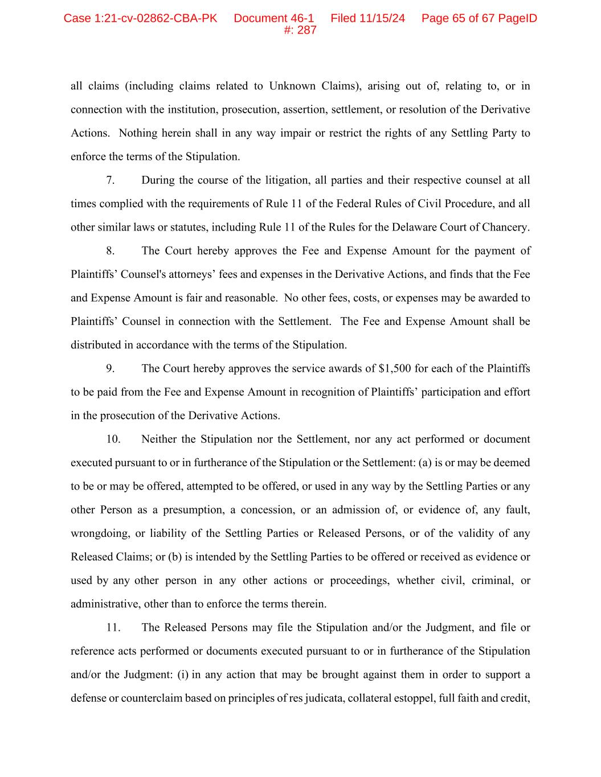
all claims (including claims related to Unknown Claims), arising out of, relating to, or in connection with the institution, prosecution, assertion, settlement, or resolution of the Derivative Actions. Nothing herein shall in any way impair or restrict the rights of any Settling Party to enforce the terms of the Stipulation. 7. During the course of the litigation, all parties and their respective counsel at all times complied with the requirements of Rule 11 of the Federal Rules of Civil Procedure, and all other similar laws or statutes, including Rule 11 of the Rules for the Delaware Court of Chancery. 8. The Court hereby approves the Fee and Expense Amount for the payment of Plaintiffs’ Counsel's attorneys’ fees and expenses in the Derivative Actions, and finds that the Fee and Expense Amount is fair and reasonable. No other fees, costs, or expenses may be awarded to Plaintiffs’ Counsel in connection with the Settlement. The Fee and Expense Amount shall be distributed in accordance with the terms of the Stipulation. 9. The Court hereby approves the service awards of $1,500 for each of the Plaintiffs to be paid from the Fee and Expense Amount in recognition of Plaintiffs’ participation and effort in the prosecution of the Derivative Actions. 10. Neither the Stipulation nor the Settlement, nor any act performed or document executed pursuant to or in furtherance of the Stipulation or the Settlement: (a) is or may be deemed to be or may be offered, attempted to be offered, or used in any way by the Settling Parties or any other Person as a presumption, a concession, or an admission of, or evidence of, any fault, wrongdoing, or liability of the Settling Parties or Released Persons, or of the validity of any Released Claims; or (b) is intended by the Settling Parties to be offered or received as evidence or used by any other person in any other actions or proceedings, whether civil, criminal, or administrative, other than to enforce the terms therein. 11. The Released Persons may file the Stipulation and/or the Judgment, and file or reference acts performed or documents executed pursuant to or in furtherance of the Stipulation and/or the Judgment: (i) in any action that may be brought against them in order to support a defense or counterclaim based on principles of res judicata, collateral estoppel, full faith and credit, Case 1:21-cv-02862-CBA-PK Document 46-1 Filed 11/15/24 Page 65 of 67 PageID #: 287

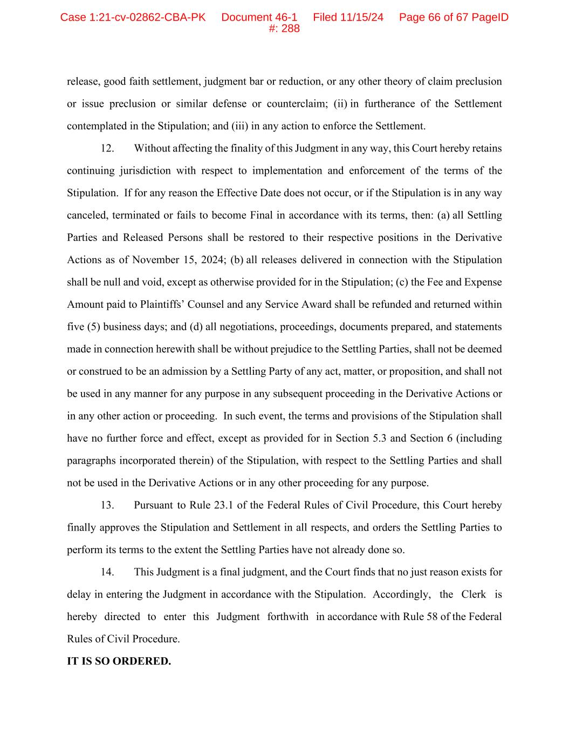
release, good faith settlement, judgment bar or reduction, or any other theory of claim preclusion or issue preclusion or similar defense or counterclaim; (ii) in furtherance of the Settlement contemplated in the Stipulation; and (iii) in any action to enforce the Settlement. 12. Without affecting the finality of this Judgment in any way, this Court hereby retains continuing jurisdiction with respect to implementation and enforcement of the terms of the Stipulation. If for any reason the Effective Date does not occur, or if the Stipulation is in any way canceled, terminated or fails to become Final in accordance with its terms, then: (a) all Settling Parties and Released Persons shall be restored to their respective positions in the Derivative Actions as of November 15, 2024; (b) all releases delivered in connection with the Stipulation shall be null and void, except as otherwise provided for in the Stipulation; (c) the Fee and Expense Amount paid to Plaintiffs’ Counsel and any Service Award shall be refunded and returned within five (5) business days; and (d) all negotiations, proceedings, documents prepared, and statements made in connection herewith shall be without prejudice to the Settling Parties, shall not be deemed or construed to be an admission by a Settling Party of any act, matter, or proposition, and shall not be used in any manner for any purpose in any subsequent proceeding in the Derivative Actions or in any other action or proceeding. In such event, the terms and provisions of the Stipulation shall have no further force and effect, except as provided for in Section 5.3 and Section 6 (including paragraphs incorporated therein) of the Stipulation, with respect to the Settling Parties and shall not be used in the Derivative Actions or in any other proceeding for any purpose. 13. Pursuant to Rule 23.1 of the Federal Rules of Civil Procedure, this Court hereby finally approves the Stipulation and Settlement in all respects, and orders the Settling Parties to perform its terms to the extent the Settling Parties have not already done so. 14. This Judgment is a final judgment, and the Court finds that no just reason exists for delay in entering the Judgment in accordance with the Stipulation. Accordingly, the Clerk is hereby directed to enter this Judgment forthwith in accordance with Rule 58 of the Federal Rules of Civil Procedure. IT IS SO ORDERED. Case 1:21-cv-02862-CBA-PK Document 46-1 Filed 11/15/24 Page 66 of 67 PageID #: 288


Dated: The Honorable Carol B. Amon UNITED STATES DISTRICT COURT JUDGE Case 1:21-cv-02862-CBA-PK Document 46-1 Filed 11/15/24 Page 67 of 67 PageID #: 289

UNITED STATES DISTRICT COURT
EASTERN DISTRICT OF NEW YORK



NOTICE OF PENDENCY AND PROPOSED SETTLEMENT OF STOCKHOLDER DERIVATIVE ACTION

|
TO: ALL OWNERS OF THE COMMON STOCK OF PELOTON INTERACTIVE, INC. (“PELOTON” OR THE “COMPANY”) CURRENTLY AND AS OF NOVEMBER 15, 2024 (“CURRENT PELOTON STOCKHOLDERS”):
THIS NOTICE RELATES TO THE PENDENCY AND PROPOSED SETTLEMENT OF STOCKHOLDER DERIVATIVE LITIGATION. PLEASE READ THIS NOTICE CAREFULLY AND IN ITS ENTIRETY. IF YOU ARE A CURRENT PELOTON STOCKHOLDER, THIS NOTICE CONTAINS IMPORTANT INFORMATION ABOUT YOUR RIGHTS.
THIS ACTION IS NOT A “CLASS ACTION.” THUS, THERE IS NO COMMON FUND UPON WHICH YOU CAN MAKE A CLAIM FOR A MONETARY PAYMENT.
YOU ARE HEREBY NOTIFIED, pursuant to an Order of the U.S. District Court for the Eastern District of New York (the “Court”), that a proposed settlement has been reached by the parties to the following putative stockholder derivative actions brought on behalf and for the benefit of Peloton Interactive, Inc. (“Peloton” or the “Company”): (i) In re Peloton Interactive, Inc. Derivative Litigation, Consol. Case No. 1:21-cv-02862-CBA-PK (the “EDNY Derivative Action”); (ii) In re Peloton Interactive, Inc. Stockholder Derivative Litigation, Consol. Case No. 2022-1051-KSJM (Del. Ch.) (the “Chancery Derivative Action”); and (iii) Blackburn v. Foley, Case No. 22-cv-01618-GBW (D. Del.) (the “Blackburn Derivative Action”) (collectively, the “Derivative Actions”).1
As explained below, a hearing will be held on June 13, 2025 at 11:00 a.m., before the Honorable Carol Bagley Amon at the U.S. District Court for the Eastern District of New York, at the Theodore Roosevelt Court House, 225 Cadman Plaza East, Brooklyn, NY 11201 (the “Final Settlement Hearing”), at which the Court will determine whether to approve the Settlement. You have an opportunity to be heard at this hearing.
The Court may, in its discretion, change the date and/or time of the Final Settlement Hearing without further notice to you. The Court also has reserved the right to hold the Final Settlement Hearing telephonically or by videoconference without further notice to you. If you
1 All capitalized terms herein have the same meanings as set forth in the Settling Parties’ Stipulation of Settlement dated November 15, 2024 (the “Stipulation”), which is available for viewing on Peloton’s website at https://investor.onepeloton.com/legalinfo.

intend to attend the Settlement Hearing, please consult the Court’s calendar or Peloton’s website, https://investor.onepeloton.com/legalinfo, for any change in the date, time, or format of the Final Settlement Hearing.
The terms of the Settlement are set forth in the Stipulation and summarized in this Notice. If approved by the Court, the Settlement will fully resolve the Derivative Actions, including the dismissal of the Derivative Actions with prejudice. For a more detailed statement of the matters involved in the Derivative Actions, the Settlement, and the terms discussed in this Notice, the Stipulation may be inspected at the Clerk of Court’s office, U.S. District Court for the Eastern District of New York, Theodore Roosevelt Court House, 225 Cadman Plaza East, Brooklyn, NY 11201. The Stipulation is also available on the website of Peloton at https://investor.onepeloton.com/legalinfo. For a fee, all papers filed in the EDNY Derivative Action and the Blackburn Derivative Action are available at www.pacer.gov, and all papers filed in the Chancery Derivative Action are available at www.courtconnect.courts.delaware.gov.
This Notice is not intended to be an expression of any opinion by the Court with respect to the merits of the claims made in the Derivative Actions, but is only to provide notice to you of the pendency and proposed settlement of the Derivative Actions.
THERE IS NO CLAIMS PROCEDURE. This case was brought purportedly to protect the interests of Peloton. The Settlement will result in enhancements or the maintenance of the Company’s corporate governance practices, not in any payment to individuals, and accordingly, there will be no claims procedure.
I.THE DERIVATIVE ACTIONS
The Derivative Actions are brought by Plaintiffs solely on behalf of and for the benefit of Peloton and against the Defendants. Peloton is a global fitness company with a first-of-its-kind subscription platform that seamlessly combines innovative hardware, distinct software, and exclusive content. The Derivative Actions allege that Defendants breached their fiduciary duties, and concern allegations regarding the Peloton Tread+ and the safety of the product.

II.PLAINTIFFS’ CLAIMS AND THE BENEFITS OF SETTLEMENT
Plaintiffs believe that the Derivative Actions have substantial merit, and Plaintiffs’ entry into this Stipulation and Settlement is not intended to be and shall not be construed as an admission or concession concerning the relative strength or merit of the claims alleged in the Derivative Actions. Plaintiffs and Plaintiffs’ Counsel, however, recognize and acknowledge the significant risk, expense, and length of continued proceedings necessary to prosecute the Derivative Actions against the Defendants through trial and through possible appeals. Plaintiffs’ Counsel also have taken into account the uncertain outcome and the risk of any litigation, especially in complex cases such as the Derivative Actions, as well as the difficulties and delays inherent in such litigation. Plaintiffs’ Counsel are also mindful of the inherent problems of establishing standing in derivative litigation, and the possible defenses to the claims alleged in the Derivative Actions.
Plaintiffs’ Counsel believe they have conducted extensive investigation and analysis, including, inter alia: (i) reviewing Peloton’s press releases, public statements, U.S. Securities and Exchange Commission (“SEC”) filings, corporate governance document including the Company’s Code of Conduct, Corporate Governance Guidelines, and Board-level Committee Charters; (ii) reviewing securities analysts’ reports and advisories about the Company, its operations, and its financial condition; (iii) reviewing related media reports about the Company; (iv) researching applicable law with respect to the claims alleged in the Derivative Actions and potential defenses thereto; (v) preparing and serving detailed demands for production of internal Peloton books and records pursuant to 8 Del. C. § 220; (vi) reviewing and analyzing internal Peloton books and records consisting of Peloton board minutes and related materials concerning, among other things, the facts and circumstances at issue, which were produced pursuant to books and records demands and a confidentiality agreement; (vii) reviewing and analyzing the pleadings and other papers filed in the Class Action; (viii) preparing and filing substantial, detailed derivative complaints, including the amended consolidated complaint filed in the Delaware Chancery Action; (ix) conducting damages analyses regarding the facts and

circumstances at issue; (x) researching corporate governance best practices; (xi) preparing and submitting extensive mediation statements in advance of the mediations; (xii) researching and preparing correspondence related to Plaintiffs’ settlement demands; and (xiii) negotiating this Settlement with Defendants with the assistance of the Mediator.
Based on Plaintiffs’ Counsel’s thorough review and analysis of the relevant facts, allegations, defenses, and controlling legal principles, Plaintiffs’ Counsel believe that the Settlement set forth in this Stipulation is fair, reasonable, and adequate, and confers substantial benefits upon Peloton. Based upon Plaintiffs’ Counsel’s evaluation, Plaintiffs have determined that the Settlement is in the best interests of Peloton and have agreed to settle the Derivative Actions upon the terms and subject to the conditions set forth herein.
III.DEFENDANTS’ DENIALS OF WRONGDOING AND LIABILITY
Defendants and Peloton have denied and continue to deny each and all of the claims and contentions alleged by Plaintiffs in the Derivative Actions. Defendants and Peloton have expressly denied and continue to deny all charges of wrongdoing or liability against them arising out of any of the conduct, statements, acts, or omissions alleged, or that could have been alleged, in the Derivative Actions. Each Defendant expressly maintains that at all relevant times, he or she acted in good faith and in a manner that he or she reasonably believed to be in the best interests of Peloton stockholders. Each Defendant further denies that Plaintiffs, Peloton, or its stockholders suffered damage or were harmed as a result of his or her acts, omissions, or conduct alleged, or could have been alleged, in the Derivative Actions. Defendants and Peloton expressly reserve all rights, defenses, and objections to the Derivative Actions.
Nonetheless, Peloton and Defendants have concluded that it is desirable for the Derivative Actions to be fully and finally settled in the matter and upon the terms and conditions set forth in this Stipulation. Peloton and Defendants have also taken into account the uncertainty, distraction, and risks inherent in any litigation, especially in complex cases like the Derivative Actions. Peloton and Defendants have, therefore, determined that it is desirable and beneficial that the Derivative Actions be settled in the manner and upon the terms and conditions set forth

in this Stipulation. Neither the Stipulation, nor any of its terms or provisions, nor entry of the Judgment, nor any document or exhibit referred or attached to the Stipulation, nor any action taken to carry out this Stipulation, is, may be construed as, or may be used as evidence of, an admission by Defendants or Peloton of any fault, wrongdoing, or concession of liability whatsoever.
IV.TERMS OF THE SETTLEMENT
The terms and conditions of the proposed Settlement are set forth in the Stipulation, which has been filed with the Court and is available for viewing on Peloton’s website at https://investor.onepeloton.com/legalinfo. The following is only a summary of its terms.
As consideration for the Settlement, Peloton has made and/or will make the corporate governance enhancements set forth in Exhibit A to the Stipulation (“Enhancements”). Unless a date is otherwise listed, the Enhancements shall be maintained by Peloton for a period of not less than two (2) years, which would begin on the date the settlement is approved by the Court. Peloton and the Defendants acknowledge that the prosecution and settlement of the Derivative Actions was a substantial and material factor in the Company’s decision to adopt and/or implement the Enhancements, and agree that the Enhancements are significant and extensive and confer substantial benefits upon Peloton and its stockholders.
The Enhancements include:
•the appointment of a new independent director, which took place in February 2022;
•the amendment of Peloton’s Audit Committee Charter to, among other things, state that the Committee will: (i) review with management Peloton’s risk exposures, including the safety of the Company’s products and services, customers, and employees, (ii) meet six times per year, (iii) meet in separate executive sessions with certain management functions, and (iv) receive and review an annual report of all trades of Peloton stock made by Section 16 officers during the prior year;
•maintenance of a management-level Executive Product Safety Committee, which shall: (i) be chaired or co-chaired by the Company’s Vice President, Head of Safety, Ethics and

Compliance (or functional equivalent), (ii) be responsible for new and modified product safety standards and reviews throughout the product development lifecycle (or as part of product modifications), including identifying potential risks and appropriate action to mitigate safety risks to the extent possible, (iii) evaluate and oversee the safety of new products, parts, apparel services, and features in development before they are sold or released, and (iv) have its Chair or Co-Chair, or their designee, meet with the Audit Committee at least four times per year to discuss product safety, including potential safety measures and risk mitigation, as appropriate;
•amendment of the Enterprise Risk Management Committee Charter, including to provide that the Committee will periodically review the Company’s ethics, compliance, and enterprise-risk management policies and procedures, as appropriate, and meet at least three times per year;
•amendment of the Disclosure Committee Charter to require: (i) meetings five times per year, (ii) the review of Peloton’s annual and quarterly financial reports and proxy statement to ensure that those reports and statements are accurate, complete, timely, and fairly represent the Company’s financial condition, (iii) that a senior representative of the Disclosure Committee will discuss the effectiveness of the Company’s disclosure controls over financial reporting with the Audit Committee on an annual basis, and (iv) that a representative of the Disclosure Committee attend Audit Committee meetings quarterly;
•maintenance of a VP, Head of Safety, Ethics, and Compliance (or functional equivalent) position, to, among other things: (i) oversee and administer corporate governance policies related to product safety, (ii) meet with Peloton’s Chief Legal Officer (or functional equivalent) at least quarterly to discuss litigation and compliance issues related to product safety, and to evaluate and define goals of Peloton’s compliance program in light of trends and changes in laws, (iii) serve on the Disclosure Committee, (iv) act as the compliance liaison between management and the Executive Product Safety

Committee, and (v) report to the Board annually and Audit Committee quarterly about material compliance and ethics topics;
•employee training regarding financial statements and/or GAAP to employees involved in preparing the Company’s financial statements; and
•updates to Peloton’s whistleblower reporting policies and procedures.
This Notice provides a summary of some, but not all, of the Enhancements that Peloton has agreed to adopt or maintain as consideration for the Settlement. For a list of all of the Enhancements, please see Exhibit A to the Stipulation, which is available for viewing from the Court or on Peloton’s website at https://investor.onepeloton.com/legalinfo.
V.DISMISSAL AND RELEASES
The Settlement is conditioned upon the occurrence of certain events, which include, among other things: (i) approval of the Settlement by Peloton’s Board of Directors; (ii) the Court’s issuance of an order Preliminary Approval Order; (iii) Court approval of the method of providing notice to the Current Peloton Stockholders; (iv) final approval of the Settlement by the Court following notice to Current Peloton Stockholders and the Final Settlement Hearing contemplated by the Stipulation; (v) Court entry of the Judgment, approving the Settlement and dismissing with prejudice the EDNY Derivative Action, without awarding costs to any Party, except as provided in the Stipulation; (vi) the passing of the date upon which the Judgment becomes Final; (vii) the dismissal of the Blackburn Derivative Action with prejudice; and (vii) the dismissal of the Chancery Derivative Action with prejudice (the “Effective Date”).
Upon the Effective Date, the Releasing Persons shall be deemed to have fully, finally, and forever released, relinquished, and discharged the Released Claims (including Unknown Claims) and the Released Persons from any and all derivative claims arising out of, relating to, or in connection with the defense, settlement, or resolution of the Derivative Actions or that could have been asserted in the Derivative Actions.
Except as set forth in paragraph 5.3 of the Stipulation, upon the Effective Date, Peloton and each of the Defendants shall be deemed to have fully, finally, and forever released,

relinquished, and discharged Plaintiffs, Plaintiffs’ Related Persons, and Plaintiffs’ Counsel from all claims (including Unknown Claims), arising out of, relating to, or in connection with the institution, prosecution, assertion, settlement, or resolution of the Derivative Actions. Nothing herein or in the Stipulation shall in any way impair or restrict the rights of any Settling Party to enforce the terms of the Stipulation.
VI.PLAINTIFFS’ ATTORNEYS’ FEES AND EXPENSES
After negotiating the substantive terms of the Settlement, the Settling Parties discussed a fair and reasonable sum to be paid to Plaintiffs’ Counsel for their attorneys’ fees and expenses. In recognition of the substantial benefits conferred upon Peloton as a direct result of the prosecution and Settlement of the Derivative Actions, Defendants shall cause to be paid to Plaintiffs’ Counsel the agreed-upon amount of $1,750,000, subject to Court approval (the “Fee and Expense Amount”). To date, Plaintiffs’ Counsel have neither received any payment for their services in conducting the Actions, nor have counsel been reimbursed for their out-of-pocket expenses incurred. The Settling Parties believe that the sum agreed to is within the range of attorneys’ fees and expenses approved by courts under similar circumstances in litigation of this type. Peloton’s stockholders are not personally liable for the payment of any award of attorneys’ fees and expenses.
Plaintiffs’ Counsel may apply to the Court for service awards of up to $1,500 for each of the Plaintiffs, only to be paid upon Court approval, and to be paid from the Fee and Expense Amount in recognition of Plaintiffs’ participation and efforts in the prosecution of the Derivative Actions. Neither Peloton nor any of the Defendants shall be liable for any portion of any service award.
VII.THE FINAL SETTLEMENT HEARING
The Final Settlement Hearing will be held before the Honorable Carol Bagley Amon at the U.S. District Court for the Eastern District of New York, at the Theodore Roosevelt Court House, 225 Cadman Plaza East, Brooklyn, NY 11201 (the “Final Settlement Hearing”), at which the Court will determine: (i) whether the terms of the Stipulation should be approved as fair,

reasonable, and adequate; (ii) whether all Released Claims against the Released Persons should be fully and finally released; (iii) whether to approve the Fee and Expense Amount to be paid to Plaintiffs’ Counsel, and Service Awards to Plaintiffs to be drawn therefrom, as provided in the Stipulation; and (iv) such other matters as the Court may deem appropriate. The Final Settlement Hearing may be continued by the Court without further notice.
VIII.THE RIGHT TO OBJECT AND/OR BE HEARD AT THE HEARING
Provided the conditions below are met, any Current Peloton Stockholder may object and/or appear and show cause, if he, she, they, or it has any concern as to why the Settlement should not be approved as fair, reasonable, and adequate, or why the Judgment should not be entered thereon, or why the amount of attorneys’ fees and reimbursement of expenses should not be approved. However, unless otherwise ordered by the Court, you shall only be heard or entitled to contest the approval of the terms and conditions of the Settlement, or, if approved, the Judgment to be entered thereon approving the same, or the amount of attorneys’ fees and reimbursement of expenses to Plaintiffs’ Counsel, if you have, at least fourteen (14) calendar days prior to the Final Settlement Hearing, filed with the Court a written notice of objection containing the following information:
1.Your name, legal address, and telephone number;
2.The case name and number (In re Peloton Interactive, Inc., Derivative Litigation, Case No. 1:21-cv-02862-CBA-PK);
3.Proof that you are a Peloton stockholder currently and as of November 15, 2024;
4.Documentary evidence of the date(s) you acquired your Peloton shares;
5.A statement of each objection being made;
6.Notice of whether you intend to appear at the Final Settlement Hearing (you are not required to appear); and

7.Copies of any papers you intend to submit to the Court, along with the names of any witness(es) you intend to call to testify at the Final Settlement Hearing and the subject(s) of their testimony.
If you wish to object to the proposed Settlement, you must file the written objection described above with the Court on or before May 30, 2025. All written objections and supporting papers must be filed with the Clerk of the Court, U.S. District Court for the Eastern District of New York, at the Theodore Roosevelt Court House, 225 Cadman Plaza East, Brooklyn, NY 11201 and served by that date upon each of the following Settling Parties’ counsel:
Counsel for Plaintiffs:  Gregory M. Nespole  LEVI & KORSINSKY, LLP  55 Broadway, 10th Floor  New York, NY 10006  and  Timothy Brown  THE BROWN LAW FIRM, P.C.  767 Third Avenue, Suite 2501  New York, NY 10017  and  David. C. Katz  WEISS LAW  305 Broadway, 7th Floor  New York, NY 10007  and  Phillip Kim  THE ROSEN LAW FIRM, P.A.  275 Madison Avenue, 40th Floor  New York, NY 10016 |  |  | Counsel for Nominal Defendant Peloton Interactive, Inc. and Defendants Erik Blachford, Karen Boone, Jon Callaghan, Howard Draft, John Foley, Jay Hoag, William Lynch, Pamela Thomas-Graham, Thomas Cortese, Hisao Kushi, Jill Woodworth, and Mariana Garavaglia:  Andrew B. Clubok  LATHAM & WATKINS LLP  1271 Avenue of the Americas  New York, NY 10020  Michele D. Johnson  LATHAM & WATKINS LLP  650 Town Center Drive, 20th Floor  Costa Mesa, CA 92626  Nicholas J. Siciliano  LATHAM & WATKINS LLP  330 North Wabash Avenue, Suite 2800  Chicago, IL 60611  Whitney Weber  LATHAM & WATKINS LLP  505 Montgomery Street, Suite 2000  San Francisco, CA 94111

YOUR WRITTEN OBJECTIONS MUST BE POSTMARKED OR ON FILE WITH THE CLERK OF THE COURT NO LATER THAN MAY 30, 2025. Only stockholders who have filed and served valid and timely written notices of objection will be entitled to be heard at the Final Settlement Hearing unless the Court orders otherwise.
Unless otherwise ordered by the Court, any Current Peloton Stockholder who does not make his, her, their, or its objection in the manner provided herein shall be deemed to have waived such objection and shall forever be barred and foreclosed from making any objection to the fairness, reasonableness, or adequacy of the Settlement, or to otherwise be heard, and shall otherwise be bound by the Judgment to be entered and the releases to be given.
IX.EXAMINATION OF PAPERS AND INQUIRIES
There is additional information concerning the Settlement available in the Stipulation, which is available for viewing on the Peloton website at https://investor.onepeloton.com/legalinfo. You may also inspect the Stipulation during business hours at the office of the Clerk of the Court, U.S. District Court for the Eastern District of New York, at the Theodore Roosevelt Court House, 225 Cadman Plaza East, Brooklyn, NY 11201. Or you can call Plaintiffs’ Counsel: Timothy Brown, Esq., The Brown Law Firm, P.C., 767 Third Avenue, Suite 2501, New York, NY 10017, telephone: (516) 922-5427; David C. Katz, Esq., Weiss Law, 305 Broadway, 7th Floor, New York, NY 10007, telephone: (212) 682-3025; Phillip Kim, Esq., The Rosen Law Firm, P.A., 275 Madison Avenue, 40th Floor, New York, NY 10016, telephone: (212) 686-1060; Gregory M. Nespole, Esq., Levi & Korsinsky, LLP, 55 Broadway, 10th Floor, New York, NY 10006, telephone: (212) 363-7500, for additional information concerning the settlement.

PLEASE DO NOT CONTACT THE COURT, PELOTON, OR DEFENDANTS REGARDING THIS NOTICE
Dated: April 25, 2025
BY ORDER OF THE UNITED STATES DISTRICT COURT OF THE EASTERN DISTRICT OF NEW YORK

